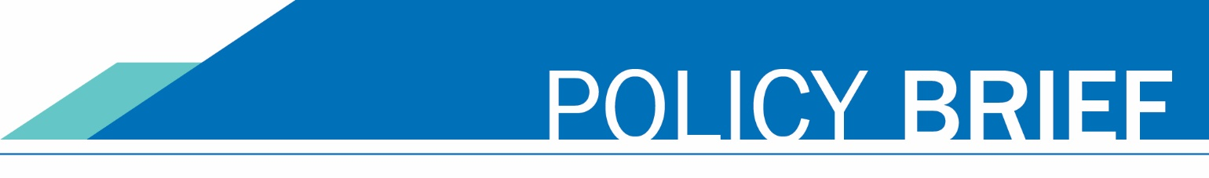

April 24, 2025

## **1% INTEREST ON PAST DUE STUDENT ACCOUNTS: POLICY & SYSTEMWIDE IMPLEMENTATION**

## Introduction

## Washington State Law mandates that interest be applied to past due debts owed to the state. For community and technical colleges, this includes outstanding student account balances. The purpose of implementing a standardized 1% monthly interest charge is to align with RCW 43.17.240, improve financial accountability, and establish consistent processes across all 34 colleges in the Washington community and technical college (CTC) system.

## To support uniform compliance and reduce operational disparities, the State Board for Community and Technical Colleges (SBCTC) is coordinating a systemwide policy and configuration for interest application within ctcLink. This policy brief outlines the legal basis, key implementation decisions, and proposed functional standards for applying interest to past due student accounts.

## Legal and Policy Basis for 1% Interest on Past Due Student Accounts

The ctcLink system is designed to comply with the following state and federal laws:

* [**RCW 43.17.240**](https://app.leg.wa.gov/rcw/default.aspx?cite=43.17.240) **Debts owed to the state—Interest rate.**
* Requiring state agencies and institutions to impose a financing charge of 1% a month on unpaid accounts starting on the date the unpaid account becomes past due.

### Purpose of a 1% Interest on Past Due Student Accounts

* **Regulatory Compliance:** Ensures that colleges are uniformly applying the required 1% monthly interest rate in accordance with RCW 43.17.240.
* **Operational Efficiency:** Reduces inconsistent or duplicative configurations at the local level, streamlining functionality within ctcLink.
* **Fairness and Transparency:** Ensures students are treated equitably across all colleges in terms of financial obligations and application of interest.
* **Financial Accountability:** Encourages timely student payments and supports institutional financial stability by reinforcing consistent and predictable debt management practices across the system.

### Key Process Attributes for the 1% Interest on Past Due Student Accounts

This supports institutional financial health, aligns with statutory requirements, and fosters transparency and accountability in student financial obligations.

To facilitate systemwide implementation, the following policy and operational guidelines are provided:

1. **Uniform Interest Rate:** All colleges will apply a 1% monthly interest rate on eligible past due balances. This rate is based on RCW 43.17.240.
2. **Eligibility of Charges**: Interest will apply to all past due student charges on the student’s account.
3. **Interest Accrual Method:** Interest will be calculated and assessed monthly, on the same calendar day each month. Interest will be assessed on the full past due balance, including any previously assessed interest (i.e., compounding interest).
4. **Centralized Configuration, Local Execution**: SBCTC will deliver a standard configuration model within ctcLink. Colleges will be responsible for managing the monthly process and ensuring proper accounting and student notification.
5. **Timeline for Implementation**: Interest charging should be implemented consistently across all CTCs. The recommended go-live will align with a future academic or fiscal term to ensure readiness and support equitable application statewide.
6. **Documentation and Exceptions**: Colleges must document any exceptions and retain records of waiver criteria, in alignment with state audit requirements. Additional guidance will be provided regarding allowable exceptions and required documentation.

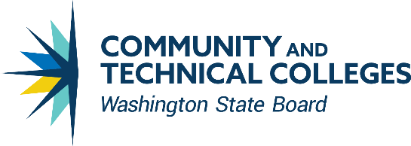CONTACT INFORMATION

Choi Halladay

Deputy Executive Director, Business Operations

State Board for Community & Technical Colleges

[CC BY 4.0](https://creativecommons.org/licenses/by/4.0/) 360-704-4303

[challaday@sbctc.edu](mailto:challaday@sbctc.edu)