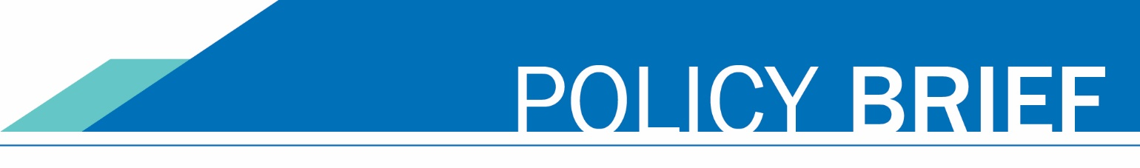

March 7, 2025

# Ensuring Compliance with the Keep Washington Working Act in Online Admissions Applications

## Introduction

The Washington State Board for Community and Technical Colleges (SBCTC) has identified a misalignment between the current "citizenship" question in the Online Admissions Application Portal (OAAP) and the requirements of the Keep Washington Working (KWW) Act. This policy brief discusses modifications to the OAAP to address these concerns, protect student data, create efficiencies in the residency determination workflow, and support our commitment to creating a culture of belonging for all students while minimizing harm in our practices.

## Policy Update

To ensure compliance with state policy, best practices, and the guidance provided by the Washington state Attorney General’s Office on data collection, SBCTC leadership, in consultation with WACTC, decided to discontinue the collection of citizenship and visa information through the OAAP. This decision aligns with the requirements of the KWW Act and guarantees that only the information necessary for residency determination is collected. It also ensures full adherence to all applicable state and federal laws governing data privacy and residency verification processes. By taking this step, SBCTC is upholding its commitment to maintaining lawful and ethical data practices.

## Background

Over the past few years, the Admissions and Registration Council (ARC) requested a series of enhancements to the OAAP, particularly concerning residency determinations and the use of the Residency Affidavit language from the Washington Student Achievement Council (WSAC). These enhancements aim to quickly determine residency status for tuition and state aid programs.

## ctcLink Development Changes

The following development changes are being implemented to ensure compliance with the KWW Act and to enhance the OAAP:

* Dynamic Residency Questions: Updating the residency questions to display dynamically using the Residency Affidavit, accessible to all Washingtonians regardless of citizenship or immigration status.
* Removal of Citizenship/Visa Information: Removing citizenship and visa information from the application, including from in-progress applications.
* Updates to In-Progress Applications: Modifying in-progress applications to reflect the changes outlined in ER 999–Residency and Citizenship Work Package 1.

## Implementation Timeline

Current user acceptance testing (UAT) activities are on hold while these modifications are being addressed. Once the changes pass development and system integration testing (SIT), SBCTC will provide the colleges with information on UAT and the next steps.

Is there an estimated timeframe? Summer quarter?

## Conclusion

These modifications to the OAAP ensure alignment with the Keep Washington Working Act, protect student data, and streamline residency determination workflow. In addition, they support SBCTC's and the colleges' vision to lead with racial equity by maximizing student potential and transforming lives.

By ensuring that residency determination processes are both efficient and equitable, these changes reflect a commitment to creating a culture of belonging where all students, regardless of background or identity, feel welcomed and supported. Continued collaboration with stakeholders will not only facilitate a smooth transition and implementation of these changes but will also advance racial, social, and economic justice.

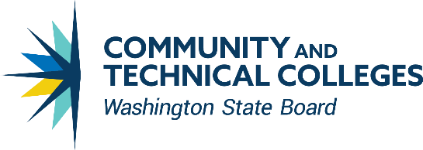CONTACT INFORMATION

Jamie Traugott

Director of Student Services & K12 Alignment



State Board for Community & Technical Colleges

[CC BY 4.0](https://creativecommons.org/licenses/by/4.0/) 360-704-3929

Except where otherwise noted jtraugott@sbctc.edu