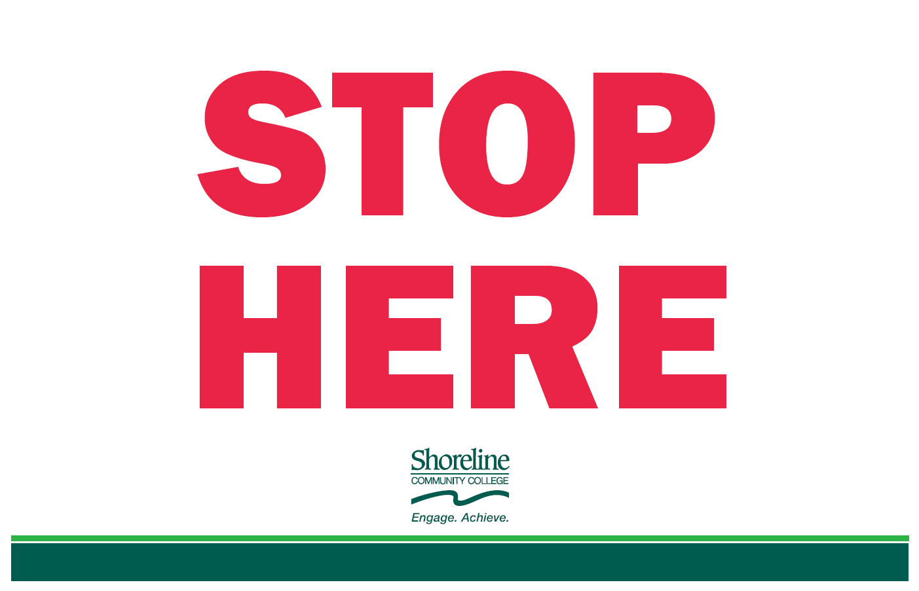

**Naloxone and Fentanyl Test Strips:**

The products below are provided free of charge by Shoreline Community College in compliance with HB 2112 (2023-24). Please only take what you need as supplies are limited. If the naloxone or fentanyl test strips have run out, contact Safety & Security so that it can be restocked (call 206-546-4633 or email [safetyandsecurity@shoreline.edu](mailto:safetyandsecurity@shoreline.edu)).

**Naloxone:** Naloxone is a medicine that temporarily stops the effect of opioids. This helps a person start to breathe again and wake up from an opioid overdose. Naloxone (the generic name) is also sold under the brand names Narcan®. You should always contact 9-1-1 if you suspect someone is overdosing.

**Fentanyl Test Strips:** Test strips can tell you if your drugs contain fentanyl but not how much fentanyl there is or how strong it is.

All campus locations for naloxone and fentanyl test strips:

Bldg. 5000 (Counseling Center) **|||** Bldg. 6000 (1st Floor Avanti Market) **|||** Bldg. 9000 (2nd Floor Restrooms)

Bldg. 7000 (2nd Floor Elevator Lobby) **|||** Bldg. 4000 (outside of 2nd Floor Main Entrance and 2nd Floor next to the restrooms)

King County Crisis Line 24-hour Crisis Line Washington Recovery Help Line Emergency Services

2-1-1 or 1-1800-621-4636 1-866-427-4747 1-866-789-1511 9-1-1