Bridge to College

Key Facts

- The Bridge to College program consists of two college readiness/transition courses—one in math, one in English Language Arts—available primarily to high school seniors at participating school districts across the state of Washington.
- The courses include a statewide automatic placement agreement approved by the CTC system (and Eastern Washington University) in 2015: students earning a B or better in the courses are guaranteed placement in a college-level course. A modification to the agreement based on changes in the high school assessment was approved in 2018; for details see the Bridge to College page on the SBCTC website.
- The courses are one of the options for students to meet the high school graduation pathway requirement.
- The courses align with the Washington state K-12 Learning Standards and college readiness expectations of college faculty in both disciplines. They were originally designed for seniors who scored below college-ready on the high school Smarter Balanced assessment, with the primary goal being helping those students avoid having to take precollege courses when they enter college immediately after high school.
- The program was developed and is led by the State Board for Community and Technical Colleges (SBCTC) in 2013-14 in partnership with the Office of the Superintendent of Public Instruction (OSPI), with initial funding support from College Spark Washington. For the last two years the program has been self-support, funded by fees paid by participating school districts; OSPI and SBCTC provide some in-kind staff support.
- Based on a series of external evaluations on the courses (reviewing multiple years of quantitative and qualitative data), the Bridge to College courses are generally serving the population of students they intended to serve and are also helping these students be successful in their entry college-level courses when they transition to college.

Significance of the Courses

- For colleges, the courses serve as another crucial outreach opportunity for communicating to and building relationships with a key group of students who have signaled an interest in college but who for various reasons often don’t enroll after high school. The course materials can also be, and have been, used in their own precollege programs.
- For students, the courses provide an engaging and challenging opportunity to develop the confidence, social-emotional learning, and academic skills that will help them be successful in their entry-level college courses in math and English.
- For teachers, the courses offer strong professional learning through a network of high school teachers dedicated to the student-focused instructional approach of the courses, along with an active partnership with higher education faculty.
- For schools and districts, the courses represent well-designed, low-cost, open-source curricula for students interested in attending college but uncertain of how well they will do there.

Level of Participation in the Program

As noted in the table below, there was a steady increase in Bridge to College participation after the pilot year, followed by a significant jump in district, school, and particularly teacher participation in 2018-19, a result of the new law designating Bridge to College courses as one of two course-based alternatives to the high school assessment graduation requirement. Participation has been stable since that time, even though the original College Spark grant has ended and schools are now paying to support the required professional learning for their Bridge to College teachers. For a full listing of the districts and high schools that offered Bridge to College in 2021-22, see Appendix A.

School Year | Districts | High Schools | Teachers | English | Math
2015-16 | 74 | 114 | 210 | 104 | 106
2016-17 | 97 | 154 | 276 | 136 | 140
2017-18 | 89 | 138 | 247 | 121 | 126
2018 -19 | 111 | 188 | 430 | 196 | 234
2019-20 | 121 | 203 | 485 | 222 | 263
2020-21 | 121 | 202 | 419 | 183 | 236
2021-22 | 115 | 188 | 423 | 210 | 213

Student Enrollment and Demographics

Over the first six full years of offering the courses, almost 50,000 students have enrolled, split roughly 60/40% between math and English. 44% of the students have been white, 30% Hispanic/Latinx, and 8% Black, with the percentage of Hispanic/Latinx students increasing over the years and the percentage of Black students remaining steady. Comparing the enrollments in Bridge to College with the overall statewide student enrollments, white students are under-represented in the courses while Black and Hispanic/Latinx students are over-represented. Just over 57% of the students in Bridge to College in that period were considered low-income (based on their free and reduced lunch status), compared to 44% of Washington K-12 students statewide. For more details see Appendix B, “Student Enrollment by Year.”

College Enrollment for Bridge to College Students

- Each year roughly three-quarters of Bridge to College students (English and math) earn a B or better in the course, making them eligible for direct placement into college level courses at Washington community and technical colleges through the statewide automatic placement agreement.
- From 2015 through 2019, of those eligible for the placement agreement 29% of the Bridge to College English course students and 35% of the Bridge to College Math students enrolled in college directly after high school. These rates are lower than the overall state rate (61% over the same period), but the Bridge to College courses are specifically serving students who haven’t been necessarily focused on college-going (or confident in their capacity for college).
- In the most recent cohort of Bridge to College students almost one-third are Hispanic/Latinx and slightly under half are White. Based on an analysis of an "equity index” (the proportion of students who go on to a postsecondary institution compared to the proportion who take the course in high school—see below), Hispanic/Latinx and Black Bridge to College students attend college at rates comparable to the proportions of students enrolled in the courses.

Bridge to College Student Enrollment in College-level Courses

- Statewide the overall percentage of students taking precollege courses when they enter community and technical colleges has been decreasing over the past few years. While this progress is a result of a variety of interventions by community and technical colleges, most schools offering Bridge to College courses are at or below the state average of students enrolling in precollege courses. This pattern suggests that the inclusion of Bridge to College has been a contributing factor to this decreasing rate.
- Across four cohorts of students, Bridge to College English students who go to college directly took college level English courses at a higher rate than the comparison non-Bridge to College students.
- While overall rates of college course-taking were relatively lower for math than for English, Bridge to College Math students took college-level math at a slightly higher rate than the comparison non-Bridge to College students.

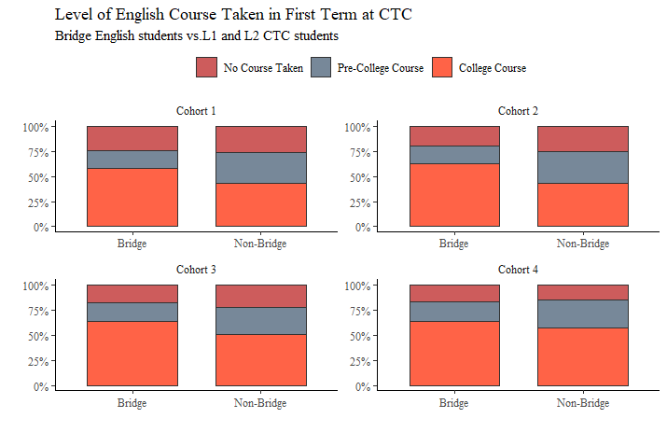
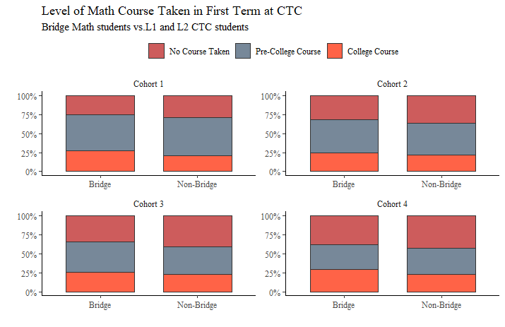
Source (“Year 6 Bridge to College Report, 2020-21,” Baker Educational Research Group)

Bridge to College Student Performance in College-level Courses

- Bridge to College students in both math and English earned slightly higher grades in college-level courses than their non-Bridge to College peers.
- Across all four cohorts analyzed in the most recent evaluation study, both math and English Bridge to College students who qualified for college-level placement (B or better in Bridge to College) earned slightly more college level credits in the respective areas (math or English) than non-Bridge to College students.

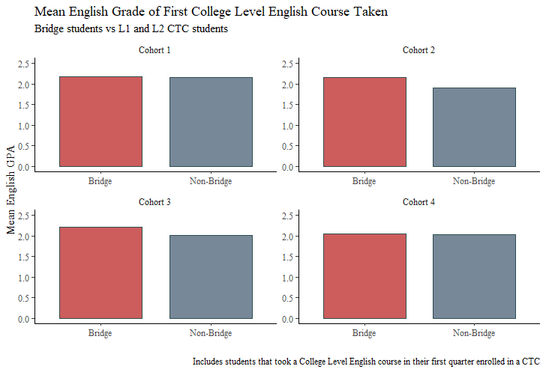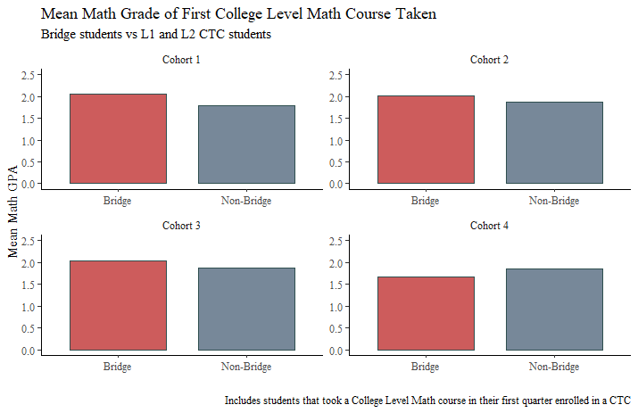

Ongoing Challenges

- The external evaluations have highlighted that there are quite a few students who earn a “B or better” who do not transition directly into college, so a future focus is to work on identifying and reducing barriers that keep students from moving directly into college.
- Additional work is needed to connect Bridge to College Math (BTCM) with the shifting focus on high school math pathways, including the new “modernized” Algebra 2 course, and continuing to refine the BTCM curriculum to meet the needs of the specific population of students enrolling in the course.
- Getting information to schools and students about how to access the placement agreement continues to be challenging. Smarter Balanced scores are not on student transcripts and some college registration occurs before transcripts that reflect the “B or better” are available.

Project Evaluation Overview

During the initial phase of the Bridge evaluation, BERC (Baker Education Research Consultants) Group researchers conducted a mixed-methods study to explore implementation and impact of the program on student outcomes. Fifteen Bridge to College schools were selected for site visitations through a stratified sampling process. Researchers divided all participating schools into groups geographically; (Eastern and Western Washington, urban and rural communities), and then randomly selected schools from each region. In spring 2016 and 2017, researchers interviewed school administrators, teachers, and students at each school. Additionally, researchers conducted observations of Bridge to College English language arts and Math classrooms. Qualitative data results from this initial phase of the Bridge to College evaluation can be found on College Spark Washington’s website.

In addition to qualitative data collected at the beginning of this initiative, quantitative data collection has continued annually since 2016. Researchers have worked with the Educational Research and Data Center (ERDC) to collect K-12 and postsecondary data for all seniors taking Bridge to College English and/or math courses across the state. These data points included demographic information, standardized assessment scores, math grades in Bridge to College, failure rates, and postsecondary course taking and achievement. These data were then analyzed to understand patterns of math engagement and success related to participation in Bridge to College courses. In total, four cohorts of Bridge to College students were tracked for the most recent research study. For additional specific supporting data reflecting the conclusions noted above, see the “Year 6 Bridge to College Report 2020-21” posted on the Bridge to College page on the SBCTC website or on the OSPI website.

Appendix A: Student Demographics by Year

BRIDGE TO COLLEGE ENGLISH |  |  | BRIDGE TO COLLEGE MATH
Student Group | Count | % | Student Group | Count | %
All Students (2015-16) | 2192 |  | All Students (2015-16) | 1675
American Indian/Alaskan Native | 70 | 3.2% | American Indian/Alaskan Native | 38 | 2.3%
Asian | 95 | 4.3% | Asian | 78 | 4.7%
Black/African American | 99 | 4.5% | Black/African American | 120 | 7.2%
Hispanic/Latino of any race(s) | 412 | 18.8% | Hispanic/Latino of any race(s) | 414 | 24.7%
Native Hawaiian/Other Pacific Islander | 46 | 2.1% | Native Hawaiian/Other Pacific Islander | 26 | 1.6%
Two or More Races | 173 | 7.9% | Two or More Races | 111 | 6.6%
White | 1297 | 59.2% | White | 888 | 53.0%
FRL | 1140 | 51.8% | FRL | 847 | 50.5%
Non-FRL | 1059 | 48.2% | Non-FRL | 830 | 49.5%
All Students (2016-17) | 2752 |  | All Students (2016-17) | 2973
American Indian/Alaskan Native | 50 | 1.8% | American Indian/Alaskan Native | 53 | 1.8%
Asian | 95 | 3.5% | Asian | 132 | 4.4%
Black/African American | 166 | 6.0% | Black/African American | 275 | 9.2%
Hispanic/Latino of any race(s) | 722 | 26.2% | Hispanic/Latino of any race(s) | 772 | 26.0%
Native Hawaiian/Other Pacific Islander | 39 | 1.4% | Native Hawaiian/Other Pacific Islander | 39 | 1.3%
Two or More Races | 206 | 7.5% | Two or More Races | 230 | 7.7%
White | 1474 | 53.6% | White | 1472 | 49.5%
FRL | 1527 | 55.5% | FRL | 1588 | 53.4%
Non-FRL | 1225 | 44.5% | Non-FRL | 1388 | 46.6%

BRIDGE TO COLLEGE ENGLISH |  |  |  |  |  | BRIDGE TO COLLEGE MATH
Student Group | Count | % |  |  | Student Group |  | Count | %
All Students (2017-18) | 1966 |  |  |  | All Students (2017-18) |  | 3525
American Indian/Alaskan Native | 47 | 2.4% |  |  | American Indian/Alaskan Native |  | 41 | 1.2%
Asian | 78 | 4.0% |  |  | Asian |  | 142 | 4.0%
Black/African American | 122 | 6.2% |  |  | Black/African American |  | 343 | 9.7%
Hispanic/Latino of any race(s) | 586 | 29.8% |  |  | Hispanic/Latino of any race(s) |  | 992 | 28.1%
Native Hawaiian/Other Pacific Islander | 39 | 2.0% |  |  | Native Hawaiian/Other Pacific Islander |  | 66 | 1.9%
Two or More Races | 128 | 6.5% |  |  | Two or More Races |  | 289 | 8.2%
White | 966 | 49.1% |  |  | White |  | 1652 | 46.9%
FRL | 1170 | 59.5% |  |  | FRL |  | 1920 | 54.4%
Non-FRL | 796 | 40.5% |  |  | Non-FRL |  | 1607 | 45.6%
All Students (2018-19) | 3252 |  |  |  | All Students (2018-19) |  | 7225
American Indian/Alaskan Native | 84 | 2.6% |  |  | American Indian/Alaskan Native |  | 147 | 2.0%
Asian | 130 | 4.0% |  |  | Asian |  | 397 | 5.5%
Black/African American | 153 | 4.7% |  |  | Black/African American |  | 710 | 9.8%
Hispanic/Latino of any race(s) | 1143 | 35.1% |  |  | Hispanic/Latino of any race(s) |  | 2096 | 29.0%
Native Hawaiian/Other Pacific Islander | 103 | 3.2% |  |  | Native Hawaiian/Other Pacific Islander |  | 168 | 2.3%
Two or More Races | 216 | 6.6% |  |  | Two or More Races |  | 538 | 7.4%
White | 1422 | 43.7% |  |  | White |  | 3171 | 43.9%
FRL | 2046 | 62.9% |  |  | FRL |  | 3947 | 54.6%
Non-FRL | 1206 | 37.1% |  |  | Non-FRL |  | 3287 | 45.4%
All Students (2019-20) | 3634 |  |  |  | All Students (2019-20) |  | 6867
American Indian/Alaskan Native | 73 | 2.0% |  |  | American Indian/Alaskan Native |  | 156 | 2.3%
Asian | 256 | 7.0% |  |  | Asian |  | 393 | 5.7%
Black/African American | 305 | 8.4% |  |  | Black/African American |  | 606 | 8.8%
Hispanic/Latino of any race(s) | 1214 | 33.4% |  |  | Hispanic/Latino of any race(s) |  | 2235 | 32.5%
Native Hawaiian/Other Pacific Islander | 130 | 3.6% |  |  | Native Hawaiian/Other Pacific Islander |  | 169 | 2.5%
Two or More Races | 244 | 6.7% |  |  | Two or More Races |  | 483 | 7.0%
White | 1413 | 38.9% |  |  | White |  | 2826 | 41.2%
FRL | 2296 | 63.1% |  |  | FRL |  | 3955 | 57.6%
Non-FRL | 1342 | 36.9% |  |  | Non-FRL |  | 2915 | 42.4%
BRIDGE TO COLLEGE ENGLISH |  |  |  |  |  | BRIDGE TO COLLEGE MATH
Student Group | Count | % |  |  | Student Group |  | Count | %
All Students (2020-21) | 3620 |  |  |  | All Students (2020-21) |  | 6862
American Indian/Alaskan Native | 74 | 2.0% |  |  | American Indian/Alaskan Native |  | 157 | 2.3%
Asian | 254 | 7.0% |  |  | Asian |  | 393 | 5.7%
Black/African American | 304 | 8.4% |  |  | Black/African American |  | 605 | 8.8%
Hispanic/Latino of any race(s) | 1207 | 33.3% |  |  | Hispanic/Latino of any race(s) |  | 2233 | 32.5%
Native Hawaiian/Other Pacific Islander | 128 | 3.5% |  |  | Native Hawaiian/Other Pacific Islander |  | 167 | 2.4%
Two or More Races | 243 | 6.7% |  |  | Two or More Races |  | 483 | 7.0%
White | 1411 | 39.0% |  |  | White |  | 2825 | 41.2%
FRL | 2285 | 63.1% |  |  | FRL |  | 3952 | 57.6%
Non-FRL | 1340 | 37.0% |  |  | Non-FRL |  | 2913 | 42.5%
All Students (6-Year total) | 17416 |  |  |  | All Students (6-year total) |  | 29127
American Indian/Alaskan Native | 398 | 2.3% |  |  | American Indian/Alaskan Native |  | 592 | 2.0%
Asian | 908 | 5.2% |  |  | Asian |  | 1535 | 5.3%
Black/African American | 1149 | 6.6% |  |  | Black/African American |  | 2659 | 9.1%
Hispanic/Latino of any race(s) | 5284 | 30.3% |  |  | Hispanic/Latino of any race(s) |  | 8742 | 30.0%
Native Hawaiian/Other Pacific Islander | 485 | 2.8% |  |  | Native Hawaiian/Other Pacific Islander |  | 635 | 2.2%
Two or More Races | 1210 | 6.9% |  |  | Two or More Races |  | 2134 | 7.3%
White | 7983 | 45.8% |  |  | White |  | 12834 | 44.1%
FRL (free and reduced lunch) | 10464 | 60.0% |  |  | FRL (free and reduced lunch) |  | 16209 | 55.6%
Non-FRL | 6968 | 40.0% |  |  | Non-FRL |  | 12940 | 44.4%

(Source—OSPI Cedars data system)
[Back to Page 2]

Appendix B: Districts and High Schools Offering Bridge to College, 2020-21

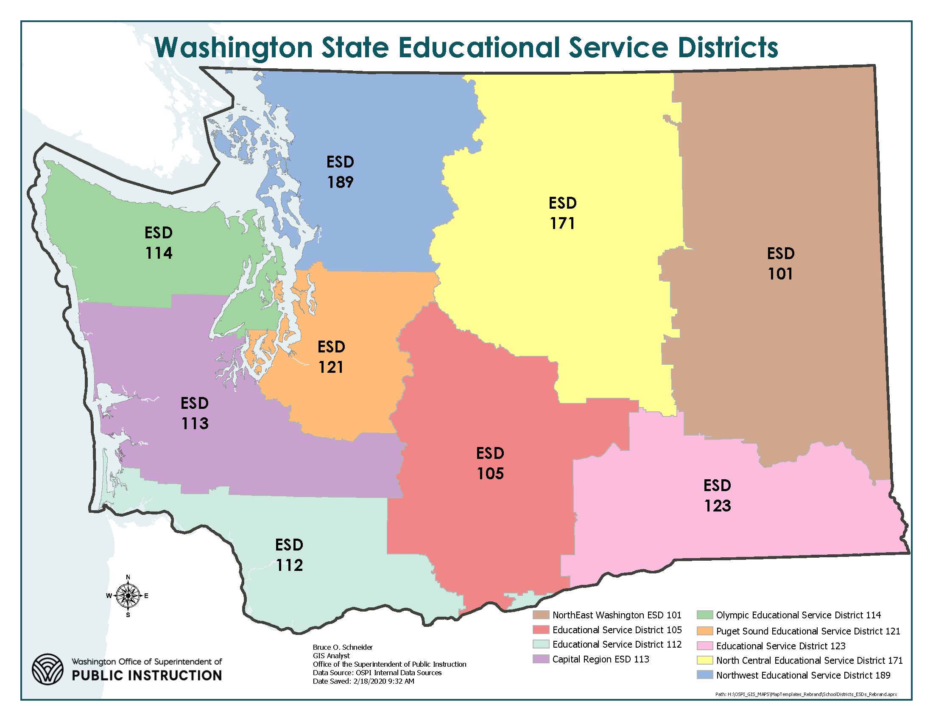

ESD | District | HSName | Math | English
101 | Central Valley School District | Central Valley High School | X | X
 |  | Mica Peak High School |  | X
 | Deer Park School District | Deer Park High School |  | X
 | East Valley SD (Spokane) | East Valley High School | X | X
 | Mead School District | Mead Senior High School | X
 |  | Mt Spokane High School | X | X
 | Medical Lake School District | Endeavors School | X | X
ESD | District | HSName | Math | English
 |  | Medical Lake High School | X | X
 | Nine Mile Falls School District | Lakeside High School | X | X
 | Northport School District | Northport High School | X | X
 | Odessa School District | Odessa High School | X
 | Selkirk School District | Selkirk High School | X | X
 | Spokane School District | Ferris High School |  | X
 |  | Lewis and Clark High School | X | X
 |  | North Central High School | X | x
 |  | On Track Academy | X | x
 |  | Rogers High School | X | X
 |  | Shadle Park High School | X | X
 | Sprague School District | Sprague High School | X | X
 | Wellpinit School District | Wellpinit High School | X | X
 | West Valley SD (Spokane) | Spokane Valley HS | X
 |  | West Valley High School | X
105 | East Valley SD (Yakima) | East Valley High School | X | X
 | Ellensburg School District | Ellensburg High School |  | X
 | Grandview School District | Grandview High School | X | X
 | Granger School District | Granger High School | X | X
 | Highland School District | Highland High School | X | X
 | Mabton School District | Mabton Jr/Sr High School | X | X
 | Mount Adams School District | White Swan High School | X | X
 | Royal School District | Royal School District | X | X
ESD | District | HSName | Math | English
 | Selah School District | Selah High School | X | X
 | Toppenish School District | Toppenish High School | X | X
 |  | CATS High School | X | X
 | Wapato School District | Wapato High School | X | X
 | Yakima School District | A C Davis High School | X | X
 |  | Eisenhower High School | X | X
112 | Battle Ground SD | Prairie High School | X
 | Camas School District | Camas High School | X
 | Castle Rock School District | Castle Rock High School | X | X
 | Evergreen School District | Heritage High School | X
 |  | Evergreen High School | X
 |  | Mountain View High School | X | X
 |  | Union High School | X | X
 | Hockinson School District | Hockinson High School | X
 | Kelso School District | Kelso High School | X | X
112 | Longview School District | R. A. Long High School | X
 | Trout Lake School District | Trout Lake |  | X
 | Vancouver School District | Fort Vancouver |  | X
 |  | Hudson's Bay High School |  | X
 |  | Vancouver Flex Academy | X
 |  | Skyview High School |  | X
 | Wahkiakum School District | Wahkiakum High School |  | X
 | Wishram School District | Wishram HS | X
ESD | District | HSName | Math | English
113 | Lake Quinault School District | Lake Quinault High School | X | X
 | Montesano School District | Montesano High School |  | X
 | North Beach School District | North Beach High School | X | X
 | North Thurston High School | North Thurston High School | X
 |  | River Ridge High School | X | X
 |  | Timberline High School | X
 | Peninsula School District | Peninsula High School | X | X
 |  | Gig Harbor High School | X
 | Rochester School District | Rochester High School | X
 | Shelton School District | CHOICE High School |  | X
 |  | Shelton High School | X | X
 | Taholah School District | Taholah High School | X | X
 | Tumwater School District | A G West Black Hills High School | X
 |  | Tumwater High School | X
 | White Pass School District | White Pass Junior Senior High | X | X
 | Yelm School District | Yelm HS | X
114 | Cape Flattery School District | Clallam Bay High School | X | X
 |  | Neah Bay High School | X | X
 | Central Kitsap School District | Central Kitsap High School | X
 | Chimacum School District | Chimacum High School | X | X
 | Crescent School District | Crescent High School | X | X
 | North Kitsap School District | North Kitsap High School | X | X
 | North Mason School District | North Mason High School | X | X
ESD | District | HSName | Math | English
 | Port Angeles School District | Port Angeles High School | X | X
 | Port Townsend School District | Port Townsend High School |  | X
 | Sequim School District | Sequim High School | X | X
 | South Kitsap School District | Explorer Academy | X | X
 |  | South Kitsap High School | X | X
121 | Bethel School District | Bethel High School | X | X
 |  | Challenger High School |  | X
 |  | Graham-Kapowsin High School | X | X
 |  | Spanaway Lake High School | X | X
 | Clover Park School District | Clover Park High School | X | X
 |  | CPSD Open Doors | X | X
 |  | Lakes High School | X | X
 | Federal Way School District | Decatur High School | X | X
 |  | Federal Way High School | X | X
 |  | Thomas Jefferson High School | X
 |  | Todd Beamer High School | X
 | Franklin Pierce School District | Franklin Pierce High School | X | X
 |  | Washington High School | X | X
 | Highline School District | Big Picture School | X
 |  | Evergreen High School | X | X
 |  | Highline High School | X | X
 |  | Tyee High School | X | X
 |  | New Start High School | X | X
ESD | District | HSName | Math | English
 |  | Mount Rainier HS | X
 | Kent School District | Kent Meridian High school | X | X
 |  | Kentlake High School | X
 |  | Kent Learning Lab | X
 | Mercer Island School District | Mercer Island High School | X
 | Northshore School District | Bothell High School | X | X
 |  | Northcreek HS | X
 |  | Inglemoor High School | X
 |  | Secondary Academy for Success | X | X
 | Peninsula School District | Gig Harbor High School |  | X
 | Puyallup School District | Puyallup High School | X | X
 |  | Emerald Ridge High School | X | X
 |  | Rogers High School | X | X
 | Renton School District | Albert Talley Sr. High School |  | X
 |  | Hazen High School |  | X
 |  | Lindbergh High School | X
 |  | Renton High School | X | X
 | Richland School District | Richland High School | X
 |  | Hanford High School | X
 | Seattle Public Schools | Cleveland High School | X | X
 |  | Franklin High School | X | X
 |  | Ingraham High School | X
 |  | Middle College High School | X
ESD | District | HSName | Math | English
 |  | Rainier Beach High School |  | X
 |  | Seattle World School | X | X
 |  | South Lake High School | X | X
 |  | West Seattle HS | X
 |  | Sugiyama High School | X | X
 |  | Chief Sealth International HS | X | X
 |  | Interagency Academy | X | X
 | Shoreline School District | Shorecrest High School | X
 |  | Shorewood High School | X | X
 | Snoqualmie Valley SD | Mount Si High School | X | X
 | Steilacoom Hist. SD | Steilacoom High School | X
 | Tacoma School District | Foss IB World School | X | X
 |  | Lincoln High School | X | X
 |  | Mount Tahoma High School | X | X
 |  | Silas (Wilson) High School | X | X
 | Tukwila School District | Foster High School | X | X
123 | Dayton School District | Dayton High School | X
 | North Franklin School District | Connell High School | X | X
 | Othello School District | Othello High School | X | X
 | Pomeroy School District | Pomeroy High School | X | X
 | Prescott School District | Prescott Junior Senior High | X
 | Walla Walla School District | Walla Walla High School | X | X
ESD | District | HSName | Math | English
171 | Brewster School District | Brewster High School | X | X
 | Bridgeport School District | Bridgeport High School | X | X
 | Cashmere School District | Cashmere High School | X
 | Grand Coulee School District | Lake Roosevelt Jr-Sr High | X | X
 | Methow Valley School District | Liberty Bell Jr-Sr High School | X | X
 | Moses Lake School District | Moses Lake High School | X
 | Omak School District | Omak High School | X | X
 | Quincy School District | Quincy High School | X | X
 | Tonasket School District | Tonasket High School | X | X
 | Warden School District | Warden High School | X | X
 | Wenatchee School District | Wenatchee High School | X | X
 |  | WestSide High School | X | X
189 | Anacortes School District | Anacortes High School | X
 | Arlington School District | Arlington High School | X | X
 | Bellingham School District | Squalicum High School | X
 | Blaine School District | Blaine HIgh School | X | X
 | Edmonds School District | Edmonds-Woodway HS | X | X
 |  | Lynnwood High School | X | X
 |  | Meadowdale High School | X | X
 |  | Mountlake Terrace High School |  | X
 |  | Scribner High School |  | X
 | Everett School District | Cascade High School | X
 |  | Everett High School | X
ESD | District | HSName | Math | English
 |  | H.M. Jackson High School | X
 | Lake Stevens School District | Lake Stevens High School | X | X
 | Lakewood School District | Lakewood High School | X | X
 | Lopez Island School District | Lopez Island High School | X
 | Lynden School District | Lynden High School | X
 | Marysville School District | Marysville Pilchuck High School | X
 | Meridian School District | Meridian High School | X | X
 | Monroe School District | Leaders In Learning High School | X | X
 | Mount Baker School District | Mount Baker High School |  | X
 | Mount Vernon School District | Mount Vernon High School | X | X
 | Mukilteo School District | ACES High School |  | X
 |  | Kamiak High School |  | X
 |  | Mariner High School | X | X
 | Oak Harbor School District | Oak Harbor High School |  | X
 | San Juan Island SD | Friday Harbor High School | X
 | Sultan School District | Sultan High School | X | X
OSPI | Summit Public School: Olympus | Summit Public School: Olympus | X
OSPI | Chief Leschi School District | Chief Leschi Schools | X | X
OSPI |  | Lumen High School | X
OSPI | Lummi Nation | Lummi Nation School |  | X
OSPI | PRIDE Prep Charter SD | Innovation HS | X | X

[Back to Page 2]

