Working Group Enhancement Request

Instructions
Submit completed form to Reuth Kim.

Enhancement Request Submitter
[CHOOSE ONE]
These organizations or individuals may initiate change requests. Choose one and include contact information for the person completing this form.

☐ College Executive Sponsor
☒ Commission Chair (WSSSC)
☐ Data Governance Committee Co-Chair
☐ SBCTC ctcLink Lead
☐ Common Process Development Team
☐ External Mandate (e.g. regulation, legislation)

Enhancement Representative
[PROVIDE CONTACT INFORMATION]
Contact information for the individual submitting the request (for example, Commission Chair). If applicable, include SBCTC Liaison assisting submitter seek governance approval for this requested enhancement.
Name, Job Title: Janet Garza, Associate Registrar
Organization Role Title (e.g. commission chair, CPW team leader): ARC workgroup lead
College: Columbia Basin College
Phone number(s), Email address: 509-544-2030, jgarza@columbiabasin.edu
SBCTC Liaison or others who assisted: Michelle Mussen, Tiffaney Robinson-Duane, Chantel Black, Ruby Hayden

Name, Job Title: Michelle Mussen, Assistant Director of Enrollment Services
Organization Role Title (e.g. commission chair, CPW team leader): ARC workgroup lead backup
College: Clark College
Phone number(s), Email address: 360-992-2818, mmussen@clark.edu

Name, Job Title: Tiffaney Robinson-Duane, Associate Registrar
Organization Role Title (e.g. commission chair, CPW team leader): ARC workgroup member
College: Pierce College
Phone number(s), Email address: 253-964-6442, tduane@pierce.ctc.edu

Name, Job Title: Chantel Black, Director of Admissions & Registration/Registrar
Organization Role Title (e.g. commission chair, CPW team leader): ARC President 2021-22
College: Spokane Community College
Phone number(s), Email address: 509-533-7067, Chantel.Black@scc.spokane.edu

Name, Job Title: Ruby Hayden, Vice President of Student Services
Organization Role Title (e.g. commission chair, CPW team leader): WSSSC liaison for ARC
College: Lake Washington Institute of Technology
Phone number(s), Email address: 425-739-8208, ruby.hayden@lwtech.edu

Enhancement Request Title
ARC OAAP Recommended Updates
Descriptive title to differentiate this from other similar requests.

Pillar/Module
Campus Solutions/OAAP
Pillar and Module associated with this requested enhancement? Separate Pillar name and Module with a hyphen: Pillar-Module

Description of Enhancement Requested
An OAAP working group within ARC, with support from ARC during our spring 2022 meeting are requesting some improvements to OAAP. These updates would all be global.

- RUNNING START - we can ask residency questions but can’t use it until they transition to general level.
  - REQUEST: Residency be mandatory on RS OAAP keeping the same language as the general OAAP
- HIGH SCHOOL INFORMATION SECTION - have two separate sections for high school and colleges attended. It is a bit confusing and not clear that you can enter college information as well.
  - REQUEST: Update menu and main header from “High School Information” to say “High School/College Information” and make the secondary header that states “College Information” more prominent (maybe bold and blue?)
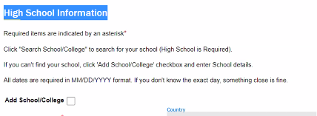
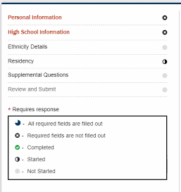
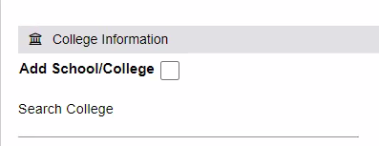
- ACADEMIC HISTORY SECTION - require that students only must enter the year or month/year that they graduated or started high school. Not the exact day/month/year. Most students don't know this information and we don't want them to have to spend unnecessary time looking for it.
  - REQUEST: Only ask for Month/Year (if need a full date, have the system default to the 1st of the month entered)
- ACCOUNT SETUP - it is a bit misleading when it says "apply." A student may think that they are done applying when they have only done the initial step of account activation. Better wordage could be to click "continue the application."
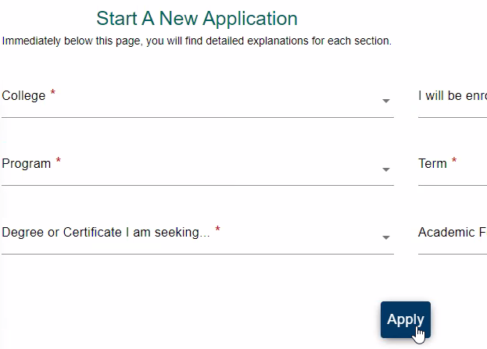
  - REQUEST: Update button from “Apply” to “Continue to Application”
- MENU NAVIGATION - for easier navigation when working with students it is helpful to have each section have a number (especially over the phone)
  - REQUEST: Add numbers to the sub menu and also the correlating number to the header of the same section
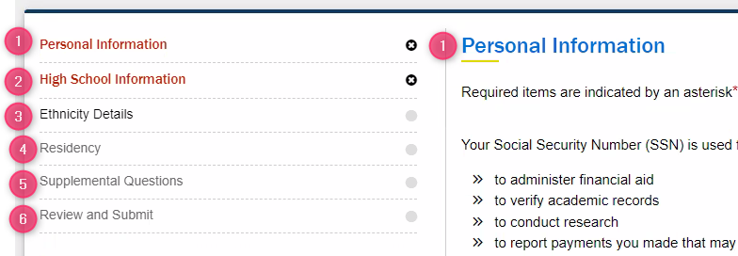
- “COMPLETED” GRAPHICS - even when all required fields are entered, it still only shows as partially completed in the circles or percentage complete at the top. This could be very concerning for someone who thinks they must have it be at 100% to submit. Right now, you must have everything filled in (even if it's not a required field) to show as 100% complete.
  - REQUEST: Update to only calculate only the required sections, exclude the optional sections/questions
- UPDATE PREFERRED EMAIL - the issue of the email submitted at the point of submission is updated/replaced with the preferred email already on file. Which causes the acceptance email to be sent to an email they may no longer have access to or be checking and causes unnecessary work for staff to use workarounds
  - REQUEST: Connect PS with the OAAP to update new preferred email to the one submitted in OAAP
- ADMIT TYPE DEFINITIONS - need transparency on who should apply for which admit type and what they mean.
  - EX: Transitional Studies; incorrectly selecting this option in OAAP
    - REQUEST: Currently at the bottom of the page, but would like it to be more prominent so it’s easy to view/see by students. Suggest it’s moved to the side or top of page and/or add clickable “?” (info) icons.
- RESIDENCY/CITIZENSHIP INFORMATION
  - Must choose Country: US then choose the citizenship status (where they choose visa type)
    - REQUEST: default Country to “US”
Provide a description of change being requested. Provide sufficient detail, including problem statement and whether the change impacts global or local configuration.

System Impact
[CHOOSE ONE]
Colleges are STRONGLY encouraged to discuss with other live PeopleSoft colleges to determine breadth of system impact before submission

☒ All College Districts ☐ Multiple College Districts: How many? ☐ Single College District

Prioritization Level
[DECLARE PRIORITY LEVEL]
Please check ONE box, and complete justification and reasoning behind the declared prioritization level
☐ Critical – Critical system impact, severely degraded critical business processes, no workaround available.
☐ Urgent – Federal/state-mandated enhancement, degraded business process; workaround exists, but is unsustainable.
☒ High – Strongly desired enhancement. Impacts business process; workaround available, high college resource impact.
☐ Medium – Strongly desired enhancement. Impacted business process; viable workaround available, but not desired.
☐ Low– Desired enhancement, productivity improvement.

Justification for the Declared Prioritization Level
At the spring 2022 meeting ARC voted to support this request, as the issues listed are causing confusion and undue stress with students submitting applications. In addition, the work load issue and search for workarounds by college staff is also causing frustration when several of the requests appear to be simple wording clarifications.
Describe the justification for selected prioritization level. Please ensure approving body (i.e. commission, executive sponsor) supports the prioritization and justification

Background Information Driving Enhance Request
This request is being put forward on behalf of ARC, due to the need for improvements after having used OAAP for a period of time.
Please provide background on why this enhancement request is being put forward. If the request started from an initial support request ticket, please provide details of the original issue reported that led to the eventual request for an enhancement to the system.

Impact Assessment If No Action Taken
The impacts if not approved would be two-fold as they impact both students and staff. Students will continue to be frustrated that the process is not clearer and will continue to submit inaccurate data. Staff will need to spend further time to find work arounds, continued outreach to students when we need to obtain corrected/addition information from, and more work to process using workarounds making it take longer to complete a process.
Please describe the impact if the enhancement request is not approved. This will help the governance group understand what will or will not happen if it declines to proceed with the enhancement request or delays addressing the request.

Details of Vetting Process
Winter quarter 2022 ARC voted to approve an OAAP workgroup to focus on issues that had been brought up with OAAP. The workgroup would discuss and bring back to ARC the recommendations for each item reviewed. The workgroup met bi-weekly and brought the above recommendations to ARC. ARC voted to support the request at the spring 2022 meeting.
Please provide details about how the enhancement request was socialized and vetted. For example, the request went through college leadership channels to the Executive Sponsor, through council and commission approvals or through federal/state mandate reviews and SBCTC ctcLink leadership.

Service Desk Ticket Reference
[COMPLETE THIS FIELD]
If applicable, provide Service Desk ticket reference number.
[ctcLink State Board Staff Use Only] Working Group Log ID: __________

Impact Analysis and Considerations

Effort Estimation
Enter the estimation of effort for design, development, testing, training and overtime timeframe for delivery into Production. If timeline or scope goes beyond the level of governance approving the enhancement then the enhancement must go back through governance approval.

Total Cost of Ownership
Detail the effort estimation to complete this enhancement, include each area of the work, (solution design, development, configuration, testing, training for example.

Decision Details
Provide a description of any details surrounding an escalation, approval or decline of the enhancement request. If multiple layers of escalation necessary, please document each discussion for future reference.

Original Submission Date: Click or tap to enter a date.
Working Group Review Date: Click or tap to enter a date.
Decision Action Taken: Choose an item.
Date of Action: Click or tap to enter a date.
Steering Committee Review Date (if needed): Click or tap to enter a date.
ctcLink Executive Leadership Committee Review Date (if needed): Click or tap to enter a date.

Date of Final Decision Action
Click or tap to enter a date.

