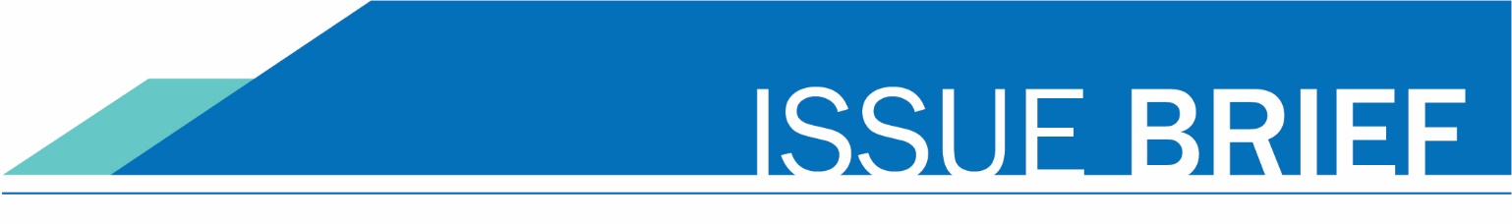
Fall 2022

system placement agreement: bridge to college and smarter balanced assessment
Since 2015, the Washington community and technical college system has offered high school students two options for automatic placement into college-level courses in English and/or math:
- Students who score above “college-ready” on the high school Smarter Balanced assessment, and
- Students who earn a B or better grade in a Bridge to College English and/or Math transition course.
The transition courses and placement agreement:
- Help high school graduates avoid taking placement tests and paying for pre-college courses when they enter college.
- Improve alignment between K-12 and entry-level college math and English curricula.
- Develop and sustain college/K-12 district partnerships and faculty/teacher collaboration.

As a result of legislation passed in 2017 shifting the timing of the high school assessment, the placement agreement language was revised in June 2018 to require specific math course-taking in their junior and/or senior years to qualify. The current agreement expired with the Class of 2022 and needs to be reviewed to determine whether, and if so how, it should be extended beginning with the Class of 2023.

Bridge to College
Bridge to College courses in English and math have been available to districts statewide since 2015-16; they are not required, but participation has grown from 74 districts (114 high schools) in the first year to 115 districts (188 high schools) in 2021-22. The courses have also been designated now as one of the options for students to meet the new high school graduation pathway requirement.

College Spark Washington provided generous initial funding for the courses as well as funding for a series of external evaluations; some brief findings from those reports (for more details see the SBCTC Bridge to College web page):
- Over the first six full years of offering the courses, almost 50,000 students have enrolled, split roughly 60/40% between math and English. 44% of the students have been white, 30% Hispanic/Latinx, and 8% Black, with the percentage of Hispanic/Latinx students increasing over the years and the percentage of Black students remaining steady.
- Each year roughly three-quarters of Bridge to College students (English and math) earn a B or better in the course, making them eligible for placement through the statewide placement agreement.
- Hispanic/Latinx and Black Bridge to College students attend college at rates comparable to the proportions of students enrolled in the courses.
- Bridge to College students take college-level courses at a slightly higher rate than a comparison group of non-Bridge to College students and earn slightly higher grades in college-level courses than their non-Bridge to College peers.

Discussion
- If they took one of the Bridge to College courses, to what extent are students entering directly from high school aware of and using the Bridge to College placement agreement?
- What current issues/challenges are colleges seeing with respect to students using this portion of the agreement?

Smarter Balanced Assessment
The timing shift of the high school assessment from the junior year to the sophomore year made the Smarter Balanced scores a part of student transcript-based placement across the system as colleges reviewed the scores in conjunction with junior and/or senior-year course-taking, especially in math. All Washington high school students are required to take four years of English so there were few issues raised with English; with a variable 3-year requirement for math, and multiple entry-level college courses, it became important for colleges to see Algebra 2 on the transcript at a minimum.

Discussion
- To what extent are students aware of and using the Smarter Balanced assessment placement agreement?
- What current issues/challenges are colleges seeing with respect to students using this portion of the agreement?

Proposed Recommendations
- It’s unclear to what extent the Smarter Balanced assessment scores are being used for placement and given the testing disruptions of the pandemic and the shift in emphasis on the high school assessment, the ongoing value of that portion of the agreement is uncertain.
- On the other hand, the success of the senior-year Bridge to College transition courses, the portion of the system placement agreement addressing the courses is more crucial to ongoing system efforts to build outreach efforts and partnerships with K-12 school districts and high schools. The courses provide an “on-ramp” to college for a critical population of students and the placement agreement serves as an incentive for those students. Implementation challenges should be addressed but the agreement should be extended indefinitely, or at least 5 years to allow for additional post-pandemic data-gathering.

