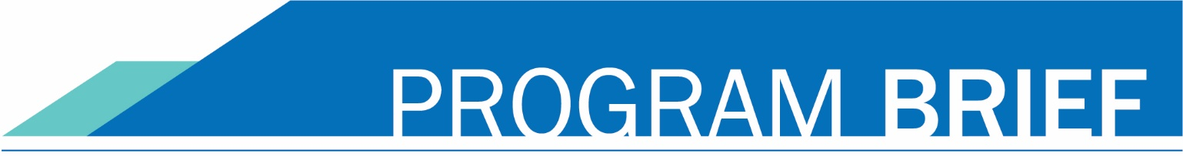
AUGUST 2022
“I took Bridge to College Math because I thought it would be beneficial to my future. It’s a real-life based math class that I could actually use. It made math more enjoyable.”
Anna, Shorecrest High School student

“I took Bridge to College English because I found out that it would give me a head start and I would be able to be on the same academic level as other community college students…..The class has taught me to be more confident and to really express my thoughts and opinions…”
Fatima, Mariner High School student

bridge to college
The Bridge to College project is the collaborative effort of three organizations committed to student learning and success in Washington: The State Board for Community and Technical Colleges (SBCTC), The Office of Superintendent of Public Instruction (OSPI) and College Spark Washington. Through Bridge to College transition courses, students engage in challenging senior-year courses in math and English that prepare them for success in college-level courses. To learn more about the courses and see a list of participating districts visit the OSPI Bridge to College webpage.

How It Works

Bridge to College transition courses are full-credit, one-year courses taught at high schools during the school day. The courses give high school seniors a unique learning opportunity that can effectively prepare them for success in college-level work.
Students who earn a B grade or above in Bridge to College courses will be eligible for the automatic statewide placement agreement in math and/or English at all participating Washington higher education institutions, currently the state’s 34 community and technical colleges and Eastern Washington University.

Who Should Take a Bridge to College Course?
While the courses were initially designed for high school seniors who scored below college-ready on the high school Smarter Balanced Assessment, they have been shown to work well for all students interested in attending college and looking for opportunities to practice the skills needed for college success.
Bridge to College English uses timely and interesting topics to engage students in rigorous reading and writing tasks that allow them to develop essential college readiness skills. Students have opportunities to develop their ideas and perspectives about issues they care about. This course will get students ready for college by developing their skills in critical reading, academic writing, speaking and listening, research and inquiry, and academic language.

Bridge to College Mathematics is an engaging course that emphasizes modeling with mathematics and the Standards for Mathematical Practice found within the Washington K-12 Mathematics Learning Standards. The course is designed to help students who have taken Algebra II be prepared to take a non-calculus pathway introductory college level mathematics course by addressing key math standards and practices essential for college- and career-readiness.

Did You Know?
- Students who take pre-college courses once they’re enrolled in college won’t be earning credits. These courses take time and cost money— and do not count toward college graduation.
- Students who enroll in college-level math directly upon entering college are far more likely to earn a college degree than students who need to take pre-college courses first.
Families: Want Bridge to College transition courses in your student’s school?
Contact your student’s guidance counselor to find out if their school offers the courses. If their school doesn’t have Bridge to College Transition courses, contact your student’s principal and ask them to offer this opportunity to students.
Teachers and Administrators: Questions on how to be a part of the Bridge to College transition program and get the courses at your school?
Contact Sally Zeiger Hanson, SBCTC Bridge Course Project Manager by emailing shanson@sbctc.edu or calling 360.704.1055. The registration process for offering the courses in the 2023-24 school year will be available on the OSPI Bridge to College web page beginning in January 2023.

