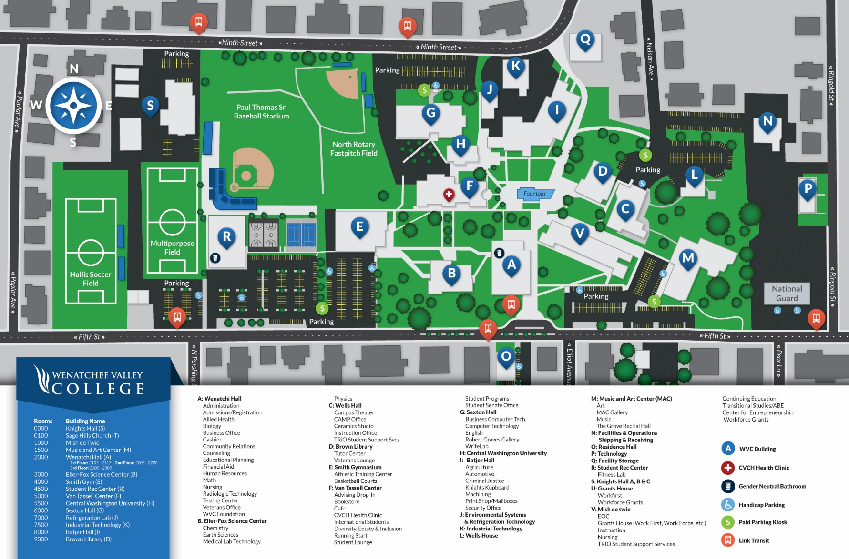

**WVC Courtesy Parking**

**NOT VALID IN RESERVED SPACES**

Guest

Student

Staff Activity: WSSSC

Date Valid: May 5-6, 2022

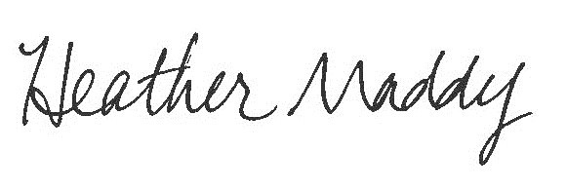

Department: Student Services Authorized by:

**PLACE PERMIT ON DASHBOARD**