regular ITEM (resolution 21-10-54)
October 21, 2021
Tab 9

Allocation Methodology for Faculty Conversions in E2SSB 5194

Brief Description
Last session the Legislature passed E2SSB 5194, a complex bill related to diversity, equity and inclusion efforts. Section 5 of the bill provided for 200 additional full-time faculty, to be accomplished by converting part-time positions to full-time positions. The $5.4 million in new funds begin next fiscal year on July 1, 2022. In order to begin the planning process for these new positions, the details of the allocation must be available to colleges as soon as possible.

How does this item link to the State Board’s Strategic Plan?
Student outcomes and success, especially for first-generation, underserved students may be significantly improved by increasing the number of full-time faculty at our colleges. These positions will be included in each district’s diversity, equity and inclusion strategic plan.

Background information and analysis
Business officers and presidents have considered several allocation methods for the $5.4 million and 200 faculty conversions beginning next fiscal year. Typically, the system uses metrics that reflect Legislative intent and consider the difference in district size. In these deliberations, faculty size, the share of part-time faculty and the share of historically underrepresented students of color were explored. Both business officers and presidents strongly supported a hybrid approach blending faculty size and share of historically underrepresented students of color. This approach was selected to honor the intent of the E2SSB 5194 –to diversify college faculty in order to improve outcomes for historically underrepresented students of color. The 200 conversions were funded by the Legislature at $27,000 each. This allocation method distributes the 200 conversions in whole numbers and increments of $27,000 to maintain consistent expectations and funding levels at each district. Details by colleges are displayed on the following page, followed by the relevant bill language.
In summary, system presidents, business officers and State Board staff recommend that $5.4 million for 200 faculty conversions be distributed based on two metrics – 50% based on share of faculty FTE and 50% based on share of historically underrepresented students of color (state-funded).

Potential questions
- How is the diversity equity and inclusion planning process at colleges being impacted by E2SSB 5194?
- How is the current environment influencing these faculty conversions?

Recommendation/preferred result
Staff recommends passage of Resolution 21-10-54
Policy Manual Change Yes ☐ No ☒
Prepared by: Cherie Berthon, operating budget director
360.704.1023, cberthon@sbctc.edu

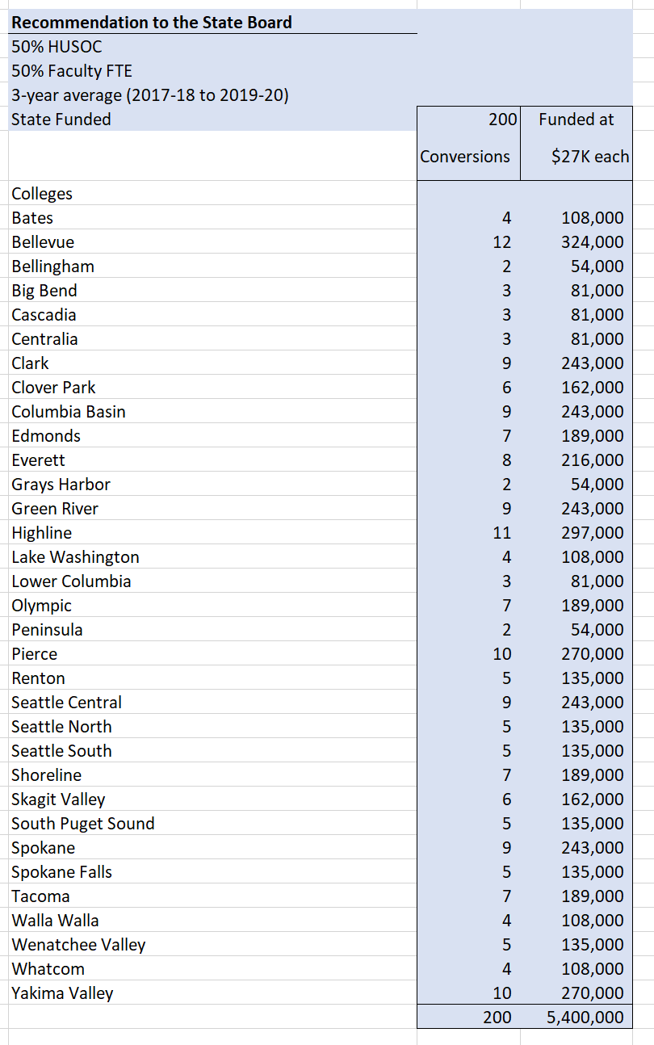
Appendix A
append
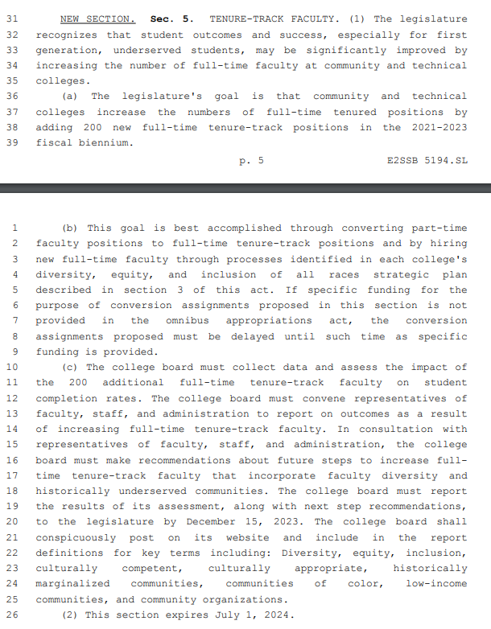

State of Washington
State Board for Community and Technical Colleges
Resolution 21-10-54
A resolution relating to the allocation of 200 faculty conversions provided for in section five of E2SSB 5194:

WHEREAS, the enacted E2SSB 5194 provided for 200 faculty conversion across the system, and;

WHEREAS, those conversions are funded beginning in Fiscal Year 23 at $27,000 each, for a total of $5.4 million in new funding.

WHEREAS, those conversions are to be part of each district’s diversity, equity and inclusion strategic plan, and;

WHEREAS, the community and technical college system has an ongoing mission to respond to student and community needs, and;

THEREFORE BE IT RESOLVED, that the State Board for Community and Technical Colleges authorizes the Director to allocate funds to districts as outlined in Appendix A.

BE IT FURTHER RESOLVED, that the State Board for Community and Technical Colleges authorizes the Executive Director to make adjustments to this action, including any necessary changes to the State Board’s Policy Manual, as necessary, for actions taken by the Governor, Legislature, data corrections, externally imposed restrictions or guidelines, uniform accounting and reporting requirements, and unanticipated changes in state or federal law.
APPROVED AND ADOPTED on October 21, 2021

Attest

________________________________ ___________________________________
Jan Yoshiwara, secretary Jay Reich, chair

