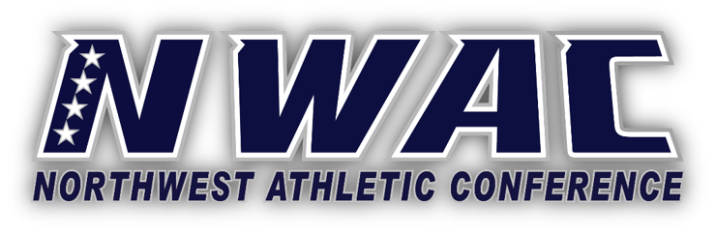
March 3/19/2021

Updated Language for Spectators, Rosters, Sophomore Eligibility, Washington Waivers

Outdoor Events, Spectator Language

With the State of Washington moving into Phase III and the Washington Activities Guidelines recently updated, NWAC Washington member colleges may allow spectators to attend outdoor athletic competitions with capacity limits subject to state/county/local regulations, and campus policies. Member colleges should be fully aware of the State of Washington Activities Guidelines for outdoor events. Fans must follow safety protocols posted at the venue.

As the Oregon Health Authority has updated language for outdoor sports activities, NWAC Oregon member colleges may allow spectators to attend outdoor athletic competitions with capacity limits subject to Oregon Health Authority, county and campus policies. This is permissible based on each Oregon member college’s county’s risk assessment (i.e., moderate, high, extreme). Fans must follow safety protocols posted at the venue.

Roster Language

Visiting/Travel team rosters are limited to essential personnel (student-athletes, coaches, trainers) as defined in each sport’s COVID-19 protocols.

There is no limit for NWAC home team rosters. Only those student-athletes who are listed in the scorebook for a particular game are to be warming up and in the home team dugout and bench areas. The same holds true for essential coaches and athletic trainers. All other home team student-athletes need to be in another area away from both benches.

Both teams must follow all safety protocols as outlined in the respective sports COVID-19 protocols.

Previous Quarter and Reduced Enrollments for Sophomore Student-Athletes for 2021-2022

On Wednesday 3-17-21 language was sent on the Previous Quarter and Reduced Enrollments for Sophomore Student-Athletes for 2021-2022. That language is effective immediately. If you have student-athletes who meet the criteria, no petitions for Spring 2021 need to be filed. Hard copy of eligibility reports should identify these student-athletes. See attachment for example.

Waivers

For years there has been a variety of interpretations on what can be done with waivers that are granted by Washington member colleges. The main question is, “Can waivers be reduced/prorated like scholarships? Yesterday after meeting with SBCTC representatives, Washington Member Colleges may reduce/prorate waivers. According to resolution 06-06-22, the State Board for Community and Technical Colleges grants to community college boards of trustees the flexibility to implement this waiver authority by all means necessary to address issues not explicitly identified in this resolution.

