Emergency Aid – WSSSC Survey March 2021
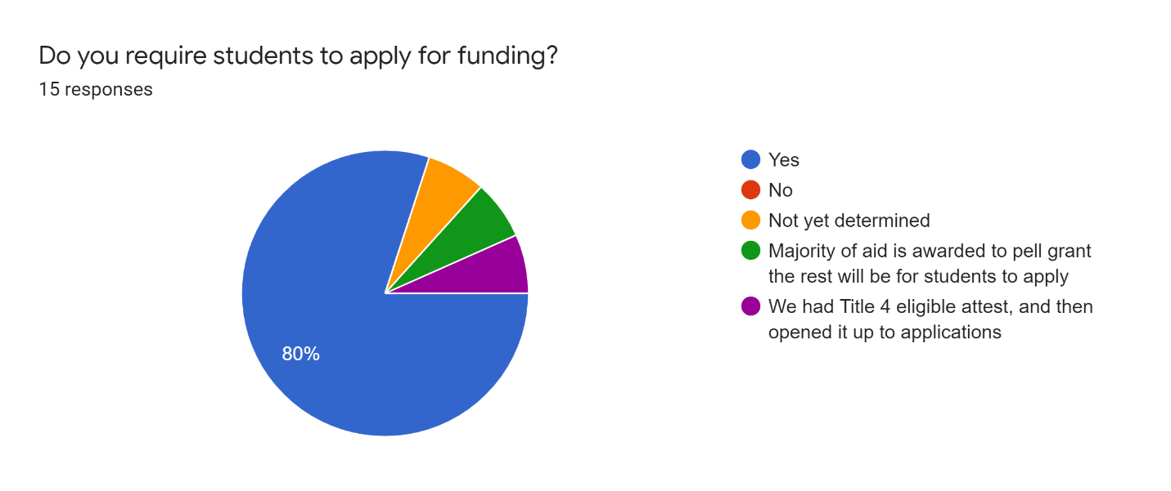

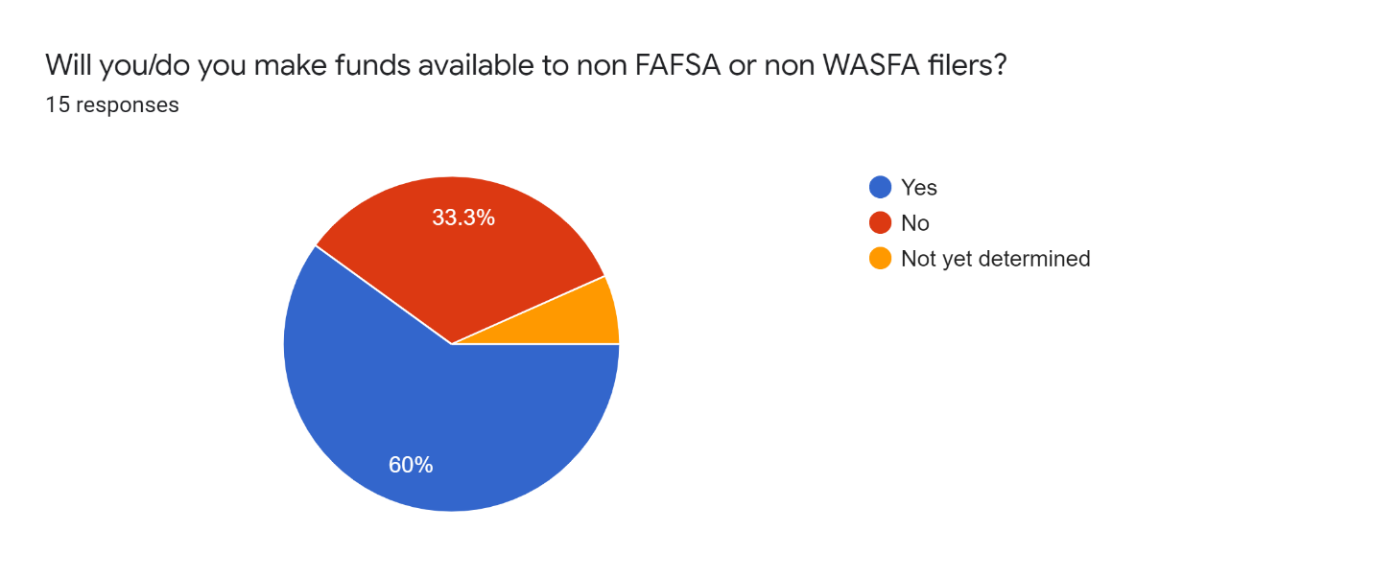
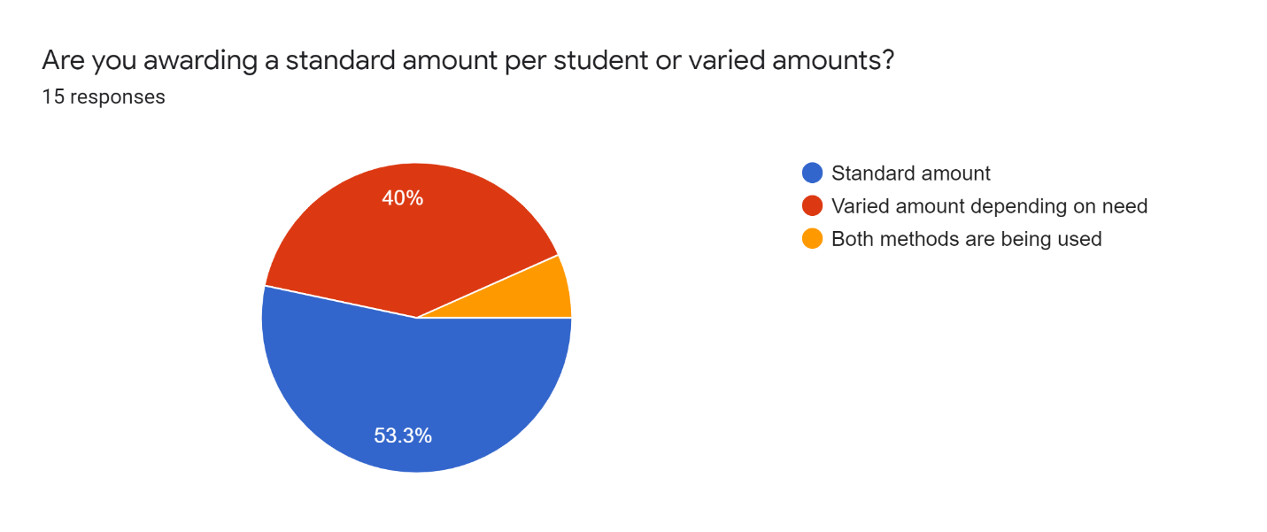
How are you defining exceptional need?
- Pell eligible
- Working to determine
- Pell grant and by demonstrated need for non-FAFSA students
- Based on how students’ describe their circumstances
- Any need that can be connected in some way to COVID
- Zero EFT
- Not sure yet

