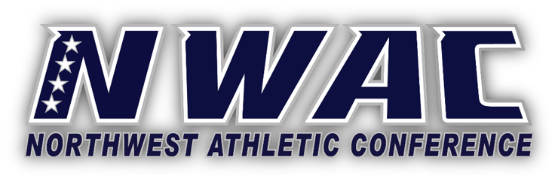
EXECUTIVE SUMMARY: NWAC Health and Safety Policies for Return to Play
Following is a summary highlighting key components of the NWAC Health and Safety Policies for Return to Play Manual. On 12/10/2020, the NWAC Executive Board approved the Health and Safety policies and procedures manual. Recently presidents of NWAC member colleges shared via a survey among other things three concerns, 1) Failure of coaches and/or student-athletes to adhere to safety protocols; 2) The institution’s responsibility to respond properly when a student-athlete or coach tests positive during the season; 3) Working with other member colleges on a consistent safety protocol for competition. This manual addresses these concerns.
These protocols are intended to provide consistency across the NWAC as the conference spans two countries and three states. Should there be a discrepancy between federal, state, and local health guidelines, member institutions must follow the stricter guidelines. Compliance with these policies will help to ensure that the NWAC has the possibility of participating in intercollegiate athletics.
Member colleges must maintain and practice current medical protocols as outlined in this document related to COVID‐19. Changes to these policies are contingent upon changes in state guidelines or advances in research and medical information.
Failure to comply or enforce these policies may be subject to disciplinary action from the NWAC.
Section 1: Introduction
Details regarding the competitive season as well as common definitions are provided. Alignment of the NWAC policies are discussed, specifically “sport courses”, as well as ensuring that all policies comply with local and state health authorities.
Section 2: Sport Phasing
The section outlines details regarding the metrics, or gating criteria, that are to be utilized in determining what activities are permitted by the NWAC. These phases are dependent on epidemiological case counts within each county. Additional details are provided for what is permitted in each phase, when to halt or resume phases.
Section 3: Safety and Risk Mitigation
The section outlines requirements from the NWAC detailing safety and risk mitigation strategies, including, but not limited to; pre-participation screening for risk, daily screening, physical distancing, training location, and contact tracing.
Section 4: Quarantines and Isolation
The section outlines the importance of daily symptom screening and management of an individual(s) that does test positive on a team.
Section 5: Testing Recommendations
This section highlights the importance of testing if institutions have adequate access to perform testing. Details the important differences between the types of testing.
Section 6: Return to Play after Covid-19 Infection
As concern rises for cardiac and other health conditions after an individual has contracted COVID-19; the NWAC Sports Medicine Advisory Council has instituted a graduated return to play for those coming back after COVID-19. This is to be managed by a certified athletic trainer or team physician.
Section 7: Travel
The section concerns details regarding travel for intercollegiate play. Details are also provided for institutions to restrict student personal travel.
Section 8: Competition and Game Management
Facility concerns and how to manage an athletic event with these restrictions are detailed. Concerns regarding spectators, essential personnel, and sport specific changes are detailed.

If you have concerns or clarifications needed specific to the medical portion of the manual please contact,
Aaron, Kilfoyle, MSc, LAT, ATC aaron.kilfoyle@ccs.spokane.edu
NWAC Sports Medicine Advisory Council President

If you have concerns or clarifications needed specific to the operations of the NWAC please contact,
Marco Azurdia mazurdia@clark.edu
Executive Director, NWAC

