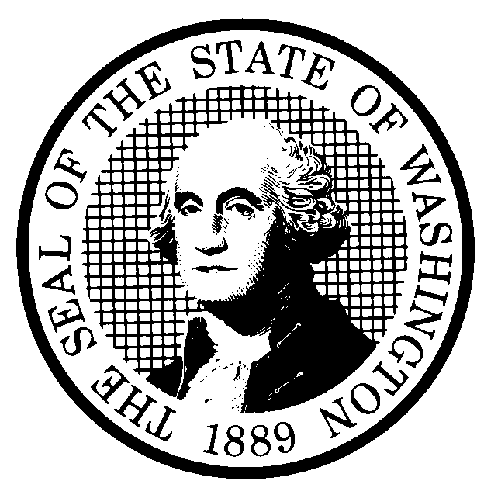 | RULE-MAKING ORDER  EMERGENCY RULE ONLY |  |  |  |  | CODE REVISER USE ONLY
CR-103E (December 2017)
(Implements RCW 34.05.350
and 34.05.360)

Agency: _______________ College
Effective date of rule:
Emergency Rules
☒ Immediately upon filing.
☐ Later (specify)
Any other findings required by other provisions of law as precondition to adoption or effectiveness of rule?
☐ Yes ☒ No If Yes, explain:
Purpose: On May 19, 2020, the Federal Register printed amendments to Title IX regulations [85 FR 30575]. The new regulations address the grievance process for formal complaints of sexual harassment and are scheduled to take effect on August 14, 2020. This requires emergency updates to the College’s Student Conduct Code to be compliant with federal regulations.
Citation of rules affected by this order:
New: Supplemental Title IX Student Conduct Procedures, WAC 132__-__-___; WAC 132__-__-__; WAC 132_-__-___ ; etc.
Repealed:
Amended: WAC 132__-___-___; WAC 132__-___-____; WAC 132__-__-___; etc.
Suspended:
Statutory authority for adoption: Chapter 34.05 RCW and RCW 28B.50.140(13); 20 U.S.C. § 1092(f); Title IX of the Education Amendments of 1972, 20 U.S.C. § 1681 et seq.
Other authority:
EMERGENCY RULE
Under RCW 34.05.350 the agency for good cause finds:
☐ That immediate adoption, amendment, or repeal of a rule is necessary for the preservation of the public health, safety, or general welfare, and that observing the time requirements of notice and opportunity to comment upon adoption of a permanent rule would be contrary to the public interest.
☒ That state or federal law or federal rule or a federal deadline for state receipt of federal funds requires immediate adoption of a rule.
Reasons for this finding: _________ College is required by the United States Department of Education to comply with the recently adopted Title IX regulations, which take effect on August 14, 2020.
Note: If any category is left blank, it will be calculated as zero.
No descriptive text.

Count by whole WAC sections only, from the WAC number through the history note.
A section may be counted in more than one category.
The number of sections adopted in order to comply with:
Federal statute: |  |  | New |  | Amended |  |  | Repealed
Federal rules or standards: |  |  | New | 9 | Amended |  | 15 | Repealed
Recently enacted state statutes: |  |  | New |  | Amended |  |  | Repealed
The number of sections adopted at the request of a nongovernmental entity:
New |  |  |  |  | Amended |  |  | Repealed
The number of sections adopted on the agency’s own initiative:
New |  |  |  |  | Amended |  | ____ | Repealed
The number of sections adopted in order to clarify, streamline, or reform agency procedures:
New |  |  |  | 9 | Amended |  | 15 | Repealed
The number of sections adopted using:
Negotiated rule making: |  |  | New |  | Amended |  |  | Repealed
Pilot rule making: |  |  | New |  | Amended |  |  | Repealed
Other alternative rule making: |  |  | New |  | Amended |  |  | Repealed
Date Adopted:  Name:  Title: | Signature:  Place signature here

