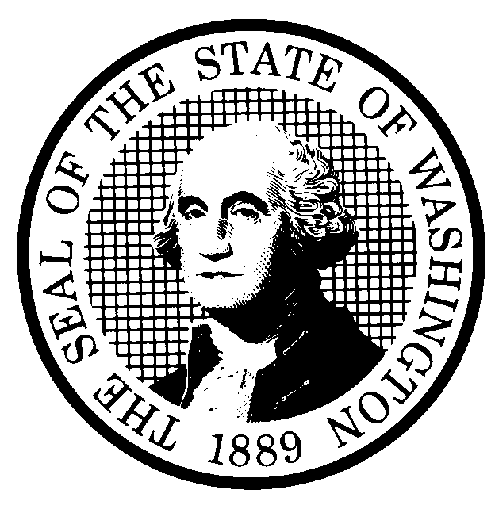 | RULE-MAKING ORDER  EMERGENCY RULE ONLY |  |  |  |  | CODE REVISER USE ONLY
CR-103E (December 2017)
(Implements RCW 34.05.350
and 34.05.360)

Agency:
Effective date of rule:
Emergency Rules
☐ Immediately upon filing.
☐ Later (specify)
Any other findings required by other provisions of law as precondition to adoption or effectiveness of rule?
☐ Yes ☐ No If Yes, explain:
Purpose:
Citation of rules affected by this order:
New:
Repealed:
Amended:
Suspended:
Statutory authority for adoption:
Other authority:
EMERGENCY RULE
Under RCW 34.05.350 the agency for good cause finds:
☐ That immediate adoption, amendment, or repeal of a rule is necessary for the preservation of the public health, safety, or general welfare, and that observing the time requirements of notice and opportunity to comment upon adoption of a permanent rule would be contrary to the public interest.
☐ That state or federal law or federal rule or a federal deadline for state receipt of federal funds requires immediate adoption of a rule.
Reasons for this finding:
Note: If any category is left blank, it will be calculated as zero.
No descriptive text.

Count by whole WAC sections only, from the WAC number through the history note.
A section may be counted in more than one category.
The number of sections adopted in order to comply with:
Federal statute: |  |  | New |  | Amended |  |  | Repealed
Federal rules or standards: |  |  | New |  | Amended |  |  | Repealed
Recently enacted state statutes: |  |  | New |  | Amended |  |  | Repealed
The number of sections adopted at the request of a nongovernmental entity:
New |  |  |  |  | Amended |  |  | Repealed
The number of sections adopted on the agency’s own initiative:
New |  |  |  |  | Amended |  |  | Repealed
The number of sections adopted in order to clarify, streamline, or reform agency procedures:
New |  |  |  |  | Amended |  |  | Repealed
The number of sections adopted using:
Negotiated rule making: |  |  | New |  | Amended |  |  | Repealed
Pilot rule making: |  |  | New |  | Amended |  |  | Repealed
Other alternative rule making: |  |  | New |  | Amended |  |  | Repealed
Date Adopted:  Name:  Title: | Signature:  Place signature here

