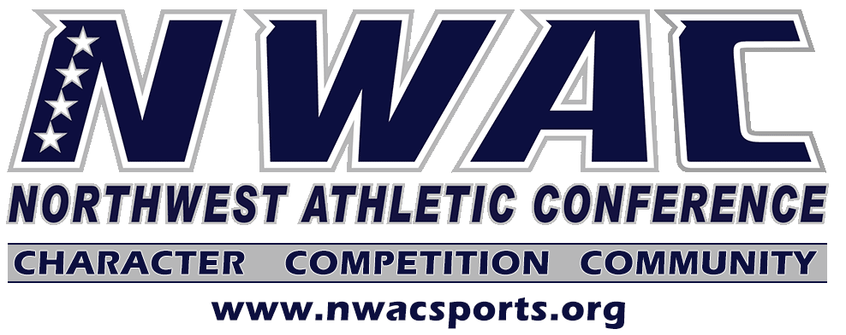

June Commission Meeting Agenda
Thursday June 18, 10am

- 2020-2021 Budget
- Discuss NWAC Return to Play Guidelines

