Pursuant to HB2513, institutions of higher education may no longer “Refuse to provide an official transcript for a current or former student on the grounds that the student owes a debt…” The HB2513 workgroup at the State Board is providing the following recommended steps to ensure institutions our following the guidance of HB2513 in ctcLink by June 11th.
Attached is a list of each institution and their perspective negative service indicators (SI) that have an impact of hold transcripts (TRAN) due to non-payment. Please be sure to have your on-campus query developers double check the list is accurate.
Clients will want to track a student while they test these changes to their negative SI’s in PCD 1st before making these changes in production.
Clients will 1st need to run the following query to see students with each SI on their list with an impact of “TRAN” – QCS_CC_SRVC_IND_DA_V2 – run the query within a term range preferred.
Example:
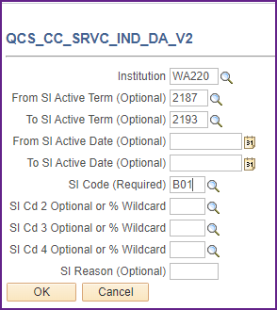
Choose a student to trust but verify changes to the SI’s were made accurately by viewing a student SI before and after the changes are made. Navigate to ‘Manage Service Indicators’ to view a test student produced from the query above.
Navigation: Campus Community > Service Indicators Student> Manage Service Indicators

Example:
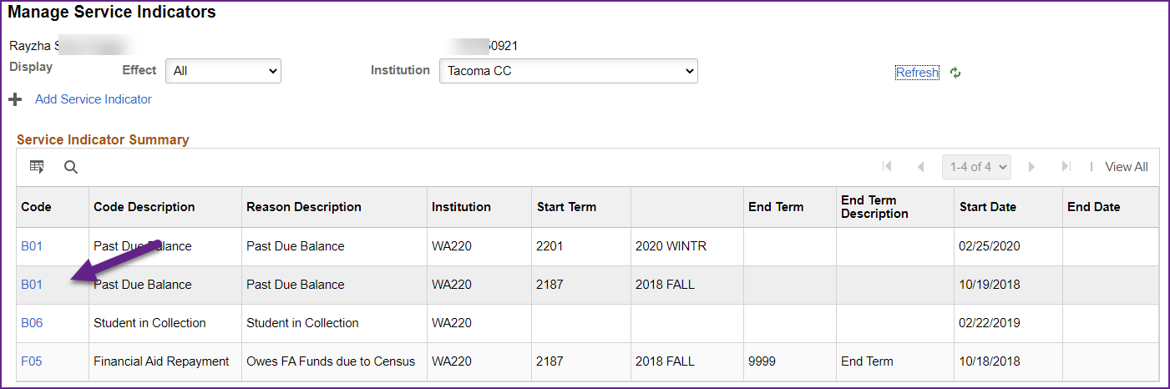
Select B01 SI
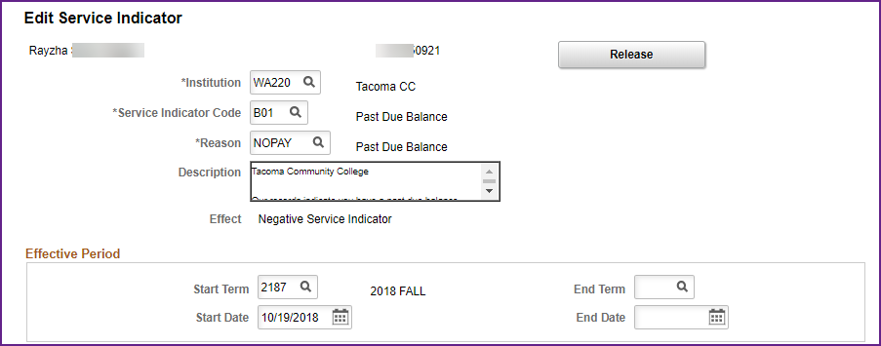
Scroll to the bottom of the page to see the “Services Impacted” section, be sure to select “View All”
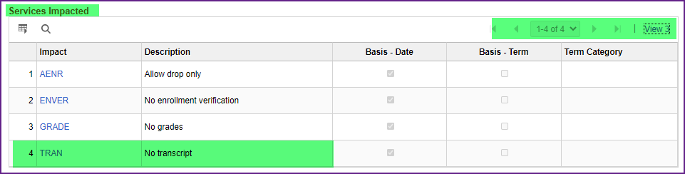
Note there are 4 rows, indicating each impact, where “TRAN” is listed before the change to B01 SI.
Next, make the change to the SI’s with service impact “TRAN” by adding a new effective dated row, choose a new effective date, delete “TRAN” impact and click “SAVE”.
Example:
Navigation: Setup SACR> Common Definitions > Service Indicators> Service Indicator Table
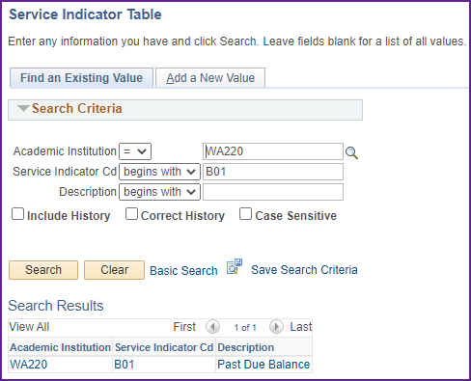
Select “B01” SI

Note in the example the ‘Effective Date’, and there is only 1 row in the “Service Indicator Details” section, and four rows in the “Service Indicator Impact” box.
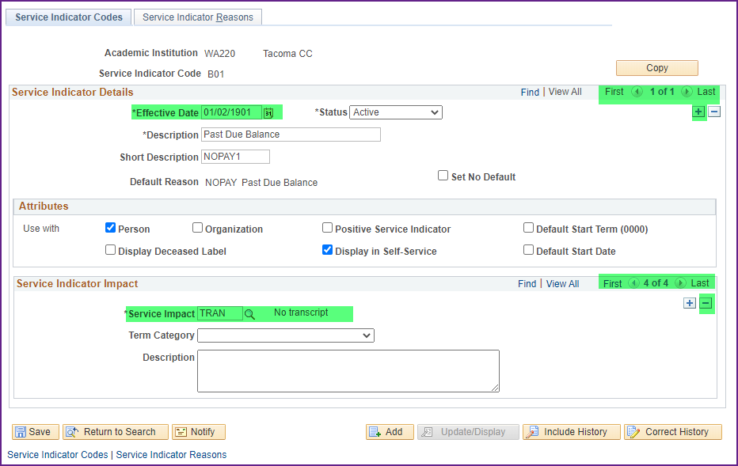
Click the “+” sign, and enter a new effective date in the “Service Indicator Details” section.
Click the “-“ sign to delete the “TRAN” row in the “Service Indicator Impact” section.
Click “Save”

Example:
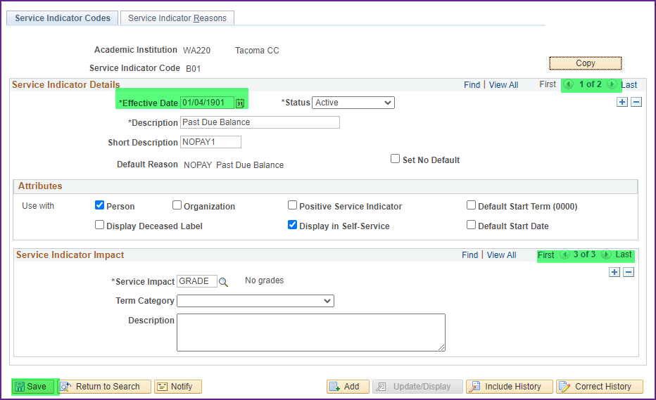
Note there are now two rows in the Service Indicator Details section and only three in the Service Indicator Impact section.
Navigate back to the student example to verify the student still has a B01 SI, but will no longer have their transcript held with this specific negative SI.

Example:
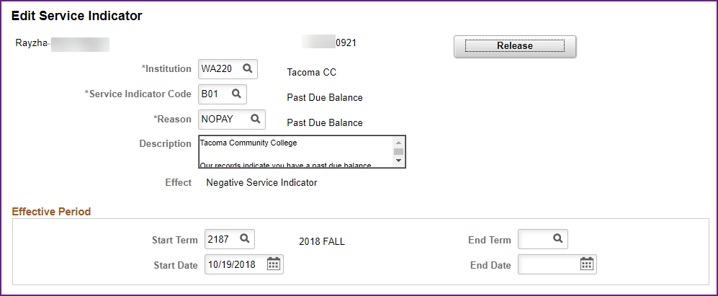
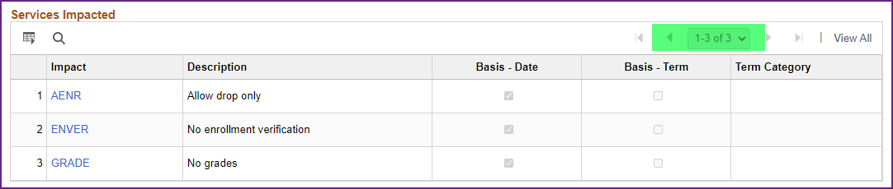
Student still has the negative SI of B01, but no longer has “TRAN” Service Impact reflected.
Client’s will need to make these changes to each negative SI with a Service Impact of “TRAN”.
Please don’t hesitate to file a ticket if you have questions about any of these steps. To help support staff recognize this request, please put in the Subject “HB2513 SI question”.

