Removing Transcript and Grade Holds

In order to maintain compliance with House Bill 2513, below are some instructions on identifying and removing transcript holds in Legacy SMS.
- Run DATAX procedure SM5004R-C to produce a list of all UA codes with transcript hold punitive action codes attached to them. The procedure in located in the “../../PLIB/INFORM” catalog.
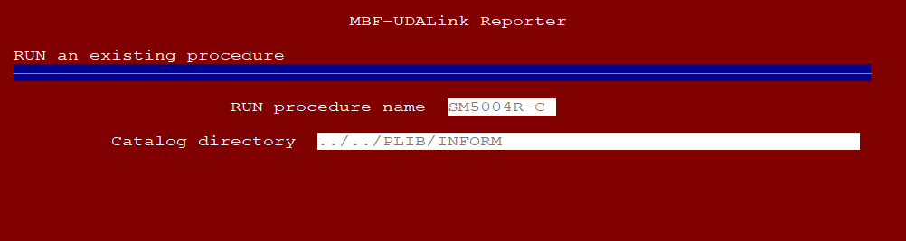
- Return to SMS and access screen SM5021. Using this screen, pull up each UA code and adjust the associated punitive action code as necessary. Ensure that changes are saved after changing each UA code.
Punitive Action codes block transcript printing via scheduled jobs and SMS screens SM6017 and SM6053.
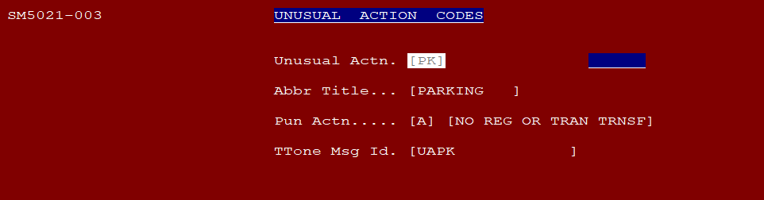
- Access SMS screen SM5025 to adjust college parameters.
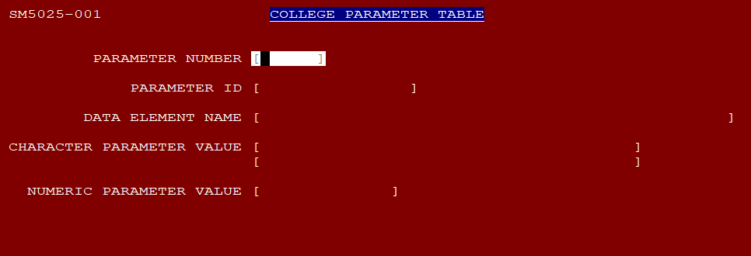
- Check parameter SM1015. This parameter controls which UA codes will block access to SMS screen SM6015 and student online unofficial transcript access. In most cases, you will want to DELETE all UA codes from this parameter.
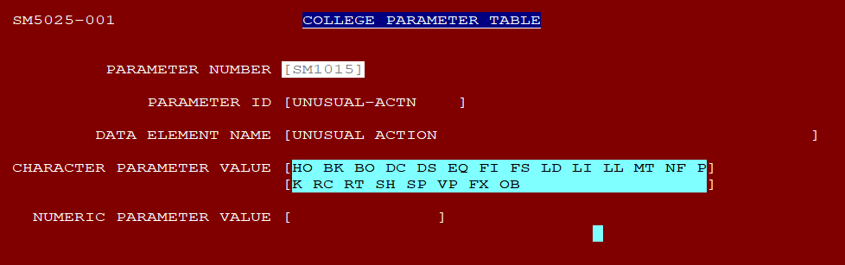
- Check parameter SM1064. This parameter controls if a student with a registration hold should be also blocked from viewing their grades. To deactivate this parameter, change the value from Y to N or blank.
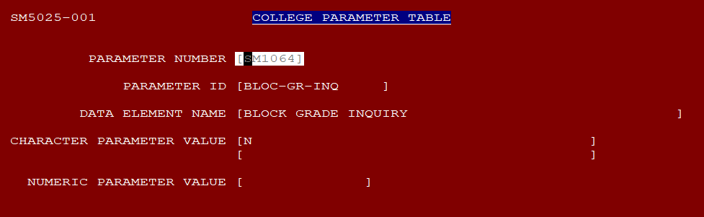

Appendix -
Listed below are all Punitive Action codes available. The yellow highlighted codes block transcript access. The green highlighted codes block grade mailers.
- CODING: BLANK = NO PUNITIVE ACTION
- 1 = NO REGISTRATION ALLOWED THROUGH "R" MODULE
- 2 = SUPPRESS PRINTING OF QUARTERLY GRADE MAILER
- 3 = NO REGISTRATION APPT
- 4 = NO REGISTRATION ALLOWED; NO QUARTERLY GRADE MAILER PRINTED
- 5 = NO REGISTRATION APPT; NO REGISTRATION ALLOWED; NO GRADE MAILER PRINTED
- 6 = SORTING CODE
- 7 = NO TRANSCRIPT TRANSFER ALLOWED
- 8 = NO GRADE MAILER PRINTED; NO TRANSCRIPT TRANSFER ALLOWED
- 9 = NO REGISTRATION ALLOWED; NO GRADE MAILER PRINTED; NO TRANSCRIPT TRANSFER ALLOWED
- A = NO REGISTRATION ALLOWED; NO TRANSCRIPT TRANSFER ALLOWED
- B = NO REGISTRATION ALLOWED; NO REGISTRATION APPOINTMENT ALLOWED

