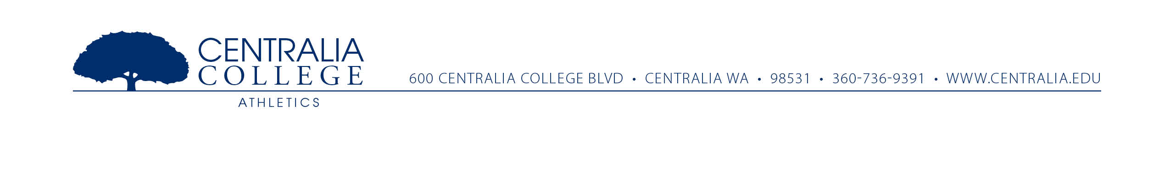
TO: Members of the NWAC
FROM: Bob Peters – Centralia College Athletic Director
RE: Women’s Bowling

I hope everyone’s summer has had a few relaxing moments and you were able to enjoy a little time away from the office. The reason for this email is to follow up from the brief conversation (at the May commissioners meeting) regarding women’s bowling as a potential sport for the NWAC.
I have had a few colleges express interest, but nothing has moved forward or been put into place at this time. Centralia College has allocated funds to start a women’s bowling club with the hope it will become NWAC recognized in the near future. On a side note, I have had a couple conversations with the local bowling alley and they are very excited about the possibility of us adding women’s bowling. They seem to be eager to offer reasonable rental rates to help us get the college involved as they have 2 area high schools with girls bowling at this time.
With that said, I would like to know if any of you have interest in participating in women’s bowling this year as a club sport. If we get enough interest we would host virtual matches (meaning you would bowl at your own local bowling alley and post scores against other schools to determine winners.) If we move forward as an NWAC sport we could choose a couple of neutral sites to host events to further expand the competitive nature of the matches.
During this year of club competition we would work collaboratively to develop the proposal to get the NWAC to recognize women’s bowling.
Once I get a firm list of interested participants I will schedule a meeting (probably conference call) to discuss the details of this year and beyond.
Please let me know by September 30 if you are interested so we can develop the firm plans and start competing.
Thank you for your time and consideration,
Bob Peters
Athletic Director
Centralia College
(360) 623-8574
bob.peters@centralia.edu

