Announcing a Webinar:
Reviewing the Updated Smarter Balanced System Placement Agreement

October 16, 2018
4 – 5 pm
Via Zoom: https://zoom.us/j/4888596738
(no registration necessary)

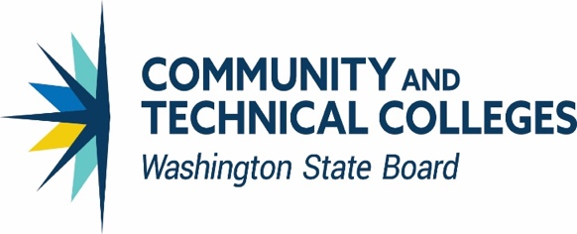
In June 2014 the community and technical college system approved the original system placement agreement for the high school Smarter Balanced assessment, administered at the time to all high school juniors (see the SBCTC web site for details). The agreement was designed to allow students to use their scores on the high school Smarter Balanced assessment to establish their readiness for college-level coursework when entering higher education institutions in Washington and create alternatives for students, if necessary, to use their senior year more effectively in getting ready for college-level work.
In spring 2017 the agreement was extended for 2 years (through the Class of 2020) to acknowledge that more time was needed to collect relevant data to be able to assess the effectiveness of the agreement. In June 2017 the Legislature passed a law (HB 2224) that a) moved the full administration of the high school assessment from the 11th grade to the 10th grade and b) defined a set of alternatives to the assessment for the purpose of meeting the graduation requirement.
Based on the changes in the assessment, the community and technical college system convened a work group in 2017-18 to determine what needed to change in the system placement agreement; those changes were approved in summer 2018, taking effect immediately for the Class of 2020 (sophomores taking the assessment in spring 2018).
In this webinar, Bill Moore, Director of K-12 Partnerships for SBCTC, and the Smarter Balanced higher education lead for Washington state, will review the key elements of the new agreement, answer questions about the implementation of the policy, and provide an update on the work being done with OSPI to create a more automated process for accessing the student score and grade information needed to honor the agreement. If you’re interested but unable to participate in the live webinar, the discussion will be recorded and posted here within a week so following the session.
Please contact Bill Moore for more information.

