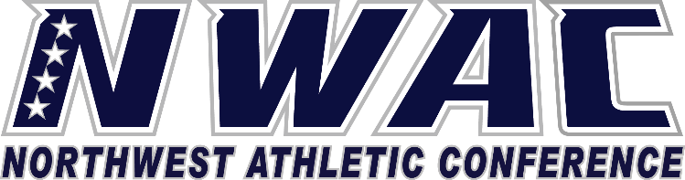

1933 Fort Vancouver Way Vancouver, WA 98663 Phone (360) 992-2833 E-mail: nwacsports@clark.edu www.nwacsports.org

NWAC EXECUTIVE BOARD MEETING AGENDA
OCTOBER 18, 2017 10:00AM

CLARK COLLEGE-CTC CAMPUS
18700 SE Mill Plain Blvd.
Vancouver, WA 98683
Room #430

- Call Meeting to Order
- Introduction of Alli Krous, Director of Operations
- Review and Approve Board Agenda
- Review and Approve Minutes from August 16, 2017
- Review Petition Waiver List (Jim Jackson) August 10, 2017-October 17, 2017
- Budget Review
- President’s Report
- Executive Director’s Report
- President’s Cup Review
- Fall Sports Championship Preview
- Soccer Friendlies and Volleyball Showcase Review
- Athletic Training Policies and Procedures Update
- Hall of Fame Information
- Sex Offender Policy Discussion
- Dual Enrollment Discussion
- Winter Conference
- Tennis Championship Request Action Item
- CSMG
- Program Review
- FGO
- Adjournment

Character, Competition, Community

www.nwacsports.org

