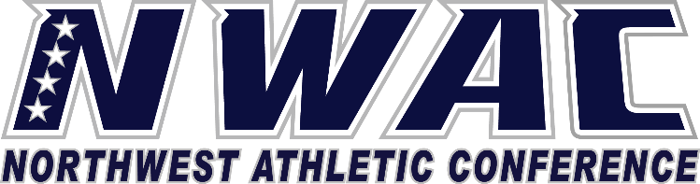

1933 Fort Vancouver Way Vancouver, WA 98663 Phone (360) 992-2833 E-mail: nwacsports@clark.edu www.nwacsports.org

ATHLETIC DIRECTOR

- How do you believe the institution, student-athletes, region, and community perceives the athletic program at your institution?

- What are the biggest obstacles that you as the athletic director face in running your athletic department?

- What are the 3-5 strengths of your athletic program?

- How do you believe your coaches view your support of them, their program and their student-athletes?

- Do you believe your athletic programs are Title IX compliant? What plans do you have in place to insure compliance with not only gender equity, but also with education students on sexual assault prevention, etc.?

- What steps do you have in place to help develop your coaches?

- Over the next 3-5 years, how do you see the athletic program evolving?

- Please speak to the process you use when working on certifying student-athletes eligibility and compliance?

- When people attend an athletic event at your institution, what thought, image, experience do you want them to walk away with? Do you believe you have been successful in making that happen?

- Do you have an emergency action plan in place for your sports? If so, please explain. Also so you have in your planning the hiring of sufficient athletic training for your programs?

- Is there something that the conference can do to help support you and/or your department?

- Are there things that you believe that your region can do to help improve the conference at the region either level and/or at the conference level?

Character, Competition, Community

www.nwacsports.org

