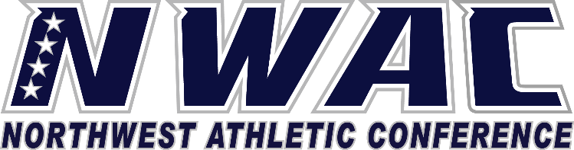

1933 Fort Vancouver Way Vancouver, WA 98663 Phone (360) 992-2833 E-mail: nwacsports@clark.edu www.nwacsports.org

Financial Aid/Scholarships

College: Date: Time: Name:

- Please explain the functions that your office performs in managing the athletic grant-in aid funds and any athletically related scholarships.
- How do you insure that all student-athletes meet the college’s criteria for aid?
- Are student- athletes given any preference in the award process?
- What departments do you work with in providing aid to student athletes?
- Please explain any interaction with the college booster club.

- Describe the working relationship between financial aid and the athletic department.

- What is the process that your office uses to determine who gets athletically related aid, scholarships, and grants when they are processed?

- Do you understand and monitor the amount of athletically related grant-in aid and waivers in each sport?

- Explain your department’s role regarding student-athlete employment.

- Who and how student-athletes jobs are monitored.

- Do you have suggestions on how the NWAC can support you/department to serve student-athletes?

Character, Competition, Community

www.nwacsports.org

