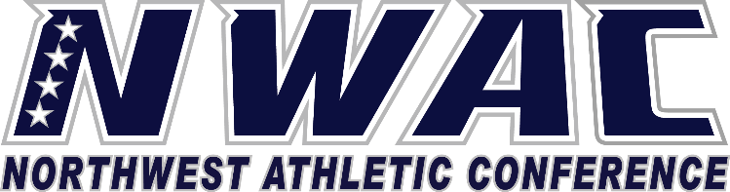

1933 Fort Vancouver Way Vancouver, WA 98663 Phone (360) 992-2833 E-mail: nwacsports@clark.edu www.nwacsports.org

Letters Of Intent/Student-Athlete Employment

College: Date: Time: Name:

- What responsibilities do you have regarding student employment?
- How do you monitor total hours worked by student athletes?
- Explain the communication process between the athletic department and your office?

- Do you have suggestions on how the NWAC can support you/department serving student-athletes?

Character, Competition, Community

www.nwacsports.org

