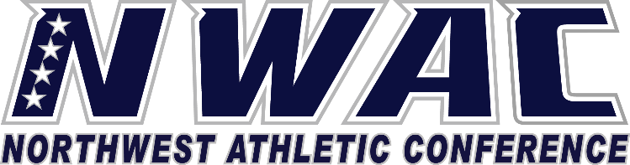

1933 Fort Vancouver Way Vancouver, WA 98663 Phone (360) 992-2833 E-mail: nwacsports@clark.edu www.nwacsports.org

Commissioners

College: Date: Time: Name: Sport:

- Please explain your roles working in conjunction with your co-commissioner as you lead the athletic department?
- Do you believe your athletic programs are Title IX compliant? What plans do you have in place to insure compliance with not only gender equity, but also with educating students on sexual assault prevention, etc.?
- What successful activities do you have in place to promote athletics on campus and within the community?
- What is your opinion of the funding resources available for your athletic program?
- What are your biggest challenges in providing a successful athletic program?
- How often do you communicate with your coaches?
- What are your thoughts on how faculty, student programs, and administration view athletics and your institution?
- What are three major needs, which would improve your athletic program?

- What roles as commissioners do you actively play in trying to create great student-athlete experiences?

- Do you have any suggestions on how the NWAC can better support you in your role as a commissioner and your athletic programs?

Character, Competition, Community

