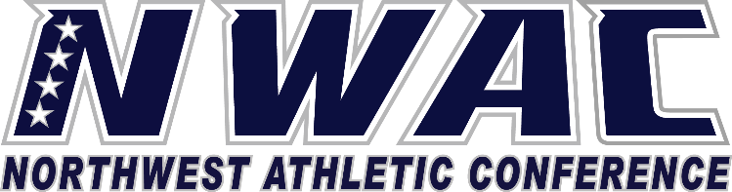

1933 Fort Vancouver Way Vancouver, WA 98663 Phone (360) 992-2833 E-mail: nwacsports@clark.edu www.nwacsports.org

Faculty

College: Date: Time: Name: Sport:

- Do you believe that faculty support the athletic programs on this campus? Please explain.
- Do you believe that most of the student athletes are committed to gaining a quality education?
- Do you believe the athletic department is committed to helping student-athletes gain a quality education and hold student-athletes accountable in the classroom? Please explain.
- Do you think that the athletic experience for the student athletes is consistent with the college mission?
- Do you have any suggestions how the athletic department could improve the student academic experience?

- Do you have any suggestions on how the conference office can assist with helping student-athletes academically?

Character, Competition, Community

www.nwacsports.org

