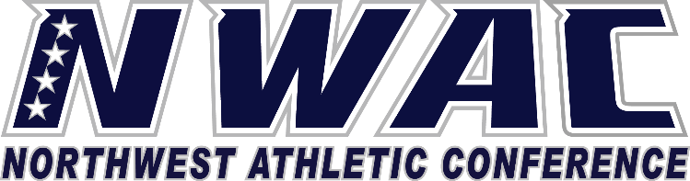

1933 Fort Vancouver Way Vancouver, WA 98663 Phone (360) 992-2833 E-mail: nwacsports@clark.edu www.nwacsports.org

Athletic Administrative Support

College: Date: Time: Name: Sport:

- What is your role within the athletic department?
- What do you see as the strengths of the department?
- Are there any areas that need upgrades?

- In terms of expectations placed on the coaches and student-athlete, are the expectations clear, practical, and supported? Do the athletic administrators hold people accountable for working towards expectations? Please explain.
- Who is your supervisor?
- Describe your familiarity with NWAC procedures and time lines that relate to the athletic department?
- Do you have any suggestion on how the NWAC can support you, student-athletes, or coaches better?
- Explain how the departmental culture is identified and nurtured.
- If you could change anything in your job, what would it be?

Character, Competition, Community

www.nwacsports.org

