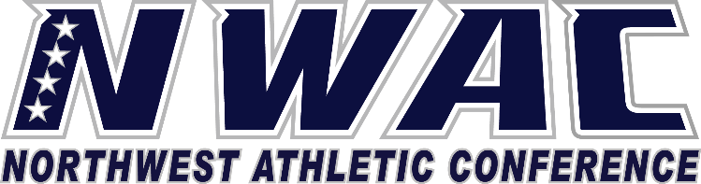

1933 Fort Vancouver Way Vancouver, WA 98663 Phone (360) 992-2833 E-mail: nwacsports@clark.edu www.nwacsports.org

President

College: Date: Time: Name:

- What are the benefits of an athletic program to your institution and the community?
- How does the mission of the athletic program meet the college mission?
- How do you gauge the success of your athletic program?
- Do you expect any changes in the scope of offerings that you now have?
- Do you believe that the athletic program is provided adequate funding?

- What are concerns you may have regarding your athletic programs?

- As the President, what do you see as the strengths of your athletic programs?

- Are there areas of the athletic program that need upgrades? What plan do you have in place to provide changes?

- How can the NWAC provide ongoing or increased support to your athletic programs?

Character, Competition, Community

www.nwacsports.org

