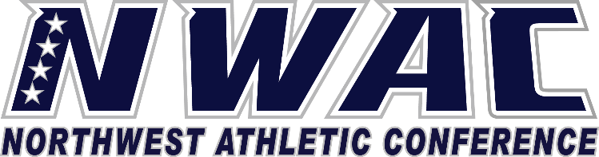

1933 Fort Vancouver Way Vancouver, WA 98663 Phone (360) 992-2833 E-mail: nwacsports@clark.edu www.nwacsports.org

Student-Athlete

College: Date: Time: Name: Sport:

- How do you like your athletic experience?
- Explain if your experience has matched with what was discussed with you when you first were recruited by the coach and the institution.

- List 3-5 strengths of your head coach/coaching staff.
- List 3-5 areas you would like to see the head coach/coaching staff improve upon.

- Please explain the expectations that the coaches place on you as a student, athlete, and when you are on the road.
- Explain the culture of your team and how the coaching staff and the athletic department foster the culture.

- Explain the support that your particular program receives from the athletic director/department.
- Explain how other services are made available to student-athletes.
- Are there any areas of the program that you think need to be improved? If so, what are they?

- On a scale of 1-10 (10 is the highest rating) please rate the athletic department support of your program in the following areas:
*academics *finances *facilities *travel/lodging

- Do you believe the athletic director holds the coaches to similar standards as the coach holds his/her student-athlete? Please explain.

- Would you consider the standards for your program and the athletic department to be high, mediocre, or low? Please explain.
- What will you remember most about your athletic experience?

- Please share any suggestions that you believe the NWAC can better support student-athletes and/or athletic programs.

Character, Competition, Community

www.nwacsports.org

