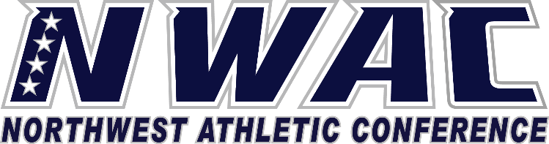

1933 Fort Vancouver Way Vancouver, WA 98663 Phone (360) 992-2833 E-mail: nwacsports@clark.edu www.nwacsports.org

Coaches

College: Date: Time: Name:

- What is your coaching philosophy specific to community college athletes?
- What do you believe are your strengths as a coach and what are areas of improvement?
- What are 3-5 characteristics that you think someone who saw your team play/or practice would use to characterize your team?
- What are the pros and cons of coaching at this level?
- What areas of your program and the overall athletic program need upgrading?
- Do your facilities meet your program needs?
- What are three keys to successful recruiting?

- Are your travel accommodations adequate for away games and championship events?
- Explain the quality communication with your Athletic Director? Do you feel that your AD and Administrative Assistant inform you of NWAC policies, procedures and important dates?
- On a scale of 1-10 (with 10 being the highest), please rate the support for you/program that you receive from the Athletic Director. Please explain your rating.

- On a scale of 1-10 (with 10 being the highest), please rate the support for you/program that you receive from the institution. Please explain your rating.

- Discuss how you believe your program and the institution perceives the athletic department.

- Discuss your belief on how your program and the athletic department is viewed by the NWAC.

- Please share any concerns or suggestions you may have for the NWAC.

- How can the NWAC better support your program?

Character, Competition, Community

www.nwacsports.org

