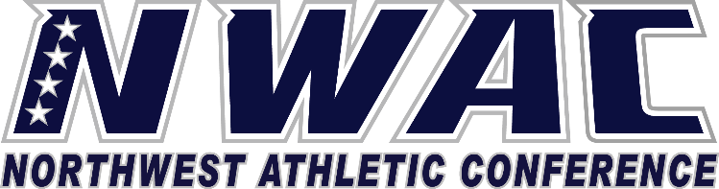

1933 Fort Vancouver Way Vancouver, WA 98663 Phone (360) 992-2833 E-mail: nwacsports@clark.edu www.nwacsports.org

Support Services/Advising

College: Date: Time: Name: Sport:

- How does your department serve the athletic department?
- Do you provide tutoring services for athletics?

- When do you first meet with student-athletes?
- Are there ways that the athletic department could help you be more efficient in serving student athletes?
- Please explain the process used in dealing with a learning challenged student athlete.

- Please share with us any suggestions you may have in how the NWAC can help serve student-athletes when it
comes to advising.

- Are you aware of NCAA/NAIA academic requirements when it comes to your student-athletes transferring to
four-year institutions?

- How does the athletic department disseminate academic and advising information to you and to student-athletes?

Character, Competition, Community

www.nwacsports.org

