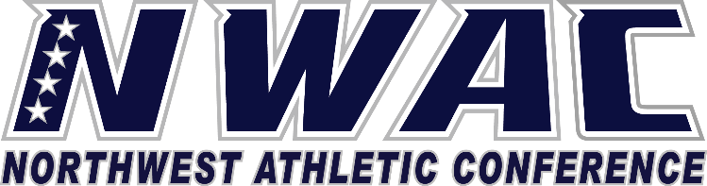

1933 Fort Vancouver Way Vancouver, WA 98663 Phone (360) 992-2833 E-mail: nwacsports@clark.edu www.nwacsports.org

Student Programs

College: Date: Time: Name:

- What is your role regarding the Athletic Department?

- From your perspective please explain what you see as the pros and cons of athletics at your institution.

- How do you see athletics relating to the college mission?

- Explain the role student programs/activities plays in funding athletics?
- Explain what you believe makes athletic programs successful? How do you or does your department support this?

- What can athletics do to support student programs and/or other student activities?

- Share any suggestions you may have on how the NWAC can support you/department to better serve student-athletes.

Character, Competition, Community

www.nwacsports.org

