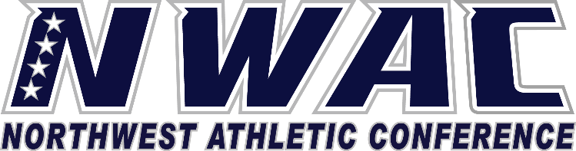

1933 Fort Vancouver Way Vancouver, WA 98663 Phone (360) 992-2833 E-mail: nwacsports@clark.edu www.nwacsports.org

Admissions/Registration/Eligibility

College: Date: Time: Name:

- Do you/your department have a role in the orientation process of student-athletes? If yes, please explain. If
not, do you believe it would be beneficial for your department to be involved in a student-athlete orientation?

- How do you rate the communication between the Athletic department and yourself/your department?

- Please explain what contact you/department have with individual student-athletes?

- Please describe any concerns you may have regarding student-athletes and the registration/eligibility process.

- Of the area of athletics you are responsible for, do you have suggestions on how the NWAC may provide any assistance to help you serve student-athletes?

- Are student-athletes given priority in the registration process?

Character, Competition, Community

www.nwacsports.org

