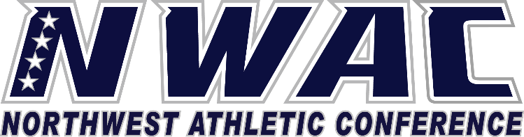

1933 Fort Vancouver Way Vancouver, WA 98663 Phone (360) 992-2833 E-mail: nwacsports@clark.edu www.nwacsports.org

Foundation/Booster Clubs

College: Date: Time: Name:

- Do you understand the NWAC rules regarding Booster Clubs and their relationship to the college?
- Explain your working relationship with the Athletic Director/Athletic Department.
- Are your funds separate from the college? What is the structure?
- In support of athletics, approximately how much money does your department raise?
- How is the money spent?
- What fundraising activities does your department hold in support of athletics?
- Please explain the significance of what winning teams mean to your fundraising efforts?
- Do you have any suggestions on how the NWAC can support your efforts in supporting student-athletes?

Character, Competition, Community

www.nwacsports.org

