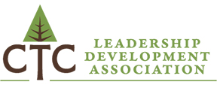
FALL 2017 CTC LEADERSHIP DEVELOPMENT ASSOCIATION CONFERENCE
November 17
HEATHMAN LODGE l VANCOUVER, WASHINGTON
“ACHIEVING ORGANIZATIONAL HEALTH THROUGH EFFECTIVE COMMUNICATION”
SPEAKERS:

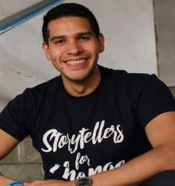 Luis Ortega is founder and director of Storytellers for Change and a Tedx speaker who has been featured as a keynote, presenter and facilitator at over 1000 events across the nation. He speaks on topics of inclusion, empathy, cultural responsive engagement, servant leadership, story-centered strategy and counter narrative. Luis will speak on "A Story-Centered Approach to Communication and Dialogue."
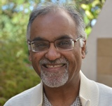 Biren “Ratnesh” Nagda is founder and principal of IDEALeadership and co-founder and director of curriculum and pedagogy at Green String Network in Nairobi, Kenya. He provides consultation on intergroup dialogue and social change, social justice leadership development, trauma healing and conflict transformation. Ratnesh will speak on “Intergroup Dialogue: Creating Spaces of Courage and Possibilities.”

FEES: $190 for participants from member colleges l $290 for participants from non-member colleges
For more information and to register:
www.ctcleads.org or contact Kati Hays: chays@sbctc.edu

