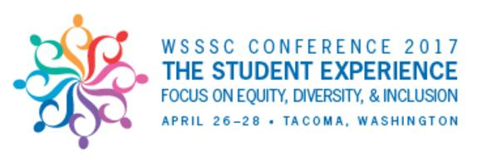
Application – WSSSC Conference Student Panel

DUE: March 17, 2017

The Washington State Student Service Commission (WSSSC) is looking for inspirational stories regarding the impact of community college education on your current or future success. This is your time to let the world know the value of a community college experience. If you wish to be a student speaker at the WSSSC state conference on April 27th, please complete the application below.

Application Process

It is the responsibility of the Applicant to submit an electronic copy of their essay along with this application to the appropriate Vice President/Dean of Student Services at their respective college. Each Vice President/Dean who receives an essay shall review the essay and forward selections along to Brian M. Murphy at brian.murphy@skagit.edu no later than March 23rd, 2017. The WSSSC Selection Committee will review and may call for additional documentation or a personal informal interview if needed for evaluation of your application. Please keep a copy of the application for your own records.

Selected applicants will be notified by April 6th, and will participate in a student panel on Thursday, April 27th at the Murano Hotel in Tacoma, Washington. Panelists will be provided a stipend of $150.

Participation on the student panel will involve answering questions about background, obstacles, success stories, future plans, and other similar questions related to the conference theme of The Student Experience Focus on Diversity and Inclusion

Arrangement of travel to and from the event is the responsibility of the student.

Agreement of Understanding

I hereby certify that the information included in this essay is true and complete to the best of my knowledge.
I understand that this Application is confidential and will not be returned to me. I give my consent to release any information about my academic and/or personal to WSSSC Selection Committee.
I agree / do not agree (choose one) to give my consent for WSSSC Selection Committee to use my name and/or picture for publicity or promotional purposes.

Applicant’s Name:___________________________________ Applicant’s SID:________________________

Personal Information

Current student status : |  |  |  | Full time |  |  | Part time |  |  | Current School
Address: |  |  |  |  |  | City |  |  |  |  |  | State |  |  | Zip
Telephone No.: |  |  |  |  |  | E-mail address:
List other colleges/universities you have attended
Student Panelists must be currently registered students at a Community or Technical College in the State of Washington

Name of College, University, or Voc. School____  _____________________________________________________  _____________________________________________________  _____________________________________________________ |  |  |  |  |  |  |  | Program of Study and Year Graduated if applicable_____  _______________________________________________________________  _______________________________________________________________  _______________________________________________________________
Personal Essay

- Please write a brief personal biography including reasons for attending a community college and how the community college experience has enhanced your life. Please share about your background, obstacles, success stories, future plans, and other similar questions related to the conference theme of
The Student Experience: Focus on Diversity and Inclusion

Please email an attached electronic version of your essay if you would prefer

