 Washington Association of Community

and Technical Colleges

Board of Presidents

April 29, 2016

**STATEMENT OF EQUITY AND INCLUSION**

As the presidents and chancellors of Washington’s 34 community and technical colleges, we recognize our stewardship of these great American institutions. Our colleges collectively enroll nearly 60 percent of students attending public higher education institutions in the state. We take pride in serving our students. For colleges to fulfill their missions, we must couple access to higher education with equitable opportunities to succeed and thrive.

Every student at a Washington state community and technical college brings a wealth of knowledge, experience and perspective. College staff and faculty have a responsibility to create a learning and service environment that encourages all students to use their strengths to advance their intellectual growth and attain their educational objectives. We, therefore, declare our commitment to equity and inclusion as a means to that important goal.

As a system of colleges, we share the following convictions:

* Every student has a right to rise on the wings of higher education and with all the economic, intellectual and empowering benefits it brings.
* A diverse student body is essential for the robust exchange of perspectives and ideas that we value in teaching and learning.
* Closing economic and educational achievement gaps are both a moral and economic necessity.
* Respecting an increasingly diverse and complex student body, we commit to recruiting and retaining diverse faculty and staff for students who need to see themselves in those who inspire them.

It is human nature to persist and thrive where there is a sense of inclusion and belonging. Thus, we further commit to a culture that encourages people to:

* Act ethically.
* Model equity and inclusion.
* Value shared contribution.
* Engage in robust intellectual inquiry with a spirit of civility and discovery.
* Demonstrate self-reflection to identify and address biases and stereotypes.
* Act against bias, bullying, incivility and dismissiveness.
* Affirm others’ worth and capability.
* Advocate for social justice as a moral calling that benefits us all.

When students rise, they lift Washington’s economy and society by contributing a wealth of perspectives, solutions and a view of the global world in which we live. As a community and technical college system, we unite in our shared responsibility: to close economic and educational achievement gaps within a climate where all people are valued and empowered to contribute their individuality and highest potential.



John R. Langrell, III

Bates Technical College

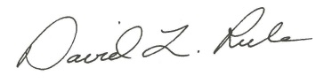

David L. Rule

Bellevue College

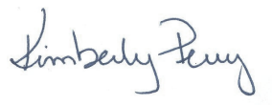

Kimberly Perry

Bellingham Technical College



Terrence Leas

Big Bend Community College



Eric W. Murray

Cascadia College

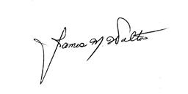

James M. Walton

Centralia College

M:\My Documents\WACTC\Electronic Signitures\Bob Knight.jpg

Robert K. Knight

Clark College

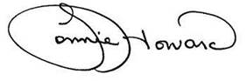

Lonnie L. Howard

Clover Park Technical College



Richard Cummins

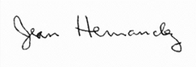Columbia Basin College

Jean Hernandez

Edmonds Community College

David N. Beyer

Everett Community College



Edward J. Brewster

Grays Harbor College



Eileen E. Ely

Green River College

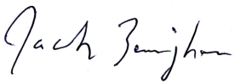

Jack Bermingham

Highline College



Amy Morrison Goings

Lake WA Institute of Technology



Christopher C. Bailey

Lower Columbia College

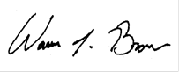

Warren Brown

North Seattle College

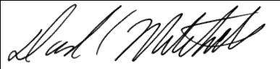

David C. Mitchell

Olympic College

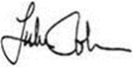

Luke Robins

Peninsula College



Michele L. Johnson

Pierce College

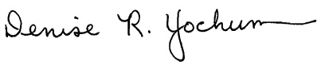

Denise R. Yochum

Pierce College Fort Steilacoom

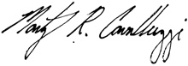

Marty R. Cavalluzzi

Pierce College Puyallup

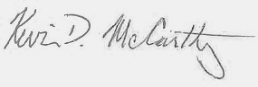

Kevin McCarthy

Renton Technical College

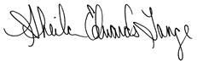

Sheila Edwards Lange

Seattle Central College



Jill A. Wakefield

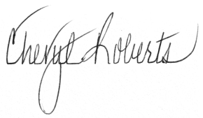Seattle Colleges

Cheryl Roberts

Shoreline Community College





Thomas A. Keegan

Skagit Valley College

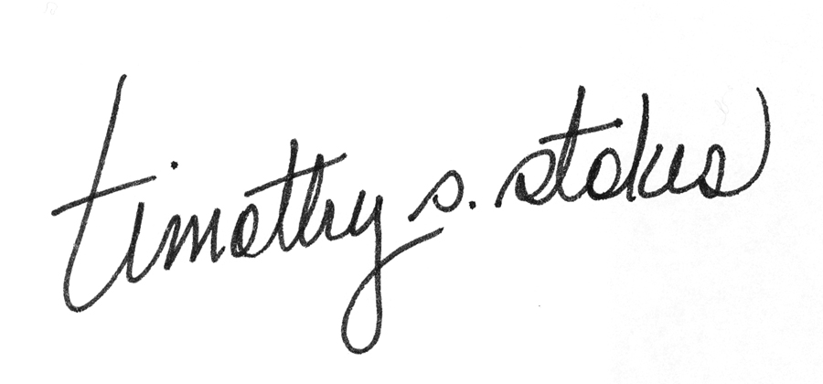

Timothy Stokes

South Puget Sound Community College

College

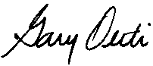

Gary Oertli

South Seattle College

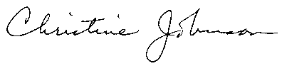

Christine Johnson

Community Colleges of Spokane

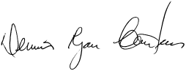

Ryan Carstens

Spokane Community College

Gullickson signature0001

Janet Gullickson

Spokane Falls Community College CollegeCollege

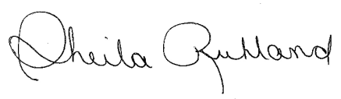

Sheila Ruhland

Tacoma Community College



Steven L. VanAusdle

Walla Walla Community College

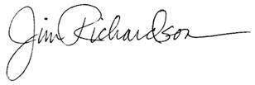

Jim Richardson

Wenatchee Valley College



Kathi Hiyane-Brown

Whatcom Community College

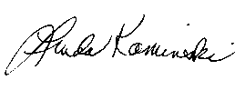

Linda Kaminski

Yakima Valley Community College