Community and technical college counselors
task force final report
November 30, 2020

Table of Contents
Table of Contents 2
Letter from the Co-Chairs 3
Acknowledgements 4
Introduction 5
Origin of HB1355 5
Background: Current Student Needs 6
Sub-Committee Reports 10
Minimum Standards 10
Best Practices 12
Staffing Ratios 19
Appendix 34
Task Force Members 34
Quotes from Student Presenters 34
SBCTC Counselor Survey Results (2020) 38
WCTCCA Counselor Survey (2018) 76
History of Counseling Services in the Washington State CTC System (1950s-2000s) 78
Additional Resources Considered by the Task Force 86

Letter from the Co-Chairs
Enclosed is the final report as required by 2019 House Bill 1355. We have appreciated this opportunity to collaborate with a workgroup of students, administrators, counselors, and lawmakers to create this report on the status and needs of counseling services at our Community and Technical Colleges. The report enclosed truly comes from a holistic viewpoint.

This task force granted us the opportunity to understand the resources students have available to address their counseling needs. What we found was great variance throughout our CTC system on counselor access and general mental health resources available to students. This report shares some of the differences in staffing ratios, training, and responses to increased demand for counseling services among the different institutions in the state. It is our intention that these findings will help guide future legislation action on this topic.

We would like to acknowledge all the hard work done by each member of this taskforce and the coordinating staff for this report. We are thankful for the dedication and passion to serve our CTCs now more than ever. Thank you for all your hard work.

Should any questions arise about this report please contact Joe Holiday, the director of Student Services with the State Board of Community and Technical Colleges, at jholliday@sbctc.edu or 360-704-4334.

Sincerely,

Marko Liias  State Senator – 21st District  Taskforce Co-Chair | Lillian Ortiz-Self  State Representative – 21st District  Taskforce Co-Chair

Acknowledgements
The Taskforce wishes to acknowledge the support of staff at the State Board for Community and Technical Colleges (SBCTC) for their assistance: Administrative Assistants Lexi Swanson and Nanette Angel, for outstanding administrative support; Policy Research Director Darby Kaikkonen for expert advice on the survey of college counseling services that informed the final report; Policy Associate Jamie Traugott for significant contributions reflected in the Best Practices section of the final report; and Associate Director Scott Copeland for planning and policy support.

We also thank legislative staff who supported legislative Taskforce member participation in numerous ways including Legislative Assistants Israel Rios and Curt Kohlwes. Thank you to the member’s assistants who assisted in scheduling and reporting on activities when members were unable to be in attendance; Sarah Myers, Hunter Cooper, Conor Agnew, Dareena Stepanyuk, Erin Lewis, Darlene Scrivner, Deanna Frey, and Rosie Leno.

Thank you to those who gave their time to share expertise and knowledge during Taskforce meetings. University of Washington Forefront Suicide Prevention members Marny Lombard, Ambyr Travis, Taylor Ryan, Jen Stuber, and Sarah Porter provided information regarding Suicide Prevention in the Community and Technical Colleges as well as an introduction to the legislative report for SB6514, Suicide Prevention Training, Behavioral Health Services and Awareness Raising Among Washington State Postsecondary Education Institutions. Thank you to the Washington State Community and Technical College students who shared regarding experiences of themselves and fellow students with their institutions’ counseling services; Katelyn Sheldon of Peninsula College, Zakariah Swanson of Pierce College who also assisted in the formation of the Final Report, Courtney Glenn of Grays Harbor, Elijah O’Brien of Pierce College, May Tran of Pierce College, and Eli Tovar of Lower Columbia College.

Introduction

Origin of HB1355
Engrossed Substitute House Bill (ESHB) 1355 was introduced in the 2019 legislative session and became law on July 28, 2019. When the bill was originally introduced, it established minimum standards for counselors employed within the community and technical college sector, and it required a counselor to student staffing ratio of 1:900. Currently, there is no statutory definition of "counselor" for the community and technical college (CTC) system.

While there are no statutorily prescribed minimum certification requirements for a person to be employed as a counselor at a CTC, community college district boards of trustees are required to establish that the candidate possesses scholarship and/or technical skill that represents appropriate study, training, and skills in the proposed area of assignment. Per statute, professional teaching personnel performing services shall hold the equivalent of a master's degree in the field of their educational service from an accredited college or university (SBCTC Policy Manual, Chapter 2.10 and Chapter 2: Appendix A, RCW 28B.50, RCW 28B.50.090, WAC 131-16-070, WAC 131-16-080 , WAC 131-16-091).

Counselors in the CTC system are considered "academic employees" and "faculty appointments" for purposes of tenure and collective bargaining. According to a 2017 survey of Community and Technical College faculty counselors, there are approximately 117 faculty counselors in the CTC system. In addition, some colleges have other professionals under titles such as “advisors,” “student navigators”, and “education planners” which also provide support for students in achieving their educational, career, and personal goals.

Throughout the legislative process though, ESHB 1355 was amended to create a taskforce to examine issues related to minimum standards, staffing ratios, and best practices for CTC counselors rather than mandate specifics. The Taskforce on Community and Technical Colleges Counselors (Taskforce) was also required to address how colleges will meet mental health needs of students and staff, and whether legislation is needed to address these issues. The State Board for Community and Technical Colleges (SBCTC) was assigned to staff the Taskforce, and the Taskforce membership was outlined in the bill as follows:
- two legislators from each of the largest caucuses of the Senate and two legislators from each of the largest caucuses of the House of Representatives;
- four counselors, at least two of which must be members of the exclusive bargaining representatives that represent counselors;
- one student;
- one member representing the SBCTC;
- two presidents from two CTCs, or the presidents' designees; and
- one vice president of student services and one vice president of instruction.

ESHB 1355 requires the Taskforce to make findings and recommendations to the Legislature by November 1, 2020. Those findings must include data on each CTC's student-to-counselor ratio. The Taskforce is set to expire December 1, 2020.

Background: Current Student Needs
Written by Dr. Earl Martin, Ed.D., LMHC, a Faculty Counselor at Everett Community College with edits from Dr. Rebekah Woods, J.D., Ph.D., President of Columbia Basin College.

1. Active Minds surveyed 2,051 high school and college students regarding the impact of COVID-19 on their mental health in September 2020.
Key Findings:
“Unsurprisingly, mental health has worsened over the course of the pandemic. Almost 75% of respondents reported their mental health has worsened, worsened somewhat, or worsened significantly since the beginning of the pandemic. High percentages of respondents have experienced stress or anxiety (87.03%), disappointment or sadness (78.06%), or felt lonely or isolated (77.47%) during the pandemic. For many respondents, stress (84.25%), anxiety (82.35%), sadness (73.23%), and depression (60.7%) have all increased since the beginning of the pandemic.
Respondents have used variety of coping strategies during the pandemic. Those most commonly used were virtual interaction with friends (68.31%), in-person interaction with friends (53.92%), being around pets (53.88%), and receiving support from their families by living at home (40.27%).
Two thirds of students (66.89%) reported an increase in supporting others with their mental wellness. Respondents reported having received information from their institution regarding mental health (66.41%), academic policies (82.5%), and healthy coping strategies (49.15%). Three quarters of respondents (77.72%) feel optimistic or hopeful about their school related goals and future job prospects. Majority of respondents indicated they know where to seek professional mental health services if they need immediate help (71.09%) and they know where to advise a friend to go if they need professional mental health services (69.77%).”
Excerpted from Active Minds (2020).

2. American Council on Education (ACE) conducted a survey of over 400 presidents (2019).
Key Findings:
“Eight out of 10 presidents indicated that student mental health has become more of a priority on their campus than it was three years ago.
As concern about student mental health has grown over the last three years, roughly seven out of 10 presidents (72 percent) reported they had reallocated or identified additional funding to address the issue. Presidents at four-year institutions were more likely to have identified or reallocated funding than presidents at public two-year colleges. One president reported raising $15 million to build a “comprehensive student well-being building.”
Across all institution types, over eight out of 10 presidents (85 percent) identified the vice president of student affairs as their primary point person to respond to student mental health.” However, they indicated it was a campus-wide effort to develop a comprehensive plan to address student mental health needs including student services, counseling, security, external resources, safety, and legal.
“We asked presidents if they had unlimited resources to dedicate to student mental health on their campus, what would be the first action they would take? Over half (58 percent) of presidents said they would hire additional staff—mostly in the counseling center.
Over one in five presidents would invest in more enhanced resources or programs. “We are currently working to improve our early alert system for at-risk students to improve retention and persistence,” one president wrote. “As a result of this initiative, students requiring mental health services may be identified and we need to have proper training services in place for their well-being.”
A little over one in 10 presidents mentioned professional development for faculty and staff. “I would broaden the range of people who could help students by [providing] proper training rather than staffing up the counseling center,” one president responded. For example, some institutions are providing Mental Health First Aid training for their entire campus: faculty, staff, and students.”
Students themselves are spending more time focused on their own mental health by starting organizations like Active Minds, a campus-based mental health advocacy organization. These organizations have been empirically shown to effectively shift the campus climate to be more supportive of mental health.
Students also are creatively expanding traditional resources and starting peer support programs. Sixty-five percent of presidents reported seeing their students as very or moderately engaged around the topic of mental health.”
Presidents at four-year institutions were slightly more likely to report feeling knowledgeable about student mental health issues than presidents at public two-year institutions.
Presidents at public two-year institutions were more likely to report not having the tools they needed than presidents at other institutions, while presidents at public four-year institutions were more likely to report they had the necessary tools.
When asked what additional resources would be of value, over one-quarter of presidents said professional development and training for themselves or training directed at specific campus groups like faculty, staff, students, executive leaders, and board members. “We need training to be able to identify someone who may be experiencing a mental health episode or breakdown and strategies to assist that individual,” one president wrote.
Over one-quarter of presidents also reported that concrete tools like assessments or developmental tools to help students build skills around coping and self-care would be valuable for their campus. “We need student assessment tools that signal help is needed,” one president responded. Another wrote, “We need tools to help students develop resiliency and coping strategies.”
As student mental health concerns continue to rise, and as higher education continues to wrestle with the complexity and severity of these issues, campuses remain in a position to support students who may be struggling. This is not a new role for institutions, but as these issues evolve, it becomes more important that assistance for students is available outside of counseling centers. Some institutions are training faculty and staff to identify students who need help and give them the tools to make referrals to appropriate services. The well-being of students—both inside and outside the classroom—should be the concern of all on campus. As one president wrote, “We can’t just solve this by hiring more counselors.”
Excerpted from Chessman and Taylor (2019).

3. Study: Nearly a third of Washington college students have experienced depression (2018).
It’s the first-time students at Washington colleges have participated in a specific, widely used national survey on mental health, and it shows they suffer from depression and emotional distress at roughly the same rate as students nationwide. The national survey, called the Healthy Minds Study, involved 10,000 students at 13 two- and four-year universities — including the UW, WSU, several community colleges and some private schools.
Key Findings:
Nearly 80% of college students who answered the survey reported that emotional distress impacts their academic performance, and about a third said they have suffered from depression and more than one in 10 have thought of suicide (Long, 2018).
“I feel like there’s a struggle between feeling like, I’m so overwhelmed, all my teachers are pushing so much work at me and also laying down thinking you’ve done nothing…” Elijah O’Brian, Pierce College Student

4. Student Affairs Leaders on Mental Health, Race Relations, Free Speech and More (2020).
From the first-ever Inside Higher Ed survey of student affairs leaders, conducted by Gallup. The survey was conducted from Jan. 16 to Feb. 12, 2020.
Student affairs officers have full agendas on college campuses, as they're often the point person for issues around such inflammatory issues as sexual violence, race relations and free speech. But those issues don't appear anywhere near the top when student affairs leaders are asked which issues dominate their time. The topics that do: student mental health, cited by 94 percent, and student well-being, by 91 percent. All other issues lagged well behind.
- 78 percent of student affairs leaders said the number of campus visits to mental health professionals had "increased a lot" in the last five years, and 63 percent said the same for the number of students on prescription medicine for mental health issues.
- Fifty-eight percent said that they believe their college's president is familiar enough with student affairs issues that when she or he makes a decision on student affairs, it's the right one.
- Half of student affairs leaders say they think about student mental health "a great deal." The percentages were highest at public doctoral institutions (68 percent) and private baccalaureate colleges (66 percent), and lowest at community colleges (36 percent).
- The survey found colleges to be split on the use of outside providers for mental health. Forty-seven percent said they do -- with a higher percentage at public (51 percent) than at private institutions (39 percent).
- But those that do use them are at least somewhat satisfied. Thirty percent of respondents said they were very satisfied, and 61 percent were somewhat satisfied.
Excerpted from Jaschik (2020).

References
Active Minds. (2020 September). Student mental health survey. https://www.activeminds.org/wp-content/uploads/2020/10/Student-Mental-Health-Data-Sheet-Fall-2020-1.pdf
Chessman, H., & Taylor, M. (2019, August 12). College student mental health and well-being: a survey of presidents. American Council on Education. https://www.higheredtoday.org/2019/08/12/college-student-mental-health-well-survey-college-presidents/
Jaschik, S. (2020, March 26). Student affairs leaders on mental health, race relations, free speech, and more. Inside Higher Ed. https://www.insidehighered.com/news/survey/student-affairs-leaders-mental-health-race-relations-free-speech-and-more
Long, K. (2018, January 30). Study: nearly a third of Washington college students have experienced depression. The Seattle Times. https://www.seattletimes.com/seattle-news/education/study-nearly-a-third-of-washington-college-students-have-experienced-depression/

Sub-Committee Reports
The work of the Taskforce was divided into three sub-committees that members participated in. This work was assigned according to sections 4 a, b, and c in HB1355. These three sections identify issues the Taskforce shall examine; Minimum Standards, Best Practices, and Staffing Ratios. Below are reports of the findings of each sub-committee as submitted to the Taskforce.

Minimum Standards
The subcommittee was tasked with making recommendations for minimum standards required for counselors, including requirements regarding the level of education, internship experience, practical experience, and content of coursework required.
The subcommittee consisted of a Vice President of Student Services and two faculty counselors. All members of the subcommittee had graduate degrees from regionally accredited colleges or universities in counseling related fields and had experience providing counseling services to college students. Subcommittee members based their recommendations on current standards from the 2016 Council for Accreditation of Counseling and Related Educational Programs (CACREP) and the Council for the Advancement of Standards in Higher Education, Counseling Services (2019). Recommendations were provided for level of education, content of graduate level courses, practicum and internship experience. Given that CACREP graduate programs consider both practicum and internship requirements as supervised practical training, recommendations for internship and practical experience were combined into one category.
The intent of these recommendations was to provide clear minimum standards to ensure qualified counselors but with enough flexibility to allow for differences within graduate program curricula and for hiring institutions to determine additional qualifications when hiring a faculty counselor. For example, while most graduate programs in counseling or school psychology require coursework in career counseling, most graduate programs in social work do not. The subcommittee agreed that career counseling was a core component of serving community and technical college students, however, to require a graduate course in career counseling could unintentionally preclude social workers from meeting minimum standards to work in the Washington State Community and Technical College System. Similarly, while the subcommittee strongly believed that faculty counselors should engage in ongoing continuing education, it was their opinion that such requirements went beyond the minimum standards set forth by this bill. Individual Community and Technical Colleges would not be prohibited from requiring continuing education or even professional licensure of their counselors.
The Subcommittee members also recommended that current Washington State Community and Technical College (CTC) faculty counselors should be exempted from the new rules, and counselors who are exempted should be allowed to carry that exemption if they move to another CTC in the state.

Recommendations
Based on the subcommittee's research and conversations, the Minimum Standards subcommittee recommended the following:

Level of education
The minimum level of education for a Washington State Community and Technical College faculty counselor should include a graduate or professional degree from a regionally accredited institution in:
- Counseling Psychology
- School Counseling
- Clinical Social Work, or
- Related Field

- AND -

Content of Coursework
Washington State Community and Technical College faculty counselors should have completed appropriate graduate coursework with content covering the following areas:
- Assessment and testing
- Career counseling (or commensurate training within first year of hire*)
- Crisis intervention and management
- Legal and ethical issues in counseling
- Lifespan development
- Multicultural counseling
- Theories of counseling
- Treatment planning

*Commensurate experience should include a graduate course in career counseling or additional training that includes an understanding of career development theory and the appropriate application for diverse populations, proficiency in administering and interpreting various career assessments, and an understanding of how systemic oppression impacts career access and decision making.

- AND –

Practicum/internship requirements
Washington State Community and Technical College faculty counselors should have completed a supervised practicum and internship at the graduate level.

*Current Washington State Community and Technical College (CTC) faculty counselors shall be exempted from the new rules, and counselors who are exempted should be allowed to carry that exemption if they move to another CTC in the state.

“Hiring counselors from a more diverse background because we are often seeing a more diverse population of students come into our campus, and I feel like seeing a counselor from one specific demographic may be hard for a lot of students to relate to. So I feel like if we can increase the diversity in our counseling staff then we can make counseling services more inclusive to all different types of demographics of students.” – Elijah Tovar, Lower Columbia College Student

References
CACREP. (2016). Welcome to CACREP. Council for Accreditation of Counseling and Related Educational Programs. https://www.cacrep.org/
CAS. (2019). Standards. Council for Advancement Standards. https://www.cas.edu/standards
Community and Technical College Counselors—Task Force. ESHB 1355.SL Chapter 113 (2019). http://lawfilesext.leg.wa.gov/biennium/2019-20/Pdf/Bills/Session%20Laws/House/1355-S.SL.pdf
NCDA. (2020). Guidelines. National Career Development Association. https://www.ncda.org/aws/NCDA/pt/sp/guidelines

Members
Dr. Sue Orchard, Psy.D., Vice President of Student Services, Lower Columbia College
Dr. Earl Martin, Ed.D., LMHC, Faculty Counselor, Everett Community College
Nicole Hoyes Wilson, M.S.W., M.A., LMHC, Faculty Counselor, Highline College

Best Practices
The Best Practices Sub-Committee was tasked with examining best practices for counseling services in the community and technical college system and how the colleges meet the mental health needs of students. We organized our work into three areas: a review of the literature on this topic; lessons learned from the California community college system experience; and collection of emerging, promising, and excellent practices through a survey of Washington state community and technical colleges conducted in September, 2020.

Recommendations
Meeting the mental health needs of students should be an all-campus effort, with clearly delineated roles for counselors, administrators and other professionals performing related and supportive functions, and the full campus community in early warning and referral efforts.

Individual counseling approaches grounded in theory and evidence of effectiveness (meeting students’ needs) should be at the core of counseling services at community and technical colleges.

Even though there may be challenges in community and technical college environments, student engagement beyond the counseling relationship may be under-utilized: for example, the literature review indicates that student peer groups focused on supporting mental health, as well as students’ role in promoting awareness of counseling and increasing help-seeking behavior are effective tools in meeting the mental health needs of students. For example, the HOPE Squad at Grays Harbor College is a student club devoted to this purpose.

Colleges should strive to increase the visibility of their counseling services through proactive engagement with the campus community. Workshops, classroom presentations, and active relationships with academic and student services departments can increase referrals and help-seeking behaviors.

For colleges that have limited staff and resources in counseling services it is important to build dependable partnerships and referral systems with off campus community service providers, although those communities may have the same limitations. These partnerships, when available, may help to better ensure students are receiving mental health services when their treatment needs exceed what the college can provide. Partners should be culturally competent and reflect student demographics whenever possible.

- For colleges in under resourced communities, adopt tele-behavioral health approaches that have become a critical adaptation during the COVID-19 pandemic, using a digital platform that provides secure, encrypted, audio-video conference to communicate with students in real time.
In collaboration with Institutional Research, make it a priority to develop a counseling assessment model to ensure that counseling services are meeting the needs of the students they serve.

Ensure that all counselors receive regular equity, diversity, and inclusion training that includes an understanding of cultural considerations for Black, Indigenous, students of color and other vulnerable student groups. Additionally, adopt equity centered recruiting, hiring and retention practices to increase the number of counseling staff that are as diverse as the student body they serve. Considering the current political and social justice climate that is impacting our students’ mental health in visible ways, it has never been more important to achieve this objective.

Literature Review
The purpose of this literature summary is to highlight current research on effective practices in mental health counseling in the community college setting as well as key considerations when supporting mental health professionals and students. The key themes found were the importance of creating transparency and structure in mental health services, an understanding that counselors are in need of additional support, and the effectiveness of leveraging student voices and engagement to promote an inclusive mental health culture on campus (ACCA, 2013; NASPA, 2020; Nutt, 2018).

In 2013 the American College Counseling Association shared the most recent data from the community college taskforce survey which captured data from nearly 200 two-year institutions throughout the United States. Researchers found that the majority of counselors felt overwhelmed with their job duties and don’t have the necessary resources to wear multiple hats. Counselors reported that they had limited time to provide personal and mental health counseling services.

Researchers found that by establishing a transparent and inclusive counseling structure, within the community college setting, it can lead to an increased student awareness and access to counseling services (Jed Foundation, 2016; NASPA, 2020). The guiding principles to create an effective counseling department include:
- Clearly defining the scope of practice by providing clear and transparent communication on what types of counseling services are available to students.
- Providing no wrong door to access of care. Making sure all departments are being properly trained to refer and identify students to counseling services no matter where the student goes on campus.
- Leveraging student voices by integrating student voice into departmental planning. Promoting student led mental health clubs and activities to help normalize mental health at the college (NASPA, 2020).
Lastly, several researchers have found that involving students in the promotion and engagement of mental health on the college campus increases student awareness and help seeking behavior (Active Minds, 2015; Nutt, 2018). Researchers found that student peer organizations can also play an important role in shifting the campus culture towards mental health (Nutt, 2018). “Starting a conversation about mental health on a student-to-student level could change our approach to mental health, change the landscape and climate,” (Nutt, 2018 para. 8).

Lessons from California
While researching other states’ best practices around meeting community college students’ needs, we found California’s lessons learned to be helpful in our work.

In 1994, the California community college system was struggling to find ways to meet students’ needs in what they considered more effective and financially responsible ways. The state decided to institute paraprofessionals and faculty advisors to do the tasks that were formerly done by faculty counselors and to significantly decrease the number of faculty counselors employed. They tried various versions of this with little success until 2012 when California returned to the utilization of faculty counselors since students’ need for career, academic, and personal counseling extended beyond the scope of paraprofessional and faculty advisors. The community college system retained the paraprofessionals and faculty advisors but instituted clear guidelines among the three groups. They found that faculty counselors had more extensive training to handle crisis intervention, career exploration, and advising compared with paraprofessionals with associate’s or bachelor’s degrees, graduate students, or teaching faculty who also advise. Utilization of faculty counselors provided the most effective avenue for training and support for paraprofessional and faculty.

This section informed by the knowledge of Dr. Robert Hill who presented at a Best Practices sub-committee meeting.

Best Practices at Washington state Community and Technical Colleges Survey Results
The survey of community and technical colleges included a section asking colleges to identify practices and self-rate them based on criteria in the Rubric for Excellent Practice. A total of 31 colleges responded in this section of the survey, listing 120 practices. The remainder of this section is based on those responses and subsequent analysis of the data.

Responses were categorized into nine categorical themes that emerged in the data. A tenth category, “Other”, was created for practices that didn’t fall neatly into the nine themes. The following table depicts the 120 responses by theme and by college self-ratings of whether the practices were Emerging, Promising, or Excellent.

Emerging, Promising, and Excellent Practices by Categorical Themes
Theme | Emerging | Promising | Excellent | Total
Individual Counseling | 2 | 6 | 8 | 16
Specific Counseling Approaches | 7 | 8 | 12 | 27
Walk-in Hours/Flexible Scheduling | 3 | 2 | 1 | 6
General Outreach/Promotion of Services | 3 | 5 | 0 | 8
Specific, Targeted Outreach to Students | 0 | 3 | 2 | 5
Relationships with Campus/Community Partners | 2 | 5 | 6 | 13
CARE/BIT Team Involvement | 0 | 2 | 1 | 3
Program Assessment & Improvement | 4 | 3 | 2 | 9
Workshops, Classes, & Classroom Presentations | 7 | 9 | 4 | 20
Other | 2 | 7 | 4 | 13
TOTAL | 30 | 50 | 40 | 120

As the table above shows, the practices that were listed the most often were specific counseling approaches, workshops/classes/classroom presentations, and individual counseling. Interestingly, respondents also had the highest confidence in these three practices, with the highest number of responses rated either Excellent or Promising. A fourth practice, relationships with campus and community partners, also reflected a relatively high degree of confidence. Perhaps the most surprising finding was the generally high confidence colleges placed in their counseling practices overall: a full one-third of responses were self-rated as Excellent, and three-fourths of responses were rated as either Excellent or Promising. The following paragraphs provide more detailed information about the practices.

Individual Counseling and Specific Counseling Approaches
Especially when viewed together, it is clear that individual counseling sessions and specific counseling approaches are the practices colleges most rely on and feel most confident in to respond to the mental health needs of students. Some examples of specific counseling approaches are use of licensed mental health counselors, focus on crisis intervention, brief solutions-focused intervention, and a variety of proven, evidence-based therapeutic interventions such as cognitive behaviors therapy, dialectical behavioral therapy, and motivational interviewing. Some group counseling practices were placed in this category as well, for example group therapy and psycho-educational wellness groups.
“Having counselors dedicated to mental health is practice that affirms to students that their mental health is important and prioritized.”
“Students are assigned a faculty counselor for the duration of their program who provides academic support and guidance for students in 1:1 appointments.”

Workshops, Classes and Classroom Presentations
Most colleges reported promising to emerging practices in the area of Workshops, Classes, and Classroom Presentations. Specific examples include training of faculty and staff in recognizing and referring students in crisis, as well as, suicide prevention training. Responses also highlighted workshops to combat anxiety, stress, and depression among the student population. Many responses emphasize the important role workshops play in prevention, specifically in the areas of promoting healthy relationships, overall wellbeing, exam preparation, and mindfulness. Other workshops that should also be highlighted are promoting help seeking behavior in students, mental health screening, and substance abuse support.
“We provide a counseling services overview in classes to reduce stigma and connect students to counseling.”
“We offer monthly well-being sessions to respond to mental health needs of students.”
“If the student isn’t willing to acknowledge that, hey, mental health is something important, mental illness isn’t a weakness, it is an illness and it’s not something I should be afraid of; it’s not something I should be ashamed of ... all of the attempts that we’re trying to make in terms of progress will be pretty much in vain.” – May Tran, Pierce College Student

Campus and Community Partnerships
Colleges indicated a high level of confidence in the areas of campus and community partnerships. Responses ranged from collaboration at the campus level to strong connections in the community. Responses included mental health referrals, as well as, training from community agencies. Colleges also indicated strong ties between mental health counselors and various departments on campus. Counselors also rely on each other for continuous consultation regarding student appointments and support.
“We provide resource referrals for ongoing counseling needs or to meet student equity needs.”
“Crisis intervention and referral: a rubric and educational campaign is underway to assist staff and faculty across the college in recognizing different levels of student crisis, and when/how to refer to the counseling team.”
“Just spreading awareness about the services we have and how to contact them in an anonymous way, I think that’ll help a lot with people to encourage people of all backgrounds to use these services.” – Elijah O’Brian, Pierce College Student

Other Responses of Note
Some practices identified by colleges do not fit neatly into the nine themes that emerged in the data. This section briefly highlights a few of them.
- Demographics: one college reported that its counseling staff closely matches the demographics of the student population
- Sustainability: one college reported that it maintains a staff of 5 district-funded, tenured faculty counselors
- Pandemic Response: a few colleges identified promising practices in response to the COVID-19 pandemic; for example, one college highlighted COVID-19 group conversations focused on student mental health
- Academic Department Liaisons: one college assigns counselors as liaisons to specific academic programs to serve students
- Passport Program: one college highlighted its effective Passport to College program for students who were in foster care or have experienced homelessness

Lessons Learned
Be willing and ready to learn approaches that meet the client’s needs rather than trying to make the clinician’s approach one size fits all.
Don’t wait for students to come to you- meet students where they are with a robust outreach model.
Reach out to others who have implemented these practices. Assess and evaluate them once they are implemented. Adjust as needed, being open to eliminating the practice or meeting the student need in a completely different format.
Mental health counseling professionals who have worked with a diverse clientele and have a practical, hands-on, working knowledge of the issues our students face are a definite advantage in effectively serving students.
The college needs to believe that serving mental health needs of students is essential to access, retention, and equity.
Systematic advising support and interventions require a whole campus approach, beginning with strong executive leadership and clarity of vision and intended outcomes….collaborations between and across Instruction and Student Services help strengthen our commitments to Guided Pathways implementation.

References
Active Minds (2018). Active minds + California. https://www.activeminds.org/programs
American College Counseling Association (2013). The American college counseling association's (ACCA) community college task force (CCTF) 3rd national survey results. https://www.insidehighered.com/sites/default/server_files/files/ACCA%20CCTF%202012-2013%20Survey%20FINAL.PDF
Davidson, L. & Locke, J. (2011). A guide to campus mental health action planning. The Jed foundation.
http://www.jedfoundation.org/wp-content/uploads/2016/07/campus-mental-health-action-planning-jed-guide.pdf
NASPA Policy and Practice Series (2020). Strategies for addressing mental health supports on campus.
https://www.naspa.org/images/uploads/main/NASPA_Policy_and_Practice_Issue_4_Mental_Health_DOWNLOAD.pdf
Nutt, A. (2018, June 28). College students are forming mental-health clubs — and they’re making a difference. The Washington Post. https://www.washingtonpost.com/news/to-your-health/wp/2018/06/28/college-students-are-forming-mental-health-clubs-and-theyre-making-a-difference/
Research and Planning Commission. (2020). Rubric for excellent practice. Washington Community and Technical Colleges.

Members
Senator Emily Randall, 26th District, Bremerton
Dr. Rebekah Woods, J.D., Ph.D., President, Columbia Basin College
Dr. Matthew Campbell Ed.D., Vice President for Learning & Student Success, Pierce College Puyallup
Cathy Shaffer, M.A., LMHC, Faculty Counselor, Spokane Community College
Dr. Joseph P. Holliday, Ed.D., Director of Student Services, SBCTC
Shelly Hoffman, Student, Grays Harbor College

Staffing Ratios

Introduction
In undertaking the work of the Taskforce specifically focused on ratios, the Ratio Subcommittee was asked to “examine…staffing ratios of counselors and students, including considering issues raised by a staffing ratio of no more than nine hundred students to one full-time equivalent [FTE] counselor” (HB 1355, 2019). In addition, pursuant to the guidance to the Taskforce, the Subcommittee report also includes data related to “each community college’s student-to-counselor ratio” (HB 1355, 2019).

Notwithstanding this introduction, this report is divided into four primary sections.
- The first includes the findings in an expanded executive overview and summary, which includes committee details, a summary of findings, specific details on the ratio of 900:1 (per legislation), and cost implications (Pages 1-3);
- The third provides a brief literature review that informed how we would approach the tasks of the subcommittee (Pages 5-6); and
- The third presents the data and analyses that yielded the summary presented in the first section (Pages 7-13).

Executive Summary

Subcommittee Membership and Focus
The Subcommittee consisted of two Washington State Representatives, one community college faculty counselor, one community college vice president of learning and student success (instruction and student services), and one community college president. In addition, the committee was often supported by staff of the State Board of Community and Technical Colleges and other faculty counselors who were members of the Taskforce. Following the stated intent of examining ratios with regard to the community and technical colleges’ (CTCs) staffing to meet the mental health needs of students, the Subcommittee focused its work on examining ratios specific to mental health, though a broader analysis of comprehensive counseling is included throughout this evaluation.

The work of the Subcommittee involved two primary tasks:
- Review of existing literature related to counselor ratios;
- Collection and analysis of data related to counselor-to-student ratios;

Summary of Considering a Ratio of 900:1
As demonstrated in the data and analyses below, considering a ratio of 900:1 is a complicated task with many variables. Of the 34 community and technical colleges:
- Only seven colleges (21%) achieve a ratio that is at or below 900:1 across all of the categories, excluding the service ratio (a ratio of students served to the percent of counselor FTE focused on mental health service. We saw this ratio used in some of the literature we reviewed and collected service data in the survey specific to the work of this Taskforce. Additional data and analysis of this ratio are included below). Categories considered:
  - Percent of counseling FTE focused on mental health;
  - Total counseling FTE;
  - Student headcount;
  - Student FTE; and
  - Multiple counseling models.
  - Supports/structures/staffing roles that support the work are not accounted for.
- When considering Student Headcount to Total Counselor FTE, five colleges (15%) are within 100 points of 900:1, with a system average of 2000:1. When considering the ratio specific to Mental Health Counselor FTE, the system average is 4031:1 and no colleges are within 100 points of 900:1.
- While the service ratio appears to suggest a small ratio across the CTCs, our analysis suggests that in several cases this is likely a reflection of mental health services being at or beyond capacity. That is, they could not reflect a higher ratio because capacity had been reached or exceeded. Given the length of most academic terms, it is likely that service ratios above 250:1 are pushing a threshold of capacity for consistent and effective service.
  - A 250:1 service ratio would equate to roughly five student appointments per day for each day of the term.
  - Thus, a ratio of 250:1 would provide limited opportunity for each student to have more than one appointment, which is common for students seeking mental health services. Further, such a ratio would likely prompt longer wait times for an appointment, particularly during high stress/anxiety times.
  - Of 21 institutions reporting a mental health service ratio, six are at or above 250:1 (not including outliers), with more than half (11) below 135:1.
- Depending on the variables used in the ratio analysis, mean ratios across the CTC system for mental health services range from 191:1 to 4031:1. Thus, it is extremely important to examine the variables used in each analysis (e.g., model, FTE vs headcount, mental health focus, etc.)(refer to the example on Page 13 for practical application at one college).
- Additional takeaways/considerations can be found on Pages 12-13 of this report.

In summation, the Taskforce agrees that as a system we are under-resourced to provide for the mental health needs of students within the CTC system. However, while the data clearly show that few colleges are near a 900:1 ratio, because the design of counseling service models varies, and because the needs of students vary, and because our inquiry focused on a ratio of 900:1, these analyses do not reveal who is/is not being served and do not provide sufficient insights to make a recommendation with regard to a specific ratio. Location of college (i.e. rural, urban, suburban), particularly with regard to access to community mental health resources and the capacity of those resources, as well as model and focus on mental health are additional considerations. More research and regular data collection are needed to identify outcomes and further guide recommendations and accountability.

Overview of Cost Implications
One of the largest elements of this examination is to consider what would be required to achieve a ratio of 900:1. An estimate for 1250:1 is also included for comparison.

We use the ratio of Student Headcount to Mental Health Counselor FTE, then all 34 colleges would require additional funding for between 1.5-13.5 counseling FTE per college. The total salary cost for this would be estimated around $14.7 million (plus the cost of benefits and other resources). This amount was calculated based on using the known average salary by college; then using those known salaries and contracted days to determine an average salary which was used for each of the colleges for which we did not have a specific salary, then these salaries were multiplied by the staffing gap and summed. The staffing gap was determined by (Student Headcount / 900) – (Student Headcount / Counselor MH FTE). Statistical outliers and colleges with missing data were calculated at the direct cost of Student Headcount / 900 without consideration of a gap.

The committee agreed that student headcount is an important variable to use in analyzing our goals within the CTC sector of higher education. The primary reason for this is that services are provided to each student, whether full-time or part-time, and that service is not adjusted by enrollment type; a one-hour appointment is a one-hour appointment, regardless of whether the student is full- or part-time. It should be noted that these estimates are rounded up to the nearest 0.5 FTE. Funding to hire small fractions of FTEs could dramatically impact service model/design.

A second comparison cost estimate that focuses on mental health by using Mental Health Counselor FTE but uses Student FTE instead of headcount is also included. While provided here for context and used through much of the literature, this ratio probably does not accurately reflect the needs of students in the CTC system, many of whom are part-time. Using the same methodology as above, this reveals a salary need of roughly $9.1 million (plus benefits/resource costs). This would support hiring about 112 mental health counselors across the system.

Ratio | 900:1 (rounded to 0.5 FTE) | 1250:1 (rounded to 0.5 FTE)
Headcount to MH FTE | $14.7 million | $9.9 million
FTE to MH FTE | $9.1 million | $5.6 million
Salary only; all amounts exclusive of benefits and other costs.

In addition to salary costs, the dollar amounts above do not include costs for benefits, additional space required for providing confidential counseling services and the secure storage of protected files/documentation, ongoing professional learning needs, recruitment costs, and other elements requiring resources to fully implement.

Conclusions
It is important to note again the degree to which interpretation and philosophy have impacted the data reported by colleges (found below and summarized above). For example, some colleges indicated that they do not believe that advising is a counseling-related service, and thus only reported data related to the delivery of mental health services. Others believe in a more comprehensive model and reported data on a much broader spectrum of student services. Thus, interpretation and analyses of the data herein are particularly difficult with regard to clear conclusions that can be drawn.

Regardless of these considerations, the data, including student voices, reveal a system that requires significant investment in order to fully meet the mental health and related counseling needs of students in the CTC system. Such investment would increase capacity, reduce student wait times, increase promotion of counseling services on campuses, and improve the overall quality of counseling to improve student outcomes of students across Washington.

The one time that I did try [reaching out to a campus counselor] the appointment I tried to schedule was so far out that I didn’t even really think it was worth it. I’m not sure if that is something to do with our student to counselor ratio and how busy that counselor has been but I opted to use outside resources because it was so far out and I felt that I needed more urgent help.” -Elijah Tovar, Lower Columbia College Student

We have attempted to interpret the data to the best of our ability given the available resources and time constraints. Should the Legislature wish to explore this further, the ratio subcommittee and Taskforce undertaking this work recommend a more comprehensive exploration to clarify some of the new questions raised through this examination. Further, in order to best determine whether institutions are meeting the mental health needs of students, we recommend that we identify measurable mental health outcomes and collect and report these data annually in order to better understand the degree to which institutions are meeting the mental health needs of CTC students across Washington state. An improved data collection tool and repository would need to be developed, agreed upon, and implemented for longitudinal tracking of these data. We recommend that a subgroup that is representative of the current Taskforce be tasked with developing the tool, protocol, and procedures for the collection and analyses of the data.

Review of Existing Literature
While there are several published reports discussing counselor ratio in various educational sectors, few focus on counselor ratios in the CTC sector. That is, the literature is primarily focused either on a university-centric sector of higher education, or on ratios within the Preschool through 12th Grade (P12) sector. In addition, the higher education-focused reports primarily examined counseling in the context of mental health service delivery and not comprehensive models wherein counselors may have other student service duties not directly related to mental health services.

Two documents that specifically examined ratios in higher education included one from the International Accreditation of Counseling Services (IACS) and another was from the Association for University and College Counseling Center Directors (AUCCCD).

The IACS promotes itself as, “the only international organization that focuses solely on accrediting professional counseling centers on higher academic campuses” (IACS, 2019). While most CTCs across the country are not accredited through IACS, their development and promotion of standards represents a bar within higher education that can serve as guidance for institutions in shaping and providing professional counseling services. The IACS website maintains a page dedicated to counselor-to-student ratios. In their statement, they indicate a recommendation that the range of counselor-to-student ratio should be one to 1,000-1,500 (it is unclear if they are referencing the survey conducted and published by AUCCCD as no citation is included in the statement). They also note that the “average ratio of mental health professionals to students as reported in the National Survey of Counseling Center Directors (2013) is 1 to 1,600” (Reetz et. Al., 2015, 34).

The 2015 report from AUCCCD shows mean ratios across institutions ranging from 800-3500 (Reetz et. Al., 2015, 34). An interesting note is that the trendline for counselor-to-student ratio increases as the size of the institution increases. This could point both to the cost of resources, monitoring of service need, or other variables. A second important note, as stated above, is that these data are largely representative of universities/four-year institutions; CTCs represented only 4% of respondents. Since forming this Taskforce, AUCCCD published their newest report including data from their 2018-2019 survey (LeViness et. Al., 2019). Interestingly, the 2019 Report separates out CTCs because they were outliers in the dataset. In the “Unique Number of Students Served by Center,” CTCs were an outlier because they served a lower number of students. However, there is no indication of whether this was due to lower demand, due to limited capacity, or another contributing factor. A related variable included in the 2019 report included the “percent of campus served by counseling services.” While this is not defined in the report, we interpreted this to be a service ratio equating to the number of students served to the total institutional FTE. Universities/four-year institutions reported an overall mean of 13.4% while the CTCs reported a mean of 3.8%. These means could be useful in determining an appropriate/ideal staffing level. The 2019 Report did not include ratios for CTCs.

In addition to these two data sources, we also consulted a report produced by the Washington Community and Technical College Counselor’s Association (WCTCCA) which is the first known system-wide report on counselor staffing ratios (WCTCCA, 2017). (The WCTCCA is an independent association of the WA CTC counselors. It is not a part of the WACTC organizational governance structure, though it does provide resources, support, and other professional guidance for counselors and others within the CTC system.) This study followed the established California State Community College System methodology for defining a counselor-to-student ratio that measures full-time equivalent (FTE) counselors to student headcount. In this method, student headcount is measured by fall quarter enrollment (the quarter with the highest numbers of enrolled students). This study examined Fall 2017 data for both student headcount and counselor FTE. This data is limited to state-funded counselors to accurately measure the state’s funding support of these important student services. We note that counseling is defined differently in California and some of the robust support structures found in the Washington system and across the country are not full considered in the California methodology or in this report.

The 2018 WCTCCA report inspired many counselors to campaign for legislated minimum systemic “standard of care” seeking the establishment of minimum system standards for counselor hiring qualifications and staffing levels through the Washington State legislature as reflected in House Bill 1355 (2019 Legislature). The report demonstrated tremendous Counselor staffing level variation between colleges
Key Findings reported by the association included:
- The state system average was 1843 students to one FTE counselor;
- Three colleges had zero counselors;
- Three colleges had one counselor;
- The colleges ranged from between 750 to 5610 students for every one FTE counselor;
- Nine colleges had staffing ratios above 3000 students for every one FTE counselor.

Other literature included the 2004 dissertation by counselor and Taskforce member Earl Martin (2004) and The Role of Counseling Faculty and Delivery of Services in California (2012). While conveying a similar recommendation of 1:900, the documents highlight the 2003 survey of the California Community College system that reported a ratio of 1:1918 (The Academic Senate for California Community Colleges, 2012, 3).

Finally, given the close relationship of the CTCs to local school districts (most were funded through school districts until 1963), and given the large number of dual enrollment students attending CTCs, it is also worth noting literature pertaining to student-to-counselor ratios in the P12 system. While many university models are distinct in that they provide services through a dedicated clinic model, the P12 model also differs in the scope and nature of counseling, as well as some compulsory requirements that connect counselors with most students attending the school. And while the American School Counselor Association (ASCA) recommends a ratio of 1:250, its report on trends from 2004-5 to 2014-5 showed a national mean of 1:482, with Washington having a mean ratio over 500 (NACAC & American School Counselor Association, 2015).

While the literature provides interesting insights into ratios and recommendations, information and guidance for community and technical colleges is a major shortcoming, especially given their unique, dynamic, and broadly diverse student population, their commitment to advancing racial equity both in education and in industry, and the contributions of the CTC sector to higher education and the workforce both directly and through transfer pathways.

COLLECTION AND ANALYSIS OF DATA RELATED TO COUNSELOR-TO-STUDENT RATIOS
As a fundamental part of the legislation and as referenced above, the Taskforce has been asked to report data on “each community college’s student-to-counselor ratio” and to consider the ratio of 900:1. To undertake this work, the Taskforce compiled a survey that was distributed to the presidents and chancellors of all 34 Washington CTCs, with the expectation that they would forward the survey to those responsible for implementing and supporting counseling services at their college(s). The survey included 44 questions and collected 100 fields of both quantitative and qualitative data to reveal staffing levels, credentials of those employees, the focus of their work, support for mental health counseling specifically, and promising practices and challenges faced across the system. The survey was constructed and deployed in SurveyMonkey, which allows for easy submission of online responses and for the collection and analyses of the data collected. The data received responses from all (100%) of the CTCs.

While the Taskforce aimed to create a simple survey, the design of counseling services at each college can be complex, particularly at larger colleges. Thus, there is not a simple calculation of a college’s headcount or FTE to the number of counseling staff FTE, especially when considering the degree to which each counselor is dedicated to serving the mental health needs of students specifically. In addition, many counselors are supported in their work through other professional staff (i.e. academic advisors, success coaches, educational planners, career navigators, etc., as well as interns or other counseling staff who may be earning a credential). Thus, there is some complexity in reporting each community college’s student-to-counselor ratio.

Counseling Model
We identified four primary models for counseling services across the CTCs:
- Faculty Counselors focused on comprehensive counseling services (personal, educational and career counseling);
- Faculty Counselors focused primarily on clinical mental health services;
- A mix of comprehensive and mental health dedicated counselors;
- Referral/partnering with an external provider/community network (no in-house counselors);

Eighteen (18) colleges reported having (a) a comprehensive model for counseling.
Five (5) of these did not provide sufficient data for complete the ratio analyses.
Thirteen (13) colleges reported having (b) dedicated mental health counselors.
Some of these reported having additional counselors who do not focus on mental health (c).
Two (2) colleges reported having no counselors (d).
However, one is co-located with a university counseling center to which students are referred.
In addition, two (2) colleges reported having counselors who do no mental health counseling.

Ratios
Points of consideration for reporting ratios include:
- In examining ratios, we thought it was important to provide information related to both the model and the degree of mental health focus;
- In these contexts, ratios are reported for counseling FTE to student FTE and counseling FTE to student headcount.
  - There is little or no efficiency in serving the counseling needs of part-time students compared to serving full-time students; indeed, part-time students may need additional support.
  - However, national ratios are generally reported as an FTE to FTE ratio.
- We have also included a service ratio.
  - We do not have enough information to determine whether the service ratio is fully meeting need or if it represents capacity at current staffing levels.
  - However, it is perhaps the most interesting data point, especially in looking at comparisons across the system.
- Finally, there is not an analysis of need based on institution type or location (e.g. community college, technical college, rural, urban, suburban, large institution, small institution, etc.).

Data Reporting
Column 1: College
Column 2: College Student FTE
Column 3: Ratio of Student FTE to Total Counselor FTE
Column 4: Ratio of Student FTE to Counselor FTE x % of Time Focused on Mental Health
Column 5: College Student Headcount
Column 6: Ratio of Student Headcount to Total Counselor FTE
Column 7: Ratio of Student Headcount to Counselor FTE x % of Time Focused on Mental Health
Column 8: Ratio of Students Served to Counselor FTE x % of Time Focused on Mental Health (Quarterly Service Ratio)

(All ratios, FTE, and headcounts are reported as quarterly numbers. Winter 2020 data for student FTE and headcounts were used in these calculations. There tend to be more students in Fall, and fewer in Spring, though there tend to be spikes in counseling needs in Spring and to some degree Winter. Future analyses could use a more nuanced approach to represent FTE and headcount).

The bottom includes a mean of the entire column, as well as a mean that removes statistical outliers. Statistical outliers were calculated using a basic interquartile range methodology to identify upper and lower bounds. It is unclear if the outliers in this sample are related to a misreporting of data or a distinctly different staffing structure.

Ratios in the Comprehensive Model
The following chart includes the colleges that self-identified as having a comprehensive counseling model.
- Generally, in addition to mental health counseling, counselors are hired to undertake academic, career, and personal counseling.
- At least two of these colleges indicated that their counselors do not undertake any mental health counseling.
- Others indicated that while their counselors strive to meet the mental health needs of students, they are not hired to do this specifically and licensure is not a requirement.
- All 18 colleges have additional support for counselors, primarily in the form of separate/supporting academic advising centers, faculty mentors/advisors, or others who contribute to student academic and career planning and goal-setting. Six of the colleges indicated they do not have additional support, but this was likely a misinterpretation of the survey given evidence to the contrary additional information from the college and/or college website.
- Please note that the ratios included below do not factor any additional support offered through these additional faculty/staff.

For all Washington colleges using a comprehensive model:
- The student to counselor ratio using student headcount ranges from 780 – 3819 students to 1 counselor; the mean ratio for these colleges is 1810:1.
- The student to counselor ratio using FTEs ranges from 477 – 1894 students to 1 counselor; the mean ratio for these colleges is 1178:1.
- The student to counselor ratio when considering % of mental health focus and FTE ranges from 1398 – 6947 students to 1 counselor; the mean ratio is 3499:1.
  - Colleges with high ratios reported that MH counseling is not the focus of their counselors, but that they support crisis intervention with quick referral as necessary. They often report about 10% focused on mental health.
  - Colleges with ** indicated that less than 20% of counselor time is dedicated to mental health services.
  - Colleges with * indicated that more 75% or more of their counselor time is dedicated to mental health services.
- Additional details for student headcount to counselor FTE can be seen below.
- For institutions that reported their tracked appointments per quarter, ratios ranged from 65 to 817 students to 1 counselor, with a mean of 256:1.
  - These data are a mix of unduplicated headcount (individual students) and total appointments (which included multiple appointments supporting the same student). This helps explain the large variance in the data.
  - Most institutions have a limit of appointments (generally between three to six appointments) before referring to outside resources.

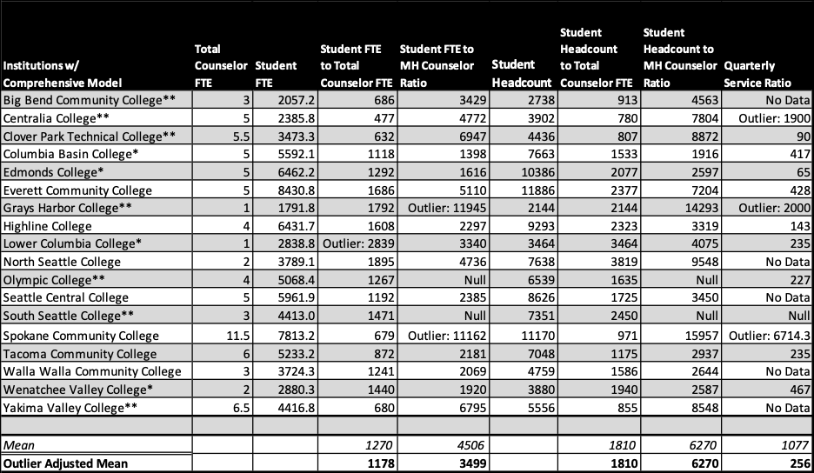

Ratios in the Primarily Clinical Mental Healthcare Model
The following chart includes the thirteen colleges that self-identified as having a counseling model in which counselors are hired primarily to provide mental health counseling services to students. Note that the Pierce College District represents two colleges (Pierce College Fort Steilacoom and Pierce College Puyallup) with consolidated data.
- Generally, specific counselors are hired to provide mental health services almost exclusively.
- Some of these colleges hire additional counseling staff to undertake other counseling/counseling-related services, such as career counseling. These additional counseling staff when reported are included in Columns 3 and 6.
- All 13 colleges have additional support for counselors, primarily in the form of separate/supporting academic advising centers, faculty advisors, or others who contribute to student academic and career planning and goal-setting. Two of the colleges indicated they do not have additional support, but this was likely a misinterpretation of the survey as revealed in other survey responses and information available on college websites.
- As above, ratios included below do not factor non-counselor additional support offered through these additional faculty/staff.

For all Washington colleges using a dedicated mental health model:
- The student to counselor ratio using student headcount ranges from 1148 – 3464 students to 1 counselor; the mean ratio for these colleges is 2311:1.
- The student to counselor ratio using total FTEs ranges from 895 – 2948 students to 1 counselor; the mean ratio for these colleges is 1734:1.
- The student to counselor ratio when considering % of mental health and FTE ranges from 1166 – 3604 students to 1 counselor; the mean ratio is 2348:1.
- Additional details for student headcount to counselor FTE can be seen below.
- All institutions reported their tracked services per quarter. Ratios ranged from 18 to 330 students to 1 counselor, with a mean of 141:1.
  - These data are a mix of unduplicated headcount (individual students) and total appointments (which included multiple appointments supporting the same student. This helps explain the large variance in the data.
  - Most institutions have a limit of appointments (generally between three to six appointments) before referring to outside resources.

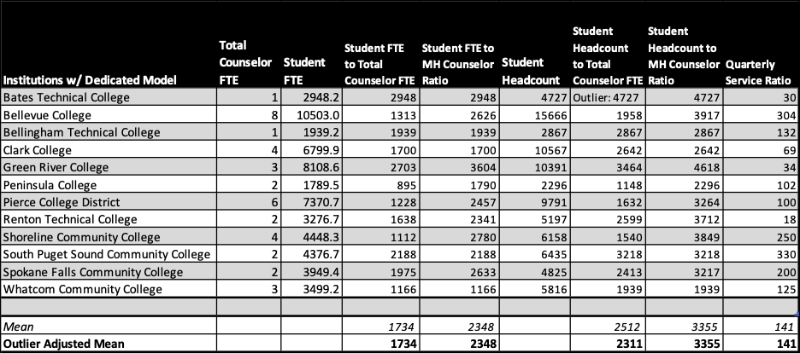

Colleges with Alternative Models
Three colleges identified alternative models to those listed above. The nature of their model does not allow for an assessment of ratios as included in this report, specifically as related to mental health counseling.

- Cascadia College partners with the University of Washington Bothell Counseling Center to serve the mental health needs of students. The model is most similar to the clinical mental health model and they serve roughly 150 students per term.

- Lake Washington Institute of Technology indicated that none of the models applied to them, thus no data were collected. However, the college website does indicate a dedicated mental health counselor who generally provides up to five sessions for short-term mental health support, followed by referrals. It is unclear whether there are additional counselors that provide other services, though the college does provide advising through navigators and other student support staff.

- Skagit Valley College has primarily served student mental health needs through referrals to community partners. However, they have recently hired a faculty counselor who has begun employment at the college this term (Fall 2020). The college has additional faculty counselors who provide direct student support through academic, career, and personal counseling, curriculum design and teaching of College Success Skills courses, and limited crisis intervention and referral. In addition, these services are supported by both exempt navigators and faculty advisors. Because of the selection of the referral model for mental health support, additional data on counselor support were not gathered.

Key Takeaways of Ratio and Model Analyses
In considering the data above, three key takeaways/considerations emerged:

- While there are substantial differences between colleges with regard to ratios of counselors to students, as well as differences depending on the model, a ratio that considers Student Headcount to Counselor FTE reveals a CTC system average of 2000:1. The typical ratio of Student FTE to Counselor FTE reveals a CTC system average ratio between 1456:1 (excluding statistical outliers).

- In considering mental health counseling specifically, mean ratios vary between a low of 2348:1 (when considering FTE and model), to a high of 6270:1 when evaluating headcount. However, when looking at the service ratio of Students to Mental Health FTE, ratios are dramatically smaller, with means ranging from 141 – 295 students to 1 counselor, noting again that ratios above 250:1 are likely at or exceeding capacity for mental health services in a quarter system.

- None of the ratios included in this report are offset by the support for tasks that might be considered counseling/counseling-related, including work such as career counseling and more broadly including academic advising. Every institution surveyed provides additional support in these areas that are provided by other employees, whether classified, exempt, or faculty, or combinations of these classifications. Indeed, between the two primary models, it is common for those with a primarily mental health focused model to have fewer counselors performing non-mental health-related duties, which can account for the substantially higher ratios when considering student populations to total counselors, and substantially lower ratios when considering student populations to total mental health counselors specifically.
- Based on all of the analyses undertaken by the Taskforce, there is a need to collect more data, particularly with regard to ensuring and assessing the delivery of mental health services to students within the CTC system.

Points 1 & 2 above lean heavily on the average ratios across the system. However, institutional data and the degree to which they meet student needs as reflected in the example below may not be revealed solely by looking at a single ratio. The differences in how we look at the data are not to be ignored.

Example: Tacoma Community College (TCC), a medium- to large-sized college with a substantial part-time enrollment, employs six counselors who dedicate an estimated 40% of their time to specifically serving individual mental health needs of students (other time is spent supporting classes/workshops, session follow-up, professional development, etc.).
- Generally, TCC has a ratio of 872:1 when considering Student FTE to Counselor FTE.
- However, when examining the number of students on campus (headcount) to the total counseling FTE dedicated solely to mental health services, that ratio jumps to 2937:1.
- Yet, the service ratio for TCC, which represents total tracked appointments (rather than individual students served), shows a quarterly ratio of 235:1. This ratio suggests roughly 4-5 appointments per day and likely includes repeat visits by the same student.

Summary Note
Finally, it is important to emphasize the degree to which interpretation and philosophy have impacted the data reported by colleges. For example, some colleges indicated that they do not believe that academic advising is a counseling-related service, and thus only reported data related to the delivery of mental health services. Others believe in a more comprehensive model and reported data on a much broader spectrum of student services. Thus, interpretation and analyses of the data herein are particularly difficult with regard to clear conclusions that can be drawn. We have attempted to interpret the data to the best of our ability given the available resources and time constraints. As repeated through this document, should the Legislature wish to explore this further, the ratio subcommittee and Taskforce undertaking this work recommend a more comprehensive exploration to clarify some of the new questions raised through this examination.

Members
Representative Lillian Ortiz-Self, M.S., M.P.A., 21st District, Shoreline (Task Force Co-Chair)
Representative Robert Sutherland, 39th District, Snohomish
Heidi Matlack M.A., LMHC, Faculty Counselor, Yakima Valley College
Dr. Sheila Edwards-Lange, Ed.D., President, Seattle Central College
Dr. Matthew Campbell Ed.D., Vice President for Learning & Student Success, Pierce College Puyallup

References
Community and Technical College Counselors—Task Force. ESHB 1355.SL Chapter 113 (2019). http://lawfilesext.leg.wa.gov/biennium/2019-20/Pdf/Bills/Session%20Laws/House/1355-S.SL.pdf
IACS. (2019). Staff to student ratios. International Accreditation of Counseling Services. https://iacsinc.org/staff-to-student-ratios/
LeViness, P., Gorman, K., Braun, L., Koenig, L., & Bershad, C. (2019, June 30). The association for university and college counseling center directors annual survey: 2019. AUCCCD. https://www.aucccd.org/assets/documents/Survey/2019%20AUCCCD%20Survey-2020-05-31-PUBLIC.pdf
Martin, E. (2004). An analysis of staffing issues related to counselors and advisors in the Washington state community and technical college system.
NACAC & American School Counselor Association. (2015). State-by-state student-to-counselor ratio report 10 year trends. https://www.schoolcounselor.org/asca/media/asca/Publications/ratioreport.pdf
Reetz, D., Krylowicz, B., Bershad, C., Lawrence, J., & Mistler, B. (2015, August 31). The association for university and college counseling center directors annual survey. AUCCCD. https://www.aucccd.org/assets/documents/aucccd%202015%20monograph%20-%20public%20version.pdf
The Academic Senate for California Community Colleges. (2012). The role of counseling faculty and delivery of counseling services in the California community colleges. https://www.sbctc.edu/resources/documents/about/task-forces-work-groups/ctc-counselors/the-role-of-counseling-faculty-and-delivery-of-counseling-services-in-california.pdf
WCTCCA. (2017). Washington state counseling services delivery models. https://www.sbctc.edu/resources/documents/about/task-forces-work-groups/ctc-counselors/wa-state-ctc-counseling-service-delivery-models.pdf

Appendix

Task Force Members
Senator Marko Liias, M.P.A, 21st District, Lynwood (Task Force Co-Chair)
Senator Emily Randall, 26th District, Bremerton
Representative Lillian Ortiz-Self, M.S., M.P.A., 21st District, Shoreline (Task Force Co-Chair)
Representative Bill Ramos, 5th District, Issaquah
Representative Skyler Rude 16th District, Walla Walla
Representative Robert Sutherland, 39th District, Snohomish
Dr. Sheila Edwards-Lange, Ed.D., President, Seattle Central College
Dr. Rebekah Woods, J.D., Ph.D., President, Columbia Basin College
Dr. Matthew Campbell Ed.D., Vice President for Learning & Student Success, Pierce College Puyallup
Dr. Sue Orchard, Psy.D., Vice President of Student Services, Lower Columbia College
Dr. Earl Martin, Ed.D., LMHC, Faculty Counselor, Everett Community College
Heidi Matlack M.A., LMHC, Faculty Counselor, Yakima Valley College
Cathy Shaffer, M.A., LMHC, Faculty Counselor, Spokane Community College
Nicole Hoyes Wilson, M.S.W., M.A., LMHC, Faculty Counselor, Highline College
Dr. Joseph P. Holliday, Ed.D., Director of Student Services, SBCTC
Shelly Hoffman, Student, Grays Harbor College

Quotes from Student Presenters

Question 1: Do you know what counseling services are available at your college and how easy it is to access them?
“At Grays Harbor College there was a mix of academic counselors and mental health counselors and some who played both roles and before I was a member of Student Government I wasn’t totally aware that we actually had mental health counselors that were also part of our academic counselors. I didn’t realize that was an option at our small campus. I would say they’re easy to access I just wasn’t as aware until I was really involved in the school…” Katelyn Sheldon, Peninsula College Student
“I had no idea we offered such a diverse, like, diverse opportunities for counseling. We have LGBTQ resources, which I had no idea that even existed at our school. And even then it takes a bit of digging through to find these resources specifically… I had no idea these existed so I feel as though one thing we can improve on is promotion…” May Tran, Pierce College Student
“We have one mental health counselor and one counselor that’s not a mental health counselor. It’s very easy to, like, access through the website to learn how to get in contact with Jennifer, our [non-mental health] counselor. It’s not as easy unfortunately to figure out how to get in contact with our mental health counselor. I don’t seem to actually see any links to contact him on our website for it.” – Eli Tovar, Lower Columbia College Student

Question 2: Do you have any ideas about how your college campus can make counseling services more inclusive – so that students from all backgrounds are encouraged to use them?
“With online right now we have a big time-difference because we have a lot of international students. Maybe if we could get them a counselor or some sort of, like even just if there was text messaging? If we could get that so that they don’t have to wake up super early to get the help that they need.” – Katelyn Sheldon, Peninsula College Student
“I know personally at the campus I’m at, it’s a little awkward when you go to check-in if you are having an appointment with a counselor. The area that you check-in is the Student Success office, so there’s often a large line of other students there and a lot of people behind the counter. And so I feel as though if we made it maybe a little more discrete, a little easier to check-in, it might encourage students to do it more.” -Zakariah Swanson, Pierce College Student
“So during Spring, or actually Winter quarter last year at Grays Harbor College, we used to have a male and female mental health counselor and we lost our female mental health counselor. And it’s actually pretty surprising how much of an impact that can make…I noticed that I was speaking with some of my peers when we were lacking a female mental health counselor saying that they just weren’t sure that they could go and talk to our current male mental health counselor.” – Courtney Glenn, Grays Harbor College
“Just spreading awareness about the services we have and how to contact them in an anonymous way, I think that’ll help a lot with people to encourage people of all backgrounds to use these services.” – Elijah O’Brian, Pierce College Student
“Hiring counselors from a more diverse background because we are often seeing a more diverse population of students come into our campus, and I feel like seeing a counselor from one specific demographic may be hard for a lot of students to relate to. So I feel like if we can increase the diversity in our counseling staff then we can make counseling services more inclusive to all different types of demographics of students.” – Eli Tovar, Lower Columbia College Student

Question 3: Is there anything else we should consider as we strive to improve the ability of our colleges to meet the mental health, educational, and career counseling needs of our students?
“Breaking the stigma of mental health and the prospect that it isn’t just people that deal with a mental illness, it’s everyone.” – Katelyn Sheldon, Peninsula College Student
“I think a lot of our students on our campus are very unaware of the resources that we offer.” – Zakariah Swanson, Pierce College Student
“It’s really important at community colleges where it’s small and it can feel, you know, not as much of a campus environment as a university, that we’re encouraging people to try the different avenues of classes to really find what they want to do.” – Courtney Glenn, Grays Harbor Student
“If the student isn’t willing to acknowledge that, hey, mental health is something important, mental illness isn’t a weakness, it is an illness and it’s not something I should be afraid of; it’s not something I should be ashamed of ... all of the attempts that we’re trying to make in terms of progress will be pretty much in vain.” – May Tran, Pierce College Student
“I think if we break the stigma around it we can have more of a system where people are going there to preserve their mental health rather than only going there when they get a confirmed mental illness and need to seek help.” – Eli Tovar, Lower Columbia College Student

Q&A from task force members to students
“I think with us going online, idealistically it should make it easier for students to reach out… But the only flaw with it is not a lot of students are engaging much online anymore…Make sure students know that, hey, just because we’re online now, it doesn’t dilute the quality of engagement” – May Tran, Pierce College
“A struggle can be that it almost doesn’t feel like you’re actually doing anything… I’ve never seen a single other student, I don’t think I know what my professor looks like, I’ve never actually heard anyone else’s other voice.” – Zakariah Swanson, Pierce College
“I think with a lot of the political and social climate and the pandemic, it’s very easy to feel like we need to be doing something more.” – Courtney Glenn, Grays Harbor
“It’s hard to engage when all you have is a screen in front of you… If you can’t do anything, a lot of student may feel as though they’re failing, or they’re not contributing enough…” – May Tran, Pierce College Student
“I feel like there’s a struggle between feeling like, I’m so overwhelmed, all my teachers are pushing so much work at me and also laying down thinking you’ve done nothing…” Elijah O’Brian, Pierce College Student
“Sometimes you want someone who you can talk to where you can go back and you can discuss those things that you discussed previously rather than every time having to explain what you’re dealing with to a new person.” – Katelyn Sheldon, Peninsula College Student

SBCTC Counselor Survey Results (2020)

Please indicate the staffing method by which your institution attempts to meet the mental health needs of students
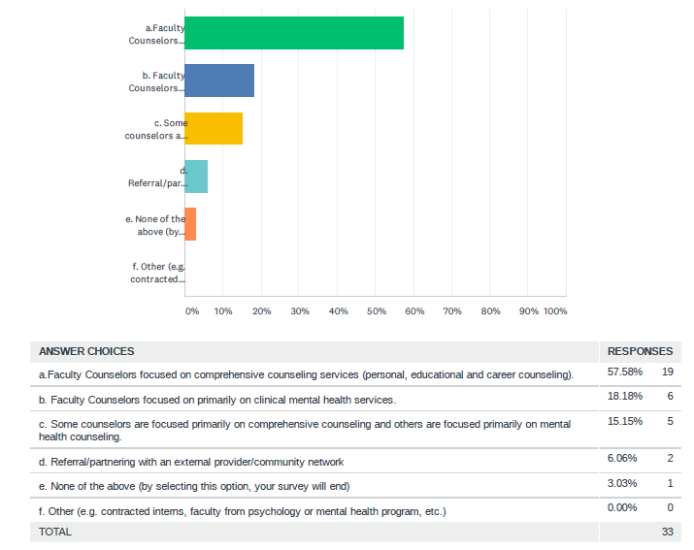

If answered b. or c. in the previous question (Later all were asked to respond)
How many FTE? |  | How many part-time FTE? |  | What estimated percentage of each FTE is specifically focused on mental health needs?
1 @.5 FTE |  | 1@.5 FTE |  | 100
6 |  | 2 |  | 50
1 |  | 0 |  | 100
5 |  | 0 |  | 5-10% (The majority is advising)
3 |  | 1 |  | 60
5 |  | 0 |  | 10 - We have faculty counselors. We don’t have a Personal Counseling Center like some campuses have. Our faculty counselors primarily do Advising and Education Planning. One is a licensed LMHC, however, that’s not her role on campus to do personal counseling. They all essentially do brief crisis intervention, then referral to outside agencies for care. We could certainly use a full time MH counselor…but don’t currently have that resource on campus.
4 |  | 0 |  | 40
1 |  | 0 |  | 15
2 |  | 1 |  | 75
4 |  | 0 |  | 70
1 |  | 0 |  | 85
2 |  | 0 |  | 40% - focused on mental health
4 |  | 0 |  | 0
1 |  | 0 |  | 100
3 |  | 0 |  | 100%
2 |  | 0 |  | 70% is what we are working towards (new service on campus and is growing)
4 |  | 0 |  | 40
2 |  | 0 |  | 2
11 |  | 0.5 |  | 1.5
2 |  | 0 |  | well over 60% of their time
6 |  | 0 |  | 40
3 |  | 0 |  | 100
6 |  | 0.5 |  | 10

If answered d.
Name of organization(s) | Briefly describe your protocol for referral (e.g., when you refer students, referral limitations such as enrollment type or provider capacity) |  | Do you think providers have sufficient capacity to accept these referrals? |  | Please briefly describe your strengths and challenges of your community referral resources.
University of Washington Bothell Counseling Center | Our college pays a yearly fee for students to have short term counseling, 6 sessions, at the UWB Counseling Center. Students can also join groups and attend workshops. These services have no session limits. Our students must be enrolled in classes for the quarter they are seeking counseling. |  | Yes
Sea Mar and Behavioral Counseling Associates | Referrals are made when mental health needs cannot be sufficiently met within the short-term counseling model or when needs fall outside the expertise of our counselors. |  | Yes |  | The biggest challenge our students face with community referrals is adequate funding and/or medical insurance coverage to pay for services. The intake procedure for some of our students to obtain services from Sea Mar has at times been a challenge because intake primarily was offered during drop in hours that didn’t fit student needs. Our college was able to arrange for Sea Mar intake counselors to come to the college campus when needed for intake appointments.
DSHS, Catholic Community Services, SeaMar, Goodwill, Washington Dept of Vocational Rehabilitation, County Free Legal Help Community Action, Friendship House, YMCA, Oasis Teen Shelter, County Crisis Mental Health, Compass Health, Regional Health/Behavioral Health, Domestic Violence and Sexual Assault Local therapists identified through psychology today website, and Local hospitals | *Using professional counseling protocol, once the student has identified a need or concern, we review service options for referral if that is in the student’s best interest. Limitations would include ability to pay for services or insurance coverage limitations, transportation to the service, childcare while student seeks help, availability at the resource site (e.g. room for new clients) and response time for student seeking support. |  | No |  | The college staff are well prepared to attend to student’s critical personal needs. However, there are not enough local services for students within the college’s three county region. Counselors often provide intermediate or short-term support while a student waits for an appointment or to arrange for transportation and/or childcare in order to access referral services.

Please describe the required credentials for faculty counselors providing services
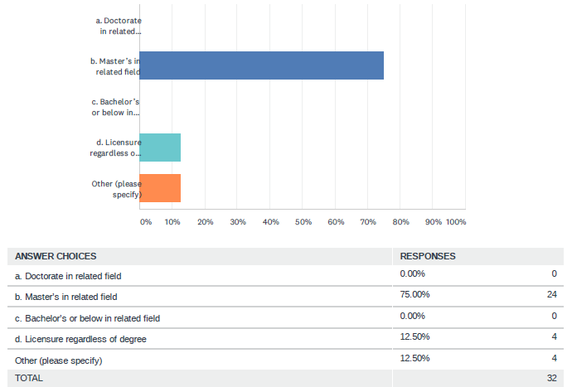

If answered d. above, please indicate license required

- Licensed mental health professional
- Washington State license for Psychologist or Mental Health Counselor.
- Master's plus licensure as a mental health professional in WA state.
- Preferred Qualifications LMHC Licensure
- Licensed or eligible to be licensed as a licensed Mental Health Counselor (LMHC), Licensed Marriage and Family Therapist (LMFT), or licensed Independent Clinical Social Worker (LICSW) in the State of Washington.
- Mental Health professional license eligible
- Licensed Mental Health Counselor
- WA MHC licensure or related (MFT, SW, etc.) (by start of contract)
- Licensed Counselor in the State of Washington or equivalent appropriate full certification or licensure (e.g., LMHC, LMFT, etc., - no. associate level) is strictly required, as well as the ability to maintain Licensure
- LMHC or Licensed Psychologist
- WA Licensed Independent Clinical Social Worker (LICSW) and Licensed Mental Health Counselor through State of WA
- For those counselors who provide mental health services, they are required to have licensure

If answered other above, please specify:
- Master’s degree AND Licensure (full; not associates-level)
- Master's degree in related field plus possession of or ability to gain licensure upon hire within reasonable timeframe.
- Our mental health faculty counselors must have a Master's degree in Counseling, Social Work, Marriage and Family Therapy, etc., including personal/mental health counseling practicum supervised by counseling professional/psychologist AND be a Licensed Counselor in the State of Washington or equivalent appropriate full certification or licensure (e.g., LMHC, LMFT, etc., - no. associate level) is strictly required, as well as the ability to maintain Licensure. Our academic/career faculty counselors must have a Master’s degree in a related field, no special licensure required.
- LMHC or Licensed Psychologist.

Do you require ongoing professional development for faculty counselors?
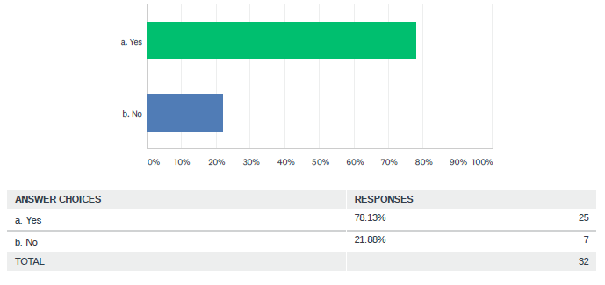

If answered “Yes” to the previous question, please select all that apply
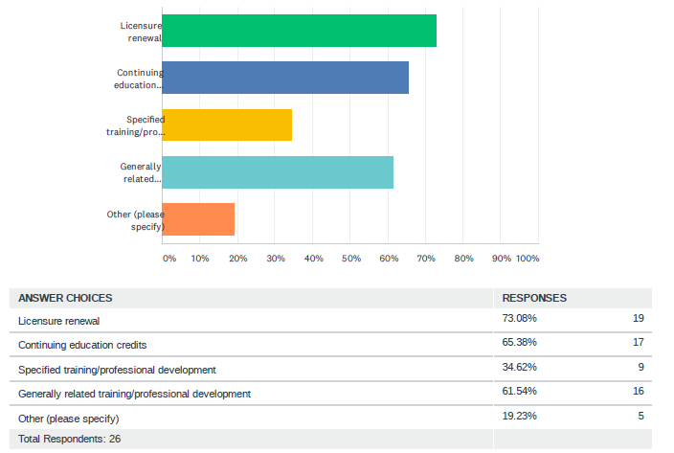

If answered other above, please specify:
- All of our counselors are licensed, which requires regular professional development CEUs
- The mental health faculty counselors must maintain their WA state licensure and take continuing education credits. The academic/career faculty counselors must participate in general professional development.
- All of the above
- Per master contract for salary advancement
- Not required but highly encouraged through PDU and yearly goals.

Do you have other individuals who perform counseling-related services? (e.g., Advising, Intake, Interns, CARE team)
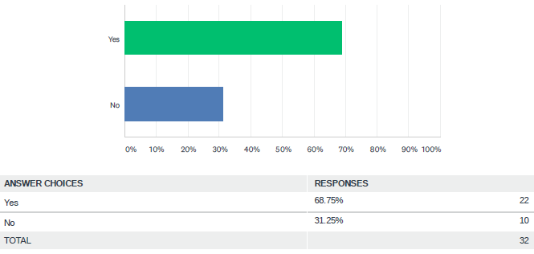

If answered “Yes” to the previous question, please describe the staff:
- Re-entry Navigator (Department of Corrections grant) .5 FTE
- Manager of Student Care, who co-chairs CARE team. Team of academic advisors who provide initial student advising.
- CARE team, success coaches, academic advising and career counseling, targeted support services available for people who identify with historically marginalized or underserved groups (specifically veterans, people with disabilities, first gen students, diversity/equity support). Our Admissions & Advising Office has a triage process for students in crisis that will get them connected with our Counselor or community resources quickly.
- Some CARE cases submitted are referred to the counseling department for follow-up. It is important to note a counselor is representing the counseling department on the CARE Team.
- Academic Advisor and CARE team members are referral sources to the UWB Counseling Center. Academic advisors and CARE team members do not provide mental health counseling.
- Assistant Director of Student Success, Specialist level staff.
- Our center has clinical interns that provide mental health services. Our Advising and Career services staff and CARE team also provide some non-mental health counseling-related services.
- Masters Level Intern
- We have four inters The Director and Assistant Director serve on the Care Team
- Both advising and Behavioral Intervention Team, make frequent counseling referrals.
- Entry Advisors (can be faculty or staff who are trained to do entry advising with new students) Academic Advising can also be done by TRIO, Running Start, Workforce Funding and Support Programs, and Athletics.
- Advisors (academic and career guidance) United Way Benefits Hub team (connecting students with campus and community resources)
- CARE team meets weekly and is designed to have an integrated approach to addressing concerning behaviors, mental health risks, referrals and faculty/staff consultations. The 8-member team is comprised of the: Student Life Dean, Disability Services Director, Campus Safety/Security Director, FA/Veterans Director, Faculty Counselor, Instruction Dean, VPSS/Student Conduct and VPSS Exec Asst.
- We have professional advisors and a CARE team, everything counseling related is referred to Faculty Counselors.
- With regard to the list in the question, counseling is specific to Mental Health counseling and only our counselors undertake this work. Advising and such is work that is performed by faculty and staff who are not engaged in Mental Health counseling.
- Academic and career advising is performed by our academic/career faculty counselors. This is viewed as distinctly different than mental health counseling. The mental health faculty counselors, who are LMFT licensed, perform some academic advising; however, the academic/career faculty counselors do not provide mental health counseling.
- We have a BIT group and academic, transfer and career advisors. We also have TRIO advisors. I'm not sure if it's considered counseling related work, as counseling duties are to be done by counselors. However, if advisors note that a student could benefit from personal and mental health support from a counselor, they refer the student to counseling.
- Customer Service Specialist 2 who provides administrative support and reception for the counseling area
- Counselors are faculty who hold a master’s or terminal degree. They provide crisis intervention, personal, career, and educational advising services. They also lead curriculum design and assessment for student development courses such as the First Quarter Experience (FQE), and typically teach these courses. Counselors are primarily assigned an advising load of students requiring extra support. Navigators are exempt employees who assist students with the intake process; advise students into the appropriate area of study; assist FQE instructors in the development of student educational plans; and advise students within their area of study. Faculty Advisors are tenure or tenure-track teaching faculty who advise 20-30 students per quarter as outlined in the Negotiated Agreement. We have a networked advising approach in which incoming students typically meet with a counselor or navigator. Depending on a student's intended program of study and satisfactory academic progress, some students are transitioned from a navigator to an assigned instructional faculty advisor who has been trained to support students in that academic program/pathway. Students assigned to counselors upon initial intake remain with those counselors throughout their duration at the College.
- Educational and Career Planners provide students with assistance on their educational and personal goals. When additional mental health support is needed, they refer students to one of our Counselors.
- Graduate student interns providing mental health and bachelor level social work intern providing social work support services.
- The college partners with area 4-year institutions to host counseling and social work interns who provide mental health/personal wellness coaching to students.
- Counseling team advises students on a limited basis. Our college have a separate Advising Department.
- Other advisors also perform career counseling type activities and Counselors serve on the CARE Team
- Educational Planners (Career, Running Start, Allied Health); CAMP; TRIO; MESA; Director of Access Services; Passport Navigators
- Curriculum Advisors are classified staff members approved to provide very limited assistance to students with course scheduling.

Do you have a diverse and representational counseling staff that reflects the identities, needs, and experiences of your student population?
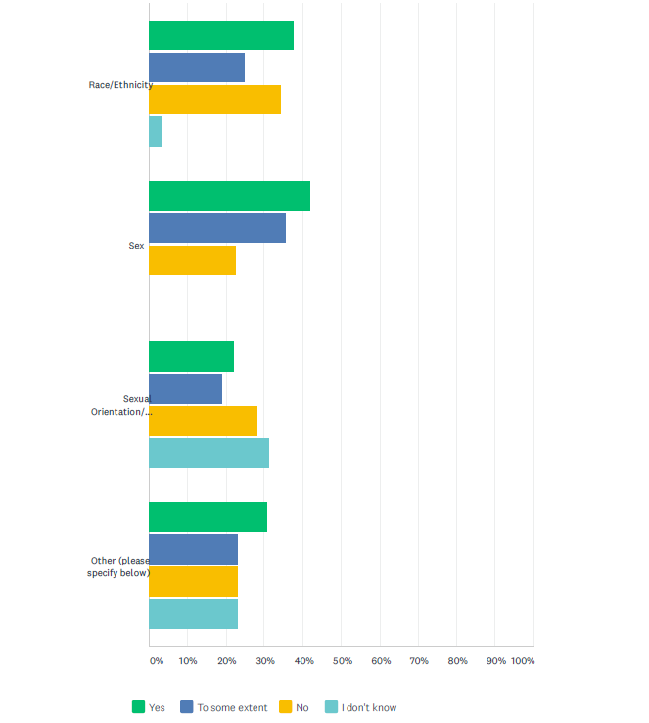
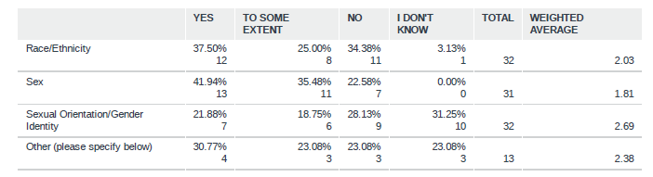

Other (please specify)
- Language abilities, diverse licensure and specialties
- We are constantly working on the unique social and racial identities of our student populations and representing them accordingly.
- We only have one faculty counselor. Because of this, we are unable to have a diverse and representational counseling staff reflecting our student population.
- language
- Disability status
- Our college only has 2 (FTE) Counselors
- Disability? Age? Veteran Status? Family of origin? International? Class? Immigration status? Difficult to answer some as these are different categories are not inclusive: sex? or assigned sex? And the third category should be two separate categories.
- Other abled body
- Age diversity
- First Generation, Migrant, Undocumented/DACA, Law Enforcement/Community Corrections
- Veterans

Have your taken intentional steps to diversify your counseling staff and/or to provide access to mental health services that reflect the diverse identities, needs, and experiences of your student population?
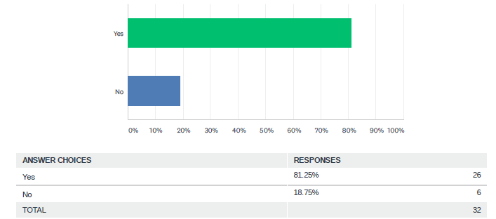
 | If Yes, please describe steps taken. If No, please describe any challenges you have had in this area.
 | - NO - Budget cuts reduced the Mental Health Counseling position to .5 FTE in 2018-2019
 | - YES - Hiring staff members with varied second language skills, advertising for counseling positions in targeted recruitment sites, training hiring committees to address bias in selection processes.
 | - YES - At present, our school has one counselor position. In addition to on-going continuing education in providing best practices, including training in equity and education undertaken this year in response to a desire to increase equity and support progress that honors national protests re: systemic racism, the present counselor maintains knowledge of and can support students in finding and connecting to available community services that the student feels is a better match for their needs, including community counseling services that specialize in providing veterans', LGBTQIA+, Native/Indigenous, or Spanish-speaking services. In our last search for a Tenure Track Faculty Counselor, we promoted the position to various Counseling education programs, associations and groups. However, a challenge in diversifying our staff continues to be a lack of diversity within our county.
 | - YES - The counseling department, today, better represents the student population compared to years before
 | - YES - Targeted job announcements and advertising for diverse professionals. Creating an atmosphere at the counseling center that has a social justice focus to retain professional staff. Professional staff work closely to build relationships with students who have a minoritized status.
 | - NO - Until the last 18 months, we have long term faculty counselors that have been with the college for between 20-30 years. A few recent retirements allowed us to hire a few new people that are more reflective of our student body. We struggle with counseling coverage in the summer.
- YES –
  - Work with Office of Diversity, Equity and Inclusion for the search and promotion process.
  - Continually working to create and maintain a referral network with culturally specific community-based services.
  - Created a Cross-Cultural Consultation group.
  - Regularly attend trainings related to power, privilege and inequity.
  - Participate in committee and advocacy work to create a campus culture that is inclusive, supportive, and welcoming for staff and students with diverse identities.
 | - NO - We've not had any staff turnover in 6+ years.
 | - YES - Counselors attend many professional development/trainings on diverse topics to better serve our student population.
- YES - We reach out to internships sites and let them know of our student population and that we are interested in interns who can best meet the needs of our students who are very diverse. We have specific interview questions that ask about experience and understanding of working with people from different identities and backgrounds.
We look for hiring staff that are multilingual; we train all of our counselors in social justice and multicultural counseling competencies.
 | - YES - We have been scaling back on resources for the past decade and that has impacted the ability to diversify our team. Inasmuch, we seek to continue our collective efforts serving a diverse student population, including but not limited to our rural student population.
 | - YES - Our college has historically had two faculty counselors (full time, tenured). One counselor retired in March 2020. Prior to that retirement, we had redesigned the job description and were going to make it mandatory to be bilingual in Spanish, so that we could address the growing Spanish speaking population in our community. Due to budget reductions, this position was not filled and we are now operating with one faculty counselor for the 2020-2021 academic year.
 | - YES - Diverse recruitment with diverse professional and community organizations and removing barriers to the application process. We regularly assess the demographics of students served compared to the demographics of the general student population. We provide culturally relative workshops regularly collaborate with the following departments: center for student leadership, intercultural center, access services, international student programs, and the cultural learning communities.
 | - YES - Through professional development, counselors participate in ongoing training to learn about and better serve the diverse populations of the students we serve. Due to a small counseling staff, we do not hire counselors often but when we do hire, we actively recruit a diverse population.
 | - YES - Prioritize and focus recruitment efforts, which include writing job descriptions to attract applicants who represent the diversity of our students; make referrals to local counseling services who are dedicated and committed to serving diverse communities.
 | - YES - Hiring practices.
 | - YES - We have built our job descriptions with this intent.
 | - YES - We have done outreach/promotion of positions to CBOs and publications that are focused for non-dominant groups. We also have tailored all of our position announcements (and particularly those for faculty) to be focused on the anti-racist commitments of the college; and these are infused through the announcement (description, responsibilities, supplemental questions, etc.) and process.
 | - YES - Our campus serves 60% students of color. It is a fundamental imperative our staff reflects this diversity. Examples include: Job postings which explicitly encourage members of underrepresented groups, veterans, and bi- or multi-lingual individuals to apply for our positions to help meet the needs of our diverse students and service district. Job postings also explicitly state our values and commitment to diversity/equity/inclusion. Our hiring processes reaffirm and address these values as well. Our staff participate in equity-focused trainings and professional development. This is expected and supported. Many staff are bi- or multi-lingual. We support staff in participating in leadership development through programs like the Social Justice Leadership Institute and Administrators of Color.
 | - YES - Counselors revamped the department’s annual work plan, increased EDI language in job postings, built stronger EDI focus into the tenure process.
 | - YES - Recruitment efforts towards diversifying hires Certified trainers in/offer quarterly mental health first aid training to members of the College community as first responders and referral points for students
 | - YES - We have taken active steps to recruit a faculty counselor that has both mental health licensure and bilingual skills, and successfully hired this position beginning Fall 2020. The previous year (2018-19), we had a failed search trying to recruit for the same knowledge, skills, and abilities. We are also actively working to build strengthened partnerships with our local mental health agencies to amplify the list of referral contacts and resources for our students.
 | - YES - We've added a male counselor to our staff.
 | - YES - We have trained Inclusion advocates in hiring committees, the work of faculty leads to develop diverse frameworks when hiring new faculty members, prioritizing EDI aspects in past and future Counseling Faculty hires to best serve our students
 | - NO - We struggle with the number of applicants who apply, with changing the current culture in our area and at our college, and with retention and support of underrepresented minority employees.
 | - YES - We have partnered with programs and departments to bring services directly to some of the most high-risk populations on our campus. For example, the counseling department has collaborated with the Office of Concurrent Enrollment to integrate introductory meetings with students in the Gateway to College program to reduce fear and stigma around participating in mental health services. Additionally, we have partnered with instructors in our Addiction Studies program who offer extra credit in some course to encourage students to utilize mental health services prior to entering the field themselves.
 | - YES - The Counseling Department intentionally reaches out to other instructional disciplines to develop programing that recruits and mentors’ students of color, through learning communities. Members of our department also participate on subcommittees that support and provide resources to justice involved students, LGBTQ students and staff, low income, and first-generation college students.
 | - YES - A Search Advocate was used in the hiring process and we refer to community providers that provide specialized treatment to meet diverse needs of student populations
- YES - We have reached out to the Yakama Nation to engage an indigenous counselor on a part-time basis.

Does your institution actively track the number of students served per term?
If Yes |  |  | If No
Please indicate the approximate number of students served |  | What kind of data are you collecting actively (e.g., number of students served daily, appointment length, etc.? | Please indicate the approximate number of students served
30 |  | Number of appointments (4 are free-of-charge) referrals to external resources types of issues presented | 30
1216 |  | Number of students served, Types of appointments, Appointment length, Satisfaction with services, Perception of cultural competence. | 1216
132 |  | Counselor tracks number of individual students who keep 1+ individual counseling appointment, total number of counseling appointments kept, number of referrals made and to what services (in general). | 132
N/A |  | none | N/A
148 unique students were served |  | Number of students, number of sessions, demographics of students who seek counseling, presenting concerns/reason for seeking counseling, outcome data from self-report symptom checklist. | 148 unique students were served
950 |  | Number of student and type of appointment | 950
On average, 276 students served by counseling staff per term, and 260 students served by medical staff per term. |  | Number of students served per term who scheduled/attended/no-showed to individual, group and/or workshop sessions, number of students served from minoritized populations, student satisfaction feedback on services. | On average, 276 students served by counseling staff per term, and 260 students served by medical staff per term.
45 |  | Number of visits; types of visits | 45
5000 per year |  | We are able to collect the number of students served, daily, quarterly and yearly. We are also able to see length of appointments. We can track the type of appointments. (career, personal, advising, individual appointments, mental health group sessions, and teaching classes.) | 5000 per year
1,981 appointments for 259 students served for 2019/2201 |  | CCAPS, How many clients, what type of appt (crisis, drop-in), no shows, cancellations | 1,981 appointments for 259 students served for 2019/2201
9/19 - 6/20; 1285 seen by CSS Counselors; 2782 seen in CSS front office; |  | Number of students served daily/quarterly/annually and nature of services provided. | 9/19 - 6/20; 1285 seen by CSS Counselors; 2782 seen in CSS front office;
In 2019-2020, two counselors served approximately 302 students per quarter. |  | Number of students and type of service (advising appointment, drop-in advising, personal counseling appointment/crisis, or career counseling appointment) | In 2019-2020, two counselors served approximately 302 students per quarter.
In the 2018-19 academic year, an average of about 76 unduplicated students were seen each quarter. |  | - Student demographics (age, gender, race/ethnicity, prior counseling history, etc.)  - number of students served per term  - sessions per term  - appointment types (intake, regular, crisis)  - referral sources | In the 2018-19 academic year, an average of about 76 unduplicated students were seen each quarter.
400/qtr. |  | Individual appointments | 400/qtr.
200/term |  | Number of students served per day/quarter; purpose of appointment | 200/term
1500 annually 19-20 |  | Number of students served, average session time | 1500 annually 19-20
102 |  | We collect data on: Number of students, number of appointments, appointments missed, length of appointments, Special Populations/Program of Study, what brings them in, what they need help with, whether they have seen a counselor and if they have a Primary Care Provider. | 102
300/term (unduplicated headcount academic year; 8-10 sessions is the max range) (district-wide) |  | Number of students served, number of sessions, type of services, professional development, outreach and presentations delivered (w/ attendance), consultations to faculty/staff, age group, student assessment/evaluation (both for in-person and Telehealth); new/returning client; appointment type (appointment, walk-in, crisis, etc.); attended/no-show/reschedule; enrollment type (Running Start, etc.); presenting condition; other student demographics... | 300/term (unduplicated headcount academic year; 8-10 sessions is the max range) (district-wide)
Mental Health counselors: 25 clients(students) served via 1:1, and dozens via class visits |  | Number of students daily, student demographics, reason for visit, duration, referral, program of study, | Mental Health counselors: 25 clients(students) served via 1:1, and dozens via class visits
300 summer 2020; 400 average fall - spring quarterly |  | Demographics number of students served daily types of appointment- e.g., career, crisis, mental health workshop participants | 300 summer 2020; 400 average fall - spring quarterly
659 |  | Number of students served, reason for visits | 659
1460 (Based on % of hours calculation and not actual numbers |  | Currently no data aside from limited data on daily appointment is being gathered. Appointment length is an hour | 1460 (Based on % of hours calculation and not actual numbers
4700+ |  | Number of students served daily, appt length, reasons for meeting with a counselor, mode of meeting (zoom, skype, phone, in person, email), drop in students | 4700+
well over 2K students per quarter for academics and nearly 300 for mental health |  | We collect the number of students served daily, quarterly, and number of visits per student. We also track the length of the appointments, purpose of the appointment, and any comments related to the appointments. | well over 2K students per quarter for academics and nearly 300 for mental health
1,693 counseling appointments for 2019-2020. |  | Each quarter, we track daily appointments of all counselors in the department. | 1,693 counseling appointments for 2019-2020.
700 per quarter |  | Name, phone number, and student ID; first time and repeat students; length of appointment, reason for appointment, type of appointment, referrals | 700 per quarter
1500 appointments per year |  | Number of student sessions and appointment length | 1500 appointments per year
Approximately 8,827 unduplicated head count students during 2018-19 academic year. |  | Number of students served daily, type of assistance requested and provided. | Approximately 8,827 unduplicated head count students during 2018-19 academic year.

Please indicate the top three services requested/provided by selecting no more than three below
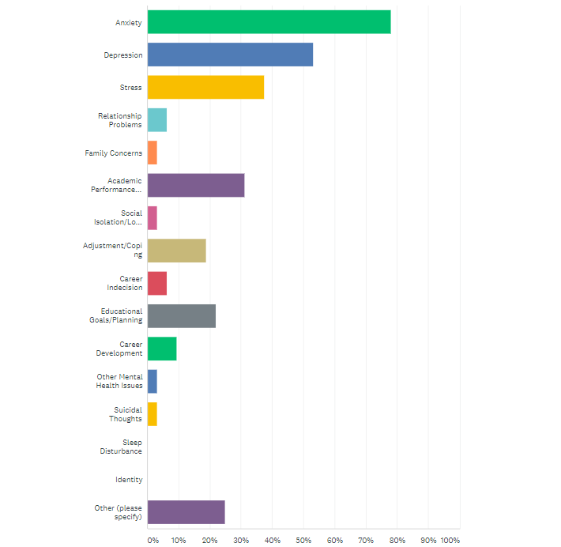
Suicidal Thoughts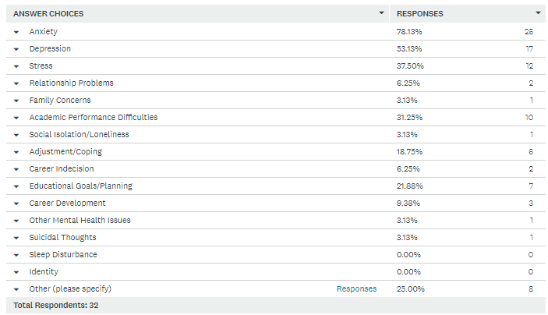

Other (please specify)
- Racial trauma and impacts of the election
- Yes to a balance of the other Mental Health-focused areas. Shifts with different populations and circumstances, with more emphasis on relationship, suicide, and coping.
- Financial hardships and struggles
- Concentration difficulties
- Academic Advising is by far the biggest request
- Adjustment/coping including relationship problems, family concerns, stress, transition and identity issues
- Mental health concerns are in combination. For example, typically, when a student visits a counselor for depression they are also exhibiting some level of anxiety. Students also have questions about transfer and career services.
- Most of these services are interrelated, so within academic performance difficulties and educational goals/planning are also stress, anxiety, other mental health issues. Relationship problems, family concerns, suicidal thoughts, adjusting coping, social issues present within these two areas as well.

Do you actively conduct assessment of counseling services?
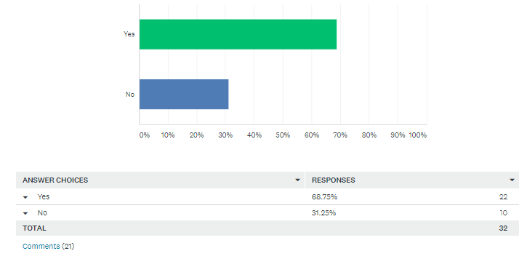

Who currently supervises counselors providing mental health services?
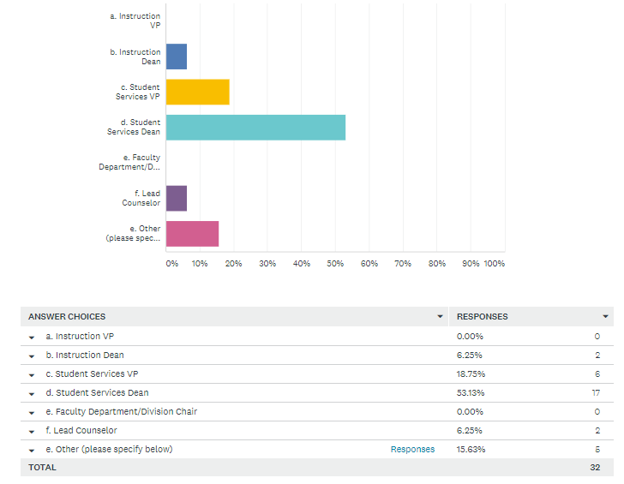

Other (please specify):
- Executive Director, Admissions and Advising
- Student Services Director
- Counselors are independently licensed and report to Director of Disability Services for operational needs.
- Interim Director of Counseling and Student Success.
- Dept. Coordinator provides day to day support and supervision of counselors, VP Student Services provides supervision to the department coordinator

Do you have special counselor credential requirements for the supervisor?
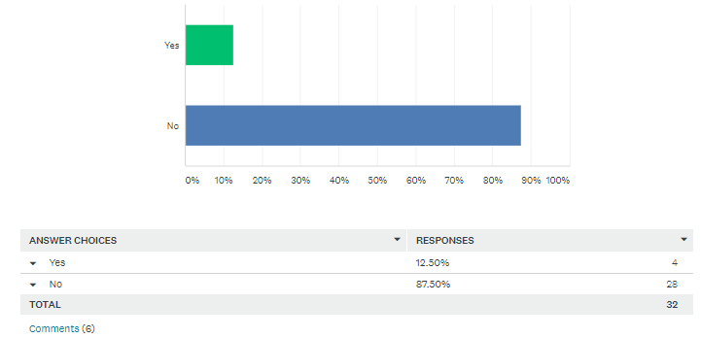

If yes, please describe:
- Licensed Psychologist in the State of Washington who has 30 plus years in collegiate mental health.
- Masters in related field
- They need to be Licensed
- The current Interim Director position is approaching one year in tenure. Prior to the creation of this position, counselors were supervised by the Dean of Student Development who did not possess counseling credentials.
- No, however current VPSS has counseling credentials, training and experience in the field.
- Supervisor does have a counseling background, but is not a LMHP.

Where are the offices for those providing mental health counseling?
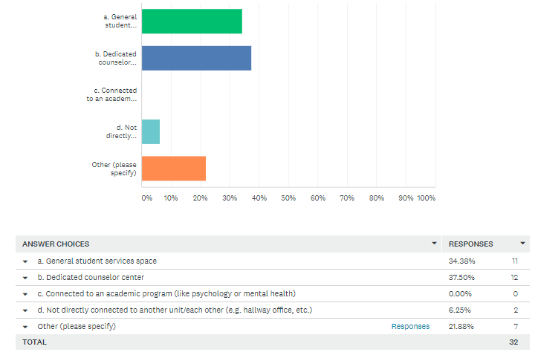

Other (please specify)
- We have limited capacity/scope with offices for counseling staff. Other counselors are placed throughout the campus.
- Counseling is located in the Student Success and Advising Center; co-located with Guided Pathways advising, Running Start, Seattle Promise and Disability Services.
- Located in Student Services, in the advising & counseling office (called the Student Success Center)
- Counselors are located in the counseling & advising center. We provide crisis intervention but no ongoing mental health services.
- Student Health Clinic (formal services), Counseling Center for informal services)
- Each counselor has a dedicated office located in the Counseling and Advising Center.
- Both A & D - we have 2 separate campuses

Please estimate the percentage of time your faculty counselors spend on these roles annually without exceeding 100% overall.
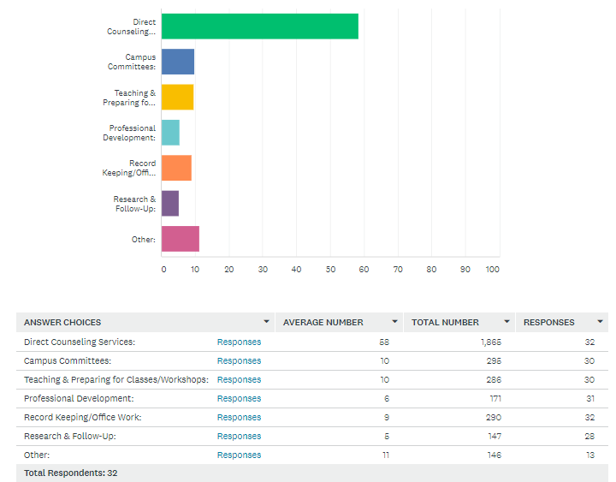

Does your college provide Counseling services during the summer quarter and/or breaks?
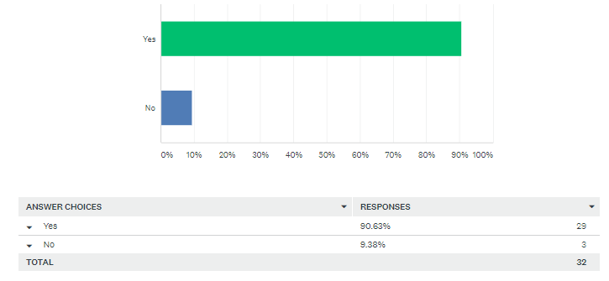

If yes above, mark all staffing practices that apply
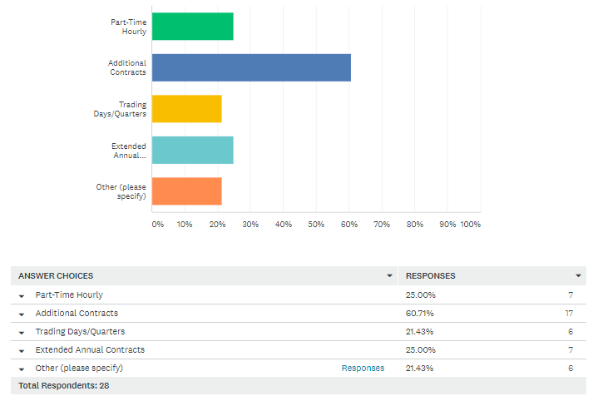

Other (please specify)
- We do not provide counseling services during the breaks in between quarters (summer quarter only)
- Faculty Counselors have a 12-month (206-day) contracts flexed to assure coverage for summer and breaks (if students are present, a counselor is present; and this is adjusted to assure more robust coverage during peak times).
- FT Counselor does an hourly timesheet for off-contract days.
- Our faculty counselors and librarians have a 206-day contract and work year-round, taking non-contract days over the course of the 4-quarter academic year.
- Our counselors are on 12-month professional staff contracts. They are all employed by University of Washington Bothell
- Flex schedule

Below is a list of Council for the Advancement of Standards (CAS) for college counselling services. If you are familiar with them, please select the three standards your college finds most challenging/difficult to meet.
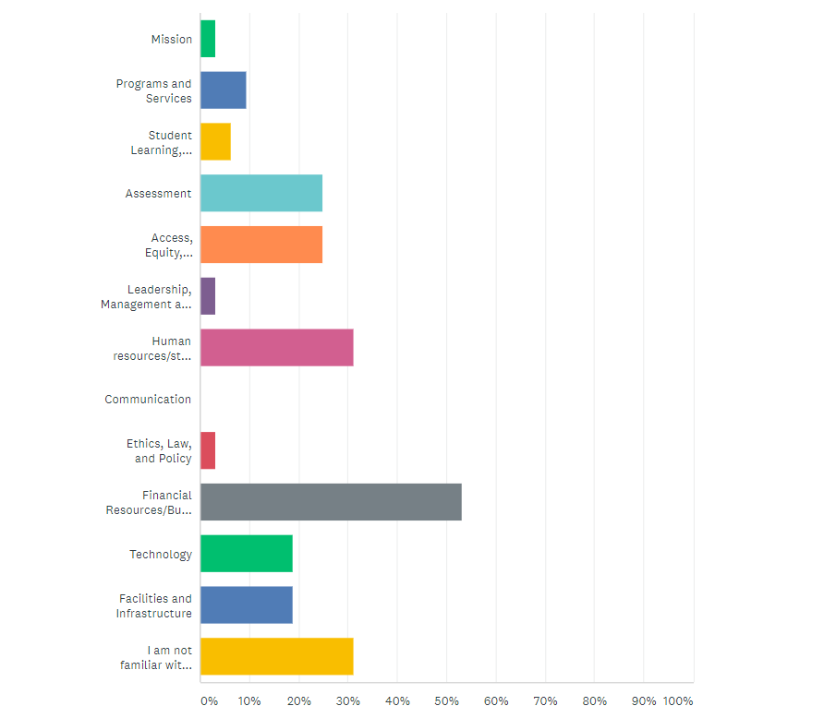
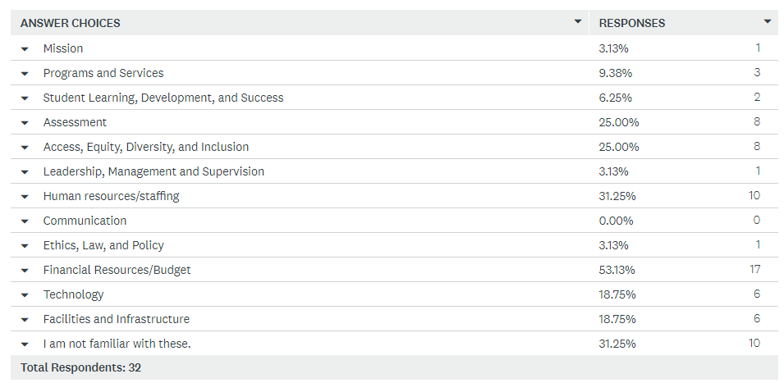

Please briefly describe the counseling model used at your college, if any, to guide counseling practice.
- Counseling services are provided by a licensed Mental Health Psychotherapist. Referrals are made by faculty/staff/ Student Conduct Officer, self-referrals by students are encouraged
- Our counseling center is focused on mental health and academic counseling. Our counselors are faculty counselors with varied credentials and expertise, all related to counseling.
- Individual counseling sessions are offered with a focus on mental health and well-being. Counseling services are solution-focused and primarily use EBTs from CBT and MI modalities, with a person-centered and affirming/culturally-informed therapeutic style. As appropriate and with student consent, referrals and/or care coordination can be provided with services both on and off campus.
- Counselors use a holistic model
- The Counseling Model is based on Collegiate Mental Health practices. Individual and group counseling is offered on a short-term basis. Focus is strength based, solution focused, relational, and developmental.
- We use a humanistic and behavioral counseling approach
- We are a student-focused wellness center with a short tern mental health treatment and referral model using evidence-based practices.
- Solutions focused, brief intervention
- We offer short term counseling and have resources to be able to refer to other agencies if needed. Our counselors use a variety of different modalities for providing counseling services to our students.
- We use the Social Justice Multicultural Counseling Modalities, we also use the treatment method vs absorption method
- It is a comprehensive model emerging and agile to the current climate as well as considering the counseling role in the development and implementation of Guided Pathways.
- Our college employs a short-term wholistic counseling approach to support students with the intersections of advising, career, and personal development. The primary personal counseling approach used is T.E.A.M Therapy developed by David D. Burns MD. This approach has strong roots in Cognitive Behavioral Therapy and includes a variety of other influences. T.E.A.M. is an acronym for “testing,” “empathy,” “agenda-setting,” and “methods.”
- Short-term, solution-focused counseling model to guide our practice.
- Comprehensive personal, educational, and career counseling using a social justice practice
- For mental health services, it's a generalist practice/system model (social work training).
- Our counseling faculty provide counseling, curriculum and services to effectively assist diverse students in getting on the path (on-boarding), staying on the path (retention) and getting the finish line to achieve their academic goal(s). To meet these goals counselors, use multiple methods: 1:1 counseling, teaching, consulting, workshops, crisis intervention, study skills/self-efficacy/college success strategies through Human Development curriculum/course offerings.
- DBT (Dialectical Behavioral Therapy) CBT (Cognitive Behavioral Therapy) Motivational Interviewing. These are all evidence based and excellent practices that our Mental Health Counselor uses. Each one is evidence based and rated EXCELLENT. The focus is short-term crisis counseling
- Three licensed mental health counselors provide individual, short-term/crisis counseling. Faculty counselors are specifically mental health counselors hired to specifically serve the mental health needs of students. Referrals are provided for long-term needs as necessitated.
- We have 2 faculty counselors who are licensed to practice mental health counseling. Our advising model uses faculty counselors who serve as professional academic/career advisors -- these faculty counselors DO NOT provide mental health counseling. Our mental health counselors are new to the college, and we describe their specific work as 'emerging' because they are new and actively creating programming and defining services. Our advising model is well established, though it is undergoing remodeling as we implement Guided Pathways.
- Promising
- Mental health model, brief, solution focused
- Counselors provide direct student support through academic advising and educational planning, curriculum design and teaching of College Success Skills courses, and crisis intervention and referral. The majority of our counselors do not have mental health counseling credentials, so we use a crisis intake and referral model to outside agencies who can support ongoing mental health services.
- We offer one-on-one appointments, walk-ins and workshops to assist students. In addition, we offer campus-wide mental health events to build awareness about mental health issues.
- Comprehensive counseling model emphasizing education, career and personal counseling
- We utilize a Comprehensive Counseling model to include academic, career, and social/emotional aspects to meet student needs.
- Our counseling model includes mostly brief, one-to one, strength-based therapeutic sessions. We also provide crisis interventions, campus outreach and community referrals.
- We use a short-term model focusing on student's strengths, resilience and academic retention.
- Counseling is guided by the college mission and the counseling mission. Counselors use a holistic approach as their model to meet student personal and academic needs and success.
- Client/student-centered, short-term, solution-focused
- Student Development Model

In the sections below, please describe any counseling practices at your college that are effective in generally meeting the needs of the students you serve.
Practice 1 - Description: | How would you rate this practice?
General Counseling services are interspersed among many departments and programs including Student Life, WorkFirst, BFET, Workforce Opportunity Specialist, Re-entry Navigator. Given the types of issues our students present (homelessness, food insecurity, lack of educational funding, etc.), these collective resources are effective in addressing these specific issues, however demand continues to grow. | Promising
Individual counseling, same day when possible (previously face-to-face, presently remote via Zoom or phone due to Covid 19): delivery time 3, data collection/types 1, results 3, statistical significance 1, impact 3, sustainability 3, replicability 2 | Excellent
Visibility: Counselors provide consistent and accurate information for the counseling webpage, counseling and student services related information on the website | Emerging
Individual Counseling | Excellent
Flexibility in appointments vs. walk-ins (delivery time) We are available when students need us. | Promising
Workshops and trainings provided to students and staff, wellness and student success-based outreach/events | Excellent
Solutions focused | Promising
We offer 90-minute personal counseling sessions for our students, and crises counseling for students in immediate need. We also offer quarterly student success workshops developed around mental health topics. Our counselors also teach our Human Development classes and work with students on conditional enrollment status or dismissal. | Excellent
Delivery Time | Promising
Data Collection - Limited data collection; reliance on one data type | Emerging
Drop in hours for academic advising. Support students with course planning and educational goals. | Emerging
Counselors collaborate as a team of equals - there is no one counselor that supervises the team. Instead we utilize a system of professional peer consultation as well as collaborate to manage counseling center responsibilities. | Promising
demographics of students using our services matches the demographics of the general population | Excellent
Solution focused. | Promising
Workshop offerings: Preparing for Exams, Choosing a Major and most recently, and Well-being and Productivity in the Time of Covid-19. | Promising
Universal- Quarterly Emails, promoting awareness around suicide prevention, drug and alcohol, etc. | Promising
DBT (Dialectical Behavioral Therapy) | Excellent
As described below, the counselors believe that the model of having counselors dedicated to mental health is practice that affirms to students that their mental health is important and prioritized. This also assures that they do not have conflicts when needing to respond to crises. | Excellent
Our advising model is a centralized advising office staffed with academic/career faculty counselors. They provide academic and career advice according to areas of study. Enrolled students are assigned a faculty counselor for the duration of their program. The academic/career faculty counselor provides academic support and guidance for students in 1:1 appointments, group settings, and classroom visits. They also teach sections of College Success 101, which is a mandatory course for new students enrolled in programs of a determined length (for example, 1 quarter programs do not require this course). The academic/career counselors are required to hold a Master's degree in a related field. They do not perform any mental health counseling. | Promising
counselors are very responsive to student need and faculty and staff referrals. They built an internal process to make sure there is always an "emergency" counselor on duty, in case an emergency comes up. | Emerging
Mental Health First Aid training for campus employees and students | Promising
Counselors and other faculty (both tenure track and adjunct) teach First Quarter Experience classes: a 2-credit mandatory college success skills course that most of our incoming first year students complete. Retention data is significantly higher for students who take these courses versus those that do not. | Excellent
One-on-one counseling appointments | Promising
Academic/educational Counseling (Probation/suspension, time management, goal setting & decision making etc. | Excellent
GUID 102 Strategies for Student Success course offered to new students. | Promising
Brief one-to-one counseling services. | Promising
Individual Counseling | Emerging
Counselors use a holistic approach and look at each individual student as a whole in serving and meeting their needs. | Promising
Individual counseling | Excellent
Mandatory Advising based on Guided Pathways | Promising
Practice 2 - Description: | How would you rate this practice?
Course presentations: Counselors present on counseling topics, services, and college success strategies. | Emerging
Skills Group to increase coping skills of students | Promising
Sustainability - five counselors are district funded tenured faculty members. | Excellent
Student success focused campus and community referrals including career exploration, housing and nutrition needs, financial aid and others | Excellent
Cognitive behavioral therapy | Emerging
We also offer the "passport" program which is our work with foster students attending the college. | Promising
Data collection | Promising
Delivery Time | Emerging
Individual career counseling appointments that include interpretation of career assessments. | Emerging
Workshops - workshops are done based on student need and/or campus community request. | Promising
Outreach and collaboration with campus partners | Promising
Cognitive Behavioral Therapy. | Promising
Counseling website: https://northseattle.edu/counseling offers extensive self-help resources that includes a link to a free, confidential, on-line MH assessment tool. Counselors send campus wide timely and relevant information for students, staff and faculty --- on topics such as: exam prep, stress management and mindfulness, preparing for a new quarter and goal setting. | Promising
Selective - interventions i.e., visit developmental English and math classes to offer co-curricular support, liaison with Multicultural Services, Student Programs | Promising
CBT (Cognitive Behavioral Therapy) | Excellent
Coursework offered to students in Human Development, e.g., Career Exploration, Stress Management, Improving Relationships | Promising
Crisis intervention and referral: a rubric and educational campaign is underway to assist staff and faculty across the college in recognizing different levels of student crisis, and when/how to refer to the counseling team. Our College is devoting increased attention and collaboration to develop trainings and workshops between the counseling team and Athletics due to increased mental health needs of student athletes. | Promising
Walk-in appointments | Promising
Consultation collaboration with Faculty/others on campus | Excellent
Designated counseling liaisons for all of the programs offered. | Promising
Wellness workshops, seminars and groups that include stress management practices and substance support groups and class visits. | Emerging
Crisis Counseling | Emerging
Counseling has community partnerships that enable easy access and referrals for students. This includes an on-campus clinic that provides medical services and mental health referrals. | Promising
Workshops | Promising
Personal counseling | Promising
Practice 3 - Description: | How would you rate this practice?
Running Start: As a specialized group of students, counselors advise RS students as they have unique academic, developmental, and emotional needs. | Emerging
Integrated cross-disciplinary wellness model incorporating medical and mental health case management. | Excellent
The establishment of the Hawk Career Readiness Program this year to work with students who are undecided on a program or study or want to explore different options available to them. | Emerging
Results | Emerging
Results | Emerging
Program evaluation (called Program Assessment & Improvement - evaluation of Counseling Services every 5 years. | Promising
Individual therapy | Excellent
Talk therapy. | Excellent
Counselors teach HDC 100 courses, fulfill elective requirement for AA degree. HDC students learn to self-assess, identify meaningful academic, career and personal goals, develop action plans, campus resources and support services and self-efficacy. | Emerging
Indicated- targeting high-risk individuals depending on identified need through workshops, individual sessions, psycho/education groups as needed. | Promising
Motivational Interviewing | Excellent
Care Team - mental health counselor serves in co-chair capacity and provides support for individual students, consultation, training and development for employees | Promising
Mandatory Advising: all incoming students participate in a mandatory registration session as part of the intake process, in which a counselor or navigator assists in selecting classes and learning how to register. This practice has improved students' time to degree progress and amplified our Guided Pathways goals to clarify an academic or career path early on. Mandatory Advising/Education Planning: all incoming students participate in a mandatory registration session as part of the intake process, in which a counselor or navigator assists in selecting classes and learning how to register. Students are then required to enroll in a First Quarter Experience course, which is a degree requirement. One of the learning outcomes of this course is a one-on -on creation of an Education Plan with their Advisor. The Education Plan is tailored to the individual student’s placement, percentage of full time, and long-term education/career goals. This practice has improved students' time to degree progress and amplified our Guided Pathways goals to clarify an academic or career path early on. | Excellent
Mental Health workshops | Emerging
Undecided Students: Helping students to clarify their career, educational goals in the context of self-exploration, always considering social/environmental factors such as: relational, cultural, etc. | Excellent
Established Happy Light & Bio-feedback Campaign to address Seasonal Affective Disorder and reduce stress. | Promising
Psychoeducation/Wellness Groups | Emerging
Counselors provide monthly wellbeing-sessions to promote general needs in areas such as: suicide, alcohol/drug abuse, healthy relationships, stress, test anxiety and other mental health needs. | Promising
Wellness/prevention education | Promising
Social Services referral | Promising

Please describe any counseling practices at your college that are effective specifically in meeting the mental health needs of students.
Practice 1 - Description: | How would you rate this practice?
Licensed Psychotherapist with extensive professional network in the greater community. After coming on board in January 2020, many students are just "finding" our Counselor | Emerging
Call campaign 1x quarter during Covid 19 offered to any new student or any student not connected to a student service cohort already receiving outreach, typically to provide high touch caring contact, ensure access to resources needed for success during remote learning, provide referral and/or warm hand-off to relevant resource: delivery time 3, data collection/types 1, results 3, statistical significance 1, impact 3, sustainability 3, replicability 3 | Excellent
Counselors are available during day-time classes to address student counseling needs as they arise. | Emerging
The same as listed in questions 29 - 32. | Promising
Delivery Time - a counselor is on duty every day of the week and on nights/weekends when needed. Counselor expertise is broad, allowing for a multitude of support. | Promising
Individual, relationship and family counseling. | Excellent
Solutions focused | Promising
Covid-19 Group Conversations-Supporting Students' Mental Health During Covid-19 | Promising
Statistical significance | Emerging
Data Collection | Emerging
Individual personal counseling appointments where a collaborative approach is used to determine areas for growth regarding mental health needs, and a personalized treatment plan is developed. | Promising
Counseling Services Overviews - requested presentations given in classes about why students might want to seek out counseling, reduce any stigma around seeking counseling, and the how they connect with a counselor. | Excellent
Regular counseling workshops and mental health screenings | Promising
Solution focused. | Promising
Provide faculty/staff consultation on approaches to support students who are experiencing academic difficulty and/or experiencing crisis. Counselors also participate as a member of CARE team | Promising
Selective - interventions i.e., offer co-curricular support Mindfulness course | Promising
Short-term, individual mental health counseling by licensed mental health counselors along with resource referral as needed (on/off campus) (could be for ongoing counseling needs or for meeting equity needs of students) (Requires *dedicated* Mental Health counselors to do and do well to fully support students). | Excellent
Our licensed mental health faculty counselors are building out their programming. This model includes short term 1:1 mental health counseling, crisis assistance, workshops, referrals for continuing service off campus, mental health awareness building, trainings for faculty and staff, etc. They have created social media and YouTube content, and Canvas content (including videos) for students and faculty to access. The also carry small academic advising loads that will reduce as their mental health clientele grows. The mental health counselors are required to hold a Master's degree and maintain Washington State licensure. | Emerging
Individual appointments with a mental health professional | Promising
Other mental health events | Emerging
Crisis Counseling | Excellent
Designated counseling supervisor for master level counseling interns | Promising
Career Development | Emerging
Individual Counseling | Emerging
Individual, short-term counseling; crisis intervention; referrals and presentations. Self-serving Informational handouts throughout campus providing resources in all mental health areas. | Promising
Individual counseling | Excellent
Personal Counseling | Promising
Practice 2 - Description: | How would you rate this practice?
Adaptive Scheduling: Counselors have adjusted their schedules to meet the mental health needs of the student as the needs arise. | Emerging
Results - developmental strategies and community partnerships have allowed our students to be successful after intervention. Students are able to transfer strategies to practice and be successful. | Promising
Group therapy and psycho-educational presentations. | Excellent
Student Success Workshops- i.e. Wake up to Better Sleep, Healthy Relationships, Bio-Hacks to Reduce Stress and Improve Mood, Test Anxiety | Excellent
Impact | Excellent
Delivery Time | Emerging
Referrals - based on our model and the limited amount of time students spend on campus, we help students find longer-term help depending on their need. | Excellent
Daily drop-in hours | Excellent
Cognitive Behavioral Therapy. | Promising
In response to Covid-19, counselors sent tailored correspondence to campus community on how to manage stress related to Covid-19, student success tips and on-line assistance to be successful in on-line classes. Counselors increased their availability to students via email, and collaborated with counselors across Seattle District colleges to research and gain a greater understanding of the ethical, legal, logistical, technical and fiscal implications of tele-counseling. | Promising
Indicated- targeting high-risk individuals depending on identified need through workshops, individual sessions, psycho/education groups as needed. Mindfulness workshops | Promising
Crisis intervention with transition to practice #1 (question 31) (Requires *dedicated* Mental Health counselors to do and do well to fully support students). | Excellent
Standalone Counseling Center | Excellent
Counseling as Rest Stop (taking time to fully listen, stream management, slowing down thinking, breathing, etc. | Excellent
Outreach campaign to advocate, inform, and normalize counseling services & resources. | Emerging
Crisis Counseling | Emerging
Partnering with other services on campus | Excellent
Practice 3 - Description: | How would you rate this practice?
Counselors participate in college events and student training which promote student wellness | Emerging
Crisis management (behavioral intervention and threat assessment, student death process, suicide and risk assessment) | Excellent
"CARE "response team phone number and an early alert system that faculty use to notify a counselor about a potential student with personal health issues. | Excellent
Sustainability | Excellent
Results | Emerging
Individual Counseling - students can seek out individual personal/mental health counseling at any point and for any reason. | Excellent
2 counselors sit on our CARE team and provide regular consultation and support for student mental health crisis | Promising
Talk therapy. | Excellent
Counselors send out campus correspondence to provide student success strategies, such as: student success and learning strategies, stress-management and mindfulness and goal setting. | Promising
Consultations and outreach as mental health counselors to faculty/staff to guide them with student concerns. Provide educational workshops to the campus on mental health issues. These practices support faculty/staff with their skills and also help others understand appropriate was to support and refer students experiencing challenges, particularly related to mental health, creating a culture of care, support, and advocacy rather than one that is punitive and/or dismissive. | Excellent
Hiring licensed mental health professionals | Promising
Emerging and addressing of deeper concerns (through the aspect of relationship building, deeper level of concerns emerge and can be addressed | Excellent
Partnered with local community resources. | Promising
Teaching/Presentations/Psychoeducation/Preventative Work | Emerging
Representation on the behavioral intervention team | Excellent

What advice or lessons learned would you share with other colleges if they desire to implement or adapt these practices to their own campuses?
- Mental health counseling professionals who have worked with a diverse clientele and have a practical, hands-on, working knowledge of the issues our students face are a definite advantage in effectively serving students.
- Assure that counselors are represented in the college-wide discussion regarding student success initiatives.
- Faculty Contracts make it hard to meet year-round demand so be thoughtful in how you structure the positions.
- Hiring a well-rounded and trained staff who are licensed in a mental health field and willing to explore new initiatives. Being co-located with our nurse practitioner. Having a space that is solely dedicated to counseling and health. Working to stay connected and integrated to other student supports on campus. Development of telehealth services and staff training specific to telehealth.
- We don't have funding for Counseling staff. We utilize Advisors, one of which is a licensed mental health practitioner. Trying to support student’s mental health needs without staffing to support is a challenge. We're starting to utilize mental health interns to build capacity. We're also up front with students about what we can provide...brief, personal counseling that is more crisis mitigation than anything else.
- We have moved away from advising to personal counseling and have to allow for dedicated time that counselors are available. Promote the services through all areas of the college. Use Marketing services to assist us to notify campus.
- Resources, comprehensive technology acquisition and training for research. Triangulate data with qualitative, quantitative, and mixed methods analyses. Lived experiences and personal narratives informing practice.
- It has been very helpful to use an evaluation of therapy form for every single counseling session. Discussions precipitated by this form has been invaluable.
- Reach out to others who have implemented these practices. Assess and evaluate them once they are implemented. Adjust as needed, being open to the idea that they may include eliminating the practice or meeting the student need in a completely different format.
- Don't wait for students to come to you - meet students where they are by providing a robust outreach model.
- Be flexible and understanding and have a good relationship with faculty. Be willing and ready to learn approaches that meet the client's needs rather than trying to make the clinician's approach one size fits all.
- Continued collaboration, support and partnerships with VPSS/VPI to offer more sections of the HDC course; training and development to become more proficient in the use of technology/telehealth counseling; and IT to assist with technology needs/concerns.
- We firmly believe that the model of having dedicated, licensed mental health counselors conveys to students that we care and prioritize student mental health (that it is not diluted with non-mental health-related responsibilities); this is purposeful to assure that students and the challenges they are facing do not "fall through the cracks." The ethics of the position require this attention to addressing and supporting in the moment.
- The faculty contract is a challenge because it's difficult to provide year-round services when faculty aren't under contract during breaks and summer.
- Campus needs to believe that serving the mental health needs of students is essential to access, retention, and equity.
- Systematic advising support and interventions require a whole campus approach, beginning with strong executive leadership and clarity of vision and intended outcomes. We have utilized large institutional grants such as Title 3 to build a holistic advising model and to commit to its sustainability. Counselors and navigators are assigned to each Area of Study, which is comprised of instructional faculty who teach in that respective area. Collaborations between and across Instruction and Student Services help strengthen our commitments to Guided Pathways implementation.
- We are in the process of identifying software to track and assess our practices. Without consistent and accurate data, it's hard to rate our practices as emerging, promising or excellent.
- Always focus on the individuality, diversity and unique perspective of each student, as they teach us about the larger community needs.
- Having adequate staffing and support staff is necessary for successfully implementing Health & Wellness campaigns to assist with administrative tasks. Additionally, having an effective software program for therapeutic note-taking and data tracking would be helpful.
- We rate as emerging because we do not have a technological platform to track needed data and to collect feedback from participants and to assess those populations not accessing services.
- Implement practices that are relevant to their particular campus needs.
- 1. For counselors to intentionally outreach to others on campus and in the community. Developing those relationships and maintaining them.
2. To have separate jobs and responsibilities for counselors and advisors. Not a blended job/role.

WCTCCA Counselor Survey (2018)
In 2018, the Washington Community and Technical College Counselor’s Association (WCTCCA) produced the first known systemwide report on counselor staffing ratios, including all 34 institutions. This study followed the established California State Community College System methodology for defining a counselor-to-student ratio that measures full-time equivalent (FTE) counselors to student headcount. Student headcount is measured by fall quarter enrollment (the quarter with the highest numbers of enrolled students). This study examined Fall 2017 data for both student headcount and counselor FTE. This data is limited to state funded counselors to accurately measure the state’s funding support of these important student services. (Note: counseling is defined differently in California and some of the support structures found in the Washington system are not included in the California methodology.)

The 2018 WCTCCA report was foundational in inspiring the professional body’s campaign for legislated minimum systemic “standard of care” seeking the establishment of minimum system standards for counselor hiring qualifications and staffing levels through the Washington State legislature sought with House Bill 1355 (2019 Legislature). The report demonstrated tremendous Counselor staffing level variation between colleges.

Key Findings among our 34 institutions include:
- The state system average was 1843 students to one FTE counselor.
- Three colleges had zero counselors.
- Three colleges had one counselor.
- The colleges ranged from between 750 to 5610 students for every one FTE counselor.
- Nine colleges had staffing rations above 3000 students for every one FTE counselor.

Fall 2017 Washington State Community & Technical College Counseling Staffing*
College | Student Headcount | Counselor FTE | Ratio
Renton | 5,254 | 7 | 750
Yakima Valley | 4,884 | 6.5 | 750
Centralia | 3,798 | 4.9 | 775
Big Bend | 2,354 | 3 | 785
Clover Park | 4,209 | 4 | 1052
Seattle Central/SVI | 8,829 | 8.05 | 1097
Skagit Valley | 5,549 | 5 | 1110
Spokane | 12,509 | 11.2 | 1117
Spokane Falls | 5,882 | 5 | 1176
Tacoma | 7,578 | 6 | 1263
Grays Harbor | 2,563 | 2 | 1282
Pierce Puyallup | 5,003 | 3 | 1668
Olympic | 7,278 | 4 | 1820
Columbia Basin | 7,535 | 4 | 1884
Lower Columbia | 3,953 | 2 | 1977
South Puget Sound | 6,088 | 3 | 2029
Wenatchee Valley | 4,186 | 2 | 2093
Everett | 9,713 | 4.5 | 2158
Shoreline | 6,857 | 3 | 2286
Bellevue | 17,393 | 6.46 | 2692
Highline | 10,242 | 3.66 | 2798
Seattle South | 8,741 | 3 | 2914
Bellingham | 3,060 | 1 | 3060
Whatcom | 6,657 | 2 | 3329
Pierce Fort Steilacoom | 6,973 | 2 | 3487
Bates | 3,882 | 1 | 3882
Seattle North | 8,468 | 2 | 4234
Clark | 12,901 | 3 | 4300
Walla Walla | 5,236 | 1 | 5236
Green River | 10,860 | 2 | 5430
Edmonds | 10,547 | 1.88 | 5610
Peninsula | 2,643 | 0 | N/A
Cascadia | 3,873 | 0 | N/A
Lake Washington | 4,468 | 0 | N/A
System Total | 227,023 | 117.15 | 1938
*State Funded

History of Counseling Services in the Washington State CTC System (1950s-2000s)
Written by Dr. Earl Martin, Ed.D., LMHC, a Faculty Counselor at Everett Community College with edits from Dr. Rebekah Woods, Ph.D. & J.D., President of Columbia Basin College.

1. “Washington Community and Technical Colleges Counselors' Association Position Paper: On Professional Staffing Standards of Counselors in Community and Technical Colleges” (2000).

Late 1950's - Early 1960's
Post WWII prosperity and GI educational opportunities spurred rapid growth of community colleges across the country (Arthur D. Little, Inc., 1966, p. 13). Four-year institutions adopted more stringent admissions policies - two-year colleges "opened the door," providing universal access to the nation's growing numbers of highly diversified student bodies. The 60's saw enrollment more than double and unprecedented research took place, as well as local, regional, and national funding and legislation.
In 1957, the Washington State Board of Education published a report from the Washington State Junior College Study Committee which stated "that provisions for counseling in considering the loads of the staff will become more essential since the counseling service is one of the most important services of the junior college" (p. 35), and recommended that "there be an increased emphasis on the expansion of the number of professional counselors" (p. 36). In 1965, the Washington State Board of Education published in its Long-Range Development Plan for Community Colleges that "A sound counseling program is a fundamental responsibility of the community college" (p. 16).

The Carnegie Report
The national push for research and reporting is exemplified by what is known as the Carnegie Report (National Committee for Appraisal and Development of Junior College Student Personnel Programs, 1965). Carnegie Corporation provided funding for a two-year study of two-year college student personnel programs. In cooperation with the American Association of Junior Colleges, an independent national committee of prominent educators was appointed. The findings of the Carnegie Report are succinctly put through the following quote from that report: "The ultimate success of the comprehensive concept of higher education rests upon adequate guidance" (p. 20). The conclusions and recommendations of this National Committee became the model for Community College Student Personnel programs across the country. "The Committee has attempted to summarize the characteristics of an effective program of student personnel services for two-year institutions" (p. 3).
The Carnegie Report recommendations are summarized below:
- Counseling is central to community college success in fulfilling its mission of providing open admission and comprehensive educational and service programs.
- The comprehensive nature of the counseling function is described, as well as students need for continuous appraisal through the counseling function.
- Professional counseling qualifications are defined as a two-year graduate degree in a Behavioral Science field with a supervised practicum.
- National ratio standards are defined as an ideal of 1:300, not to exceed one counselor for every 500 students. [These figures are based on a comprehensive counseling model, where counselors perform advising and other functions in addition to personal counseling].
- The need to ensure adequate funding for counseling programs is described.
- Recommendations include institutional support for professional development.
By opening the door … community colleges, therefore, have assumed the enormously difficult task of educating highly diversified student bodies. It is obvious that these institutions must provide highly differentiated educational programs. It should be equally clear that if students are to choose wisely … they must be assisted. The student is likely to do these things effectively only if the college recognizes the process of self-discovery [career, personal, academic] as one of its principal purposes, and if [its] services are adequate in scope and quality to give the student necessary assistance. For this reason, counseling and instruction are equal partners in the education of junior college students, more than at any other level of education (p. 2).

Policy Plan for Community College Education in the State of Washington
In response to the rising demand for educational opportunities and growing body of research on community colleges (which includes symposiums and conferences in Washington State featuring members of the Carnegie Commission), the 39th Session of the Washington Legislature directed the state to prepare a comprehensive plan for the organization of Community College education (Arthur D. Little, Inc., 1966). A Policy Plan was written (the Student Service portion of which was based in large part upon the recommendations of the Carnegie Report). The Plan states that "the degree to which the community college system in the State will be successful…will depend, in important part, upon a considerable expansion of the guidance and counseling function" (p. 38), and "The community college which appears best suited for today's tasks accepts students of widely varying ages, interests and capabilities, has at its heart a strong counseling center…" (p. 14).

Five basic elements of the comprehensive community college:
- First two-years of four-year degree programs
- General education courses
- Occupational education courses
- Community services and adult education
- Counseling and Guidance (p. 14).
The State must ensure that comprehensive educational programs and services are available within each college, so that students of widely different capabilities and interests can find within each college a broad range of program offerings from which to choose, and the skilled guidance and counseling which will enable them to make sound choices. (p. 3).
Additionally, staff requirements, position descriptions and specifications of qualified personnel are mandated. Furthermore, the Policy Plan outlines how Washington State is responsible to ensure minimum standards. While individual districts are granted substantial independence, it is Washington State's responsibility to ensure that the intent of the law is carried out at each campus.
The State must ensure that whatever the desirable variations between and among community colleges may be, there is a satisfactory level of community college educational services being provided by every institution in the system… In addition to seeing that community college services and facilities are available to all its citizens, the State also has a responsibility to ensure that the programs being offered satisfy certain basic standards of quality and comprehensiveness. In other words, the range of programs offered in any college and the quality of the instruction and services being provided should not be fortuitous matters wholly dependent either upon local resources or local policies… The State therefore has an obligation … to set guidelines, standards and criteria for defining what community college education should be so as to measure the adequacy of the programs and services being offered (p. 117-118).

The Community College Act of 1967 (and The Community & Technical College Act of 1991)
Based upon the Policy Plan (and the recommended model as reported by the Carnegie Commission), Washington state's Community College Act became law in 1967 (State Board for Community College Education, n.d.). Community colleges will "offer an open door to every citizen, regardless of his academic background or experience…and offer thoroughly comprehensive education, training, and service programs" (p. 6). The supporting documentation upon which the Community College Act was based clearly shows that to achieve success in its mission of providing "open-door" (p. 4) admissions and "thoroughly comprehensive" (p. 6) programs, community colleges must provide students with adequate access to a professionally staffed, sound counseling program, because inherent in the open-door policy is the responsibility of all community colleges to provide educational opportunities for students with various occupational aspirations and with a broad range of interests, needs, and levels of abilities and intelligence. To make the open-door policy a reality, the community college must make available competent counseling services (State Board of Education and The State Board for Vocational Education, 1966, p. 2).
Professional qualifications, faculty status, counselors' comprehensive role, and ratio information are clearly defined within the supporting documentation.

The Washington State Community College System Master Plan
As mandated by the 1967 Act, the State Board is responsible for minimum standards and quality assurance (State Board for Community College Education, n.d.). This document also spells out the responsibility of the State Board for ensuring that the mission of the community college system is met, guaranteeing that the people of Washington State be served by its mission. In answering the question, “How will this be accomplished?”, the Master Plan outlines the following: The State Board does so by proposing system-wide goals and then allocating resources to achieve those goals. The State Board defines the purposes of community college education in Washington as follows: 1. To Serve the Individual…the achievement of these purposes will be supported by guidance and counseling. 2. To Serve the Community…3. To Serve the State…These purposes are to be achieved through the offering of a wide range of vocational training opportunities and related guidance services… (p. 7). The Master Plan includes the specific goal to provide "guidance and placement counseling at or above nationally recommended levels" (p. 16). As we have shown national recommendations include definitions of professional counselors (with specific training and faculty status), as well as ratio guidelines (National Committee for Appraisal and Development of Junior College Student Personnel Programs, 1965). The final draft of the Master Plan listed one counselor for each 300 students as the nationally recommended ratio (Canfield, n.d., p. 23). The document further specifies that "The State Board asked the…Legislature for special funds to bring student services, especially guidance and counseling, up to standards. It is hoped that the implementation of budgeting formulas in future years will make this need more clearly identifiable" (p. 16).

Washington's Open Door Colleges Comparing the State's Community Colleges with Recommendations by the Carnegie Commission on Higher Education
In 1970, the State Board for Community & Technical Colleges published a report entitled “WASHINGTON'S OPEN DOOR COLLEGES: Comparing the State's Community Colleges with Recommendations by the Carnegie Commission on Higher Education”. This report provides further evidence that the Carnegie Commission's findings were the model upon which Washington state's community college system was based. Of the comparison to Carnegie Commission findings, the State Board reports that the influential body recommended directions for development of community college education in the United States. The Board approved for publication a report compiled by the staff to compare the system's performance against the Carnegie Commission recommendations. In general, the staff indicated that the state system was so much in line with the commission's recommendations that it could have served as their model (Washington State Board for Community College Education, 1970, p. 1).
The central question this report sought to answer was "How has the state of Washington done in meeting the spirit of the Community College Act?" and they did so by comparing the state's community college system to recommendations of the Carnegie Commission. "In supporting the goals of the system as outlined in Design for Excellence [the Master Plan] one of the objectives is 'to provide guidance and placement counseling at or above nationally recommended levels' " (p. 14). In working toward the recommended levels of guidance and placement counseling (which the state defines as one of the five basic elements of comprehensive colleges), "the state board…has developed a budget model for student personnel services…greater financial effort is required to provide for adequate guidance services…and the real need for qualified guidance specialists" (p. 14). This study specifically lists each recommendation of the Carnegie Report followed by a report on the status of Washington's community colleges relative to the recommendations. The Carnegie Commission concludes (and the Washington study emphasizes) that "guidance is particularly critical for students who attend community colleges because many have not developed clear educational or vocational goals and a great many face the interrelated problems of financial, academic and personal pressures" (p. 14).
From “On Professional Staffing Standards or Counselors in Community and Technical Colleges” (2020).

2. “Counseling in Washington State Community Colleges.” (1984).
Dr. John Terry, the Executive Director of the State Board of Community College Education wrote:
“We who are in leadership positions in the community colleges give easy lip service to the importance of meeting student needs. Words – no matter how pious or how significant a role the speaker may hold – are meaningless unless they can be translated into action. At issue is the quality of student development. Student development cannot prosper without the participation of an effective and comprehensive counseling program. Counseling from the historic perspective has been an integral part of the community college mission. Under the stresses of retrenchment, the safe assumptions about the centrality of counseling were found to be inadequate. Student services, including counseling, were not as central to the mission as many complacently assumed, as a consequence, they became too frequently the targets of opportunity for the surgery of retrenchment.”
Source: Counseling and Guidance Directors Association of Washington Community Colleges. (1984). Counseling in Washington State Community Colleges. Seattle: Seattle Central Community College.

3. Washington State Guidelines for Comprehensive Counseling and Career Guidance Programs K-14 (1998).
For nearly three years, approximately 120 counselors, counselor educators and other key stakeholders worked at creating state guidelines for comprehensive counseling and career guidance. This effort was led by a rare cooperative effort between the Office of Superintendent of Public Instruction (OSPI) and the State Board for Community and Technical Colleges (SBCTC) to create guidelines for kindergarten through community and technical college education in Washington State.
The K-14 state guidelines were developed to:
- Clarify the counseling role as implied in educational reform, school-to-work, and other legislation.
- Update the existing Washington State model to align with national standards for comprehensive counseling programs.
- Create a seamless system to ensure that diverse, changing needs of each student would be met from kindergarten through community/technical college.
- Provide a common set of standards throughout the state.
Included was the development of counseling and guidance components and competency benchmarks in the three foundational domains of comprehensive counseling – Educational Development, Personal/Social Development and Career & Planning.
Source: Coats, R.Q., Ash, M., & Dorsey, C.J.H. (1998). Washington State Guidelines for Comprehensive Counseling and Career Guidance Programs from Kindergarten through Community and Technical College. Olympia, WA: Author.

4. Student Services in Community and Technical Colleges: A Practitioners Guide: Chapter 7 - Counseling Services. (2008).
The Washington State Student Services Manual has been published for decades and once routinely listed counselor-to-student ratio standards of 1:500. The Manual provides a description of counselor qualifications, counselor roles, best practices, quality indicators and future directions. Below are excerpts from the 2008 edition.

Services and Functions
Counselors are vital members of campus planning and retention efforts. They provide essential educational programs and services designed to meet the needs of their unique communities. Counselors use psychological theory and research to help students make progress toward their educational and career goals and with their emotional and social development.

Educational Counseling/Academic Advising
Educational counseling includes helping students learn strategies for academic success and addressing personal barriers. Counselors provide services such as interpreting basic skills and placement test results, reviewing information about educational programs and courses, explaining college policies and procedures, and guiding students to appropriate information in their fields of interest. While academic advising and educational planning are done at various levels of depth and complexity by different employees, counselors are uniquely trained to interview students and develop a holistic educational plan that takes into account a student's educational background; emotional, social, and academic readiness; levels of support; family circumstances; and schedule. Martin (2004) reports that holistic academic advising has been the most frequently requested student service provided by counselors in the community and technical college system. Other examples of educational counseling include assisting students with choosing a program of study; transferring to a university; withdrawing from classes; coping with math, speech, or test anxiety; exploring learning styles; and improving study skills.

Career Counseling
Career counseling involves students in an exploration of personal interests, motivations, values, and abilities, and teaches the development of decision-making skills through the selection of career goals. Counselors instruct students about employment trends, specific career and job search skills, as well as select, administer, and interpret standardized career assessment instruments. Counselors may oversee or work in tandem with college career centers to provide additional services. Counselors help students use career exploration databases and other resources that provide students with tools to explore occupations and various training programs.

Personal Counseling
Personal counseling addresses issues such as the balance of school, work, and home; difficulties in class; dealing with anxiety or depression; confronting prejudice or discrimination; relationship problems; identity confusion and uncertainty; managing grief, anger, or shyness; coping with major life transitions; lack of confidence and assertiveness; time and stress management; and dealing with perfectionism and unrealistic expectations.

Crisis Intervention and Mental Health Response
In collaboration with campus security, college administrators, and community referral resources, counselors assist with a host of mental health related issues. Counselors are familiar with the mental health resources in their community and make appropriate referrals as needed. Counselors generally do not provide clinical diagnosis or long-term treatment in the community college environment.

Instruction
Counselors regularly teach classes related to human development and applied psychology. The primary objective of instruction is to improve student success through coping skills, decision making, goal setting, career development, and effective life management.

Consultation and Advocacy
Counselors consult and advocate for students with instructors, administrators, and other campus offices (Lewis, Arnold, House, & Toporek, 2003). They help address complaints, assist in identifying and resolving complex situations, provide training and feedback on classroom behavior and/or challenging students, and serve the campus-wide community through committee work, planning bodies, and guest lecturing.

Staffing and Organizational Structure
According to the Revised Code of Washington (RCW 28B.52.020, 1991), community and technical college counselors are faculty members based on their status as "academic employees". They have a minimum of a master's degree in counseling, psychology, or related field (Washington Administrative Code, WAC 131-16-091, 2004) from an accredited university that includes a supervised practicum and internship in counseling. Some counselors have additional training or licensure in mental health and/or addictions counseling. Counselors adhere to a professional code of ethics, maintain confidentiality, and follow duty-to-report laws according to the professional guidelines and ethical standards set by their professional associations and state licensure boards.
The institution and the state must provide adequate financial resources to ensure the provision of a broad range of counseling services. This requires strong institutional commitment to provide necessary facilities, staffing, and operational funding. (Stringer & Coates-White, 2008).

References

Stringer, J., & Coates-White, S. (2008). Counseling Services. In Student Services in Community and Technical Colleges: A Practitioner's Guide (4th ed., pp. 28–31). https://www.sbctc.edu/resources/documents/about/task-forces-work-groups/ctc-counselors/student-services-manual-chapter-7-2008.pdf
Washington Community and Technical College Counselor’s Association. (2020, May 30). On professional staffing standards of counselors in community and technical colleges. https://www.wctcca.com/uploads/1/1/2/3/11232275/position_paper_on_professional_staffing_standards_of_counselors_in_community_and_tech_college_may_2000.pdf

Additional Resources Considered by the Task Force
For the purposes of the members of this Task Force, a resource collection was assembled on the State Board for Community and Technical College’s website. This contains relevant news articles, studies, literature reviews, reports, and other information curated by members to inform the final report. To review these resources, please visit the Task Force Resource Collection web page at this URL: https://www.sbctc.edu/about/task-forces-work-groups/ctc-counselors/resources.aspx.
Included in this collection is a legislative report from Forefront Suicide Prevention. This report is also available through the Washington State Legislature at this URL: https://app.leg.wa.gov/ReportsToTheLegislature/Home/GetPDF?fileName=SSB_6514_FINAL_REPORT_12.01.19_ed59cb8b-f7da-4c22-a31c-7992a39bca39.pdf

CC BY 4.0, unless otherwise noted.
Washington State Board for Community and Technical Colleges

