One place to make the changes - Online Service Configuration: http://worldcat.org/config/ When logging in, choose the top option, “Sign in to Service Configuration.”

Once logged in, choose “WorldCat Registry” and then “Online Catalog” to configure links to your catalog. THIS IS THE SCREEN YOU SHOULD SEE

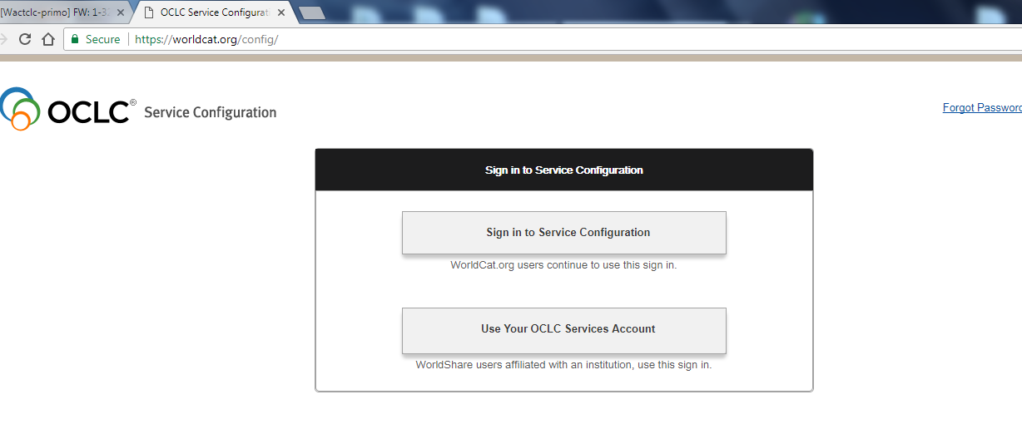

The Base URL we used is - https://edmonds-primo.hosted.exlibrisgroup.com/primo-explore/search?vid=EDMONDS&lang=en_US&sortby=rank
The URL we used for ISBN, ISSN, and OCLC Control # is - https://edmonds-primo.hosted.exlibrisgroup.com/primo-explore/search?tab=default_tab&vid=EDMONDS&fn=search&query=any,contains,
You must change “edmonds” and “EDMONDS” to your own institution coding.

Second place to make the changes - http://firstsearch.oclc.org/crs/servlet/org.oclc.fsadmin.AdmBuildLogonPage?show=admin&language=en
Go to the “Linking Tab” and then to “Web Library Catalogs” option. SIGNON SCREEN SHOULD LOOK LIKE THIS!
