In the illustration below from Primo this first title shows as a journal, which I believe is coming from the leader line in the MARC record. This record is also faceted as a “Journal”
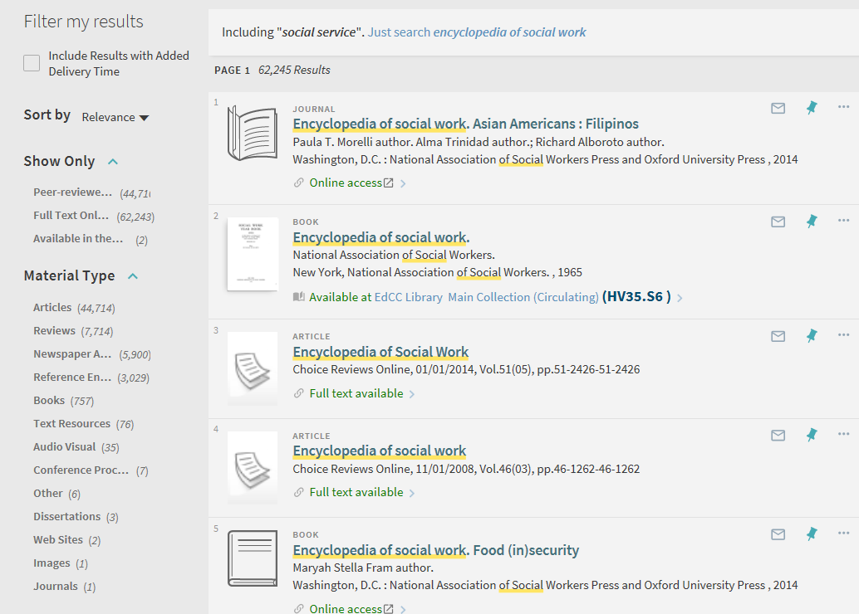
However, this record in Alma has an Electronic material type of “Document”, not journal.

In the illustration below from Primo this title shows as a “book”, which I also believe is coming from the leader line in the MARC record. This record is also faceted as a “Book”.
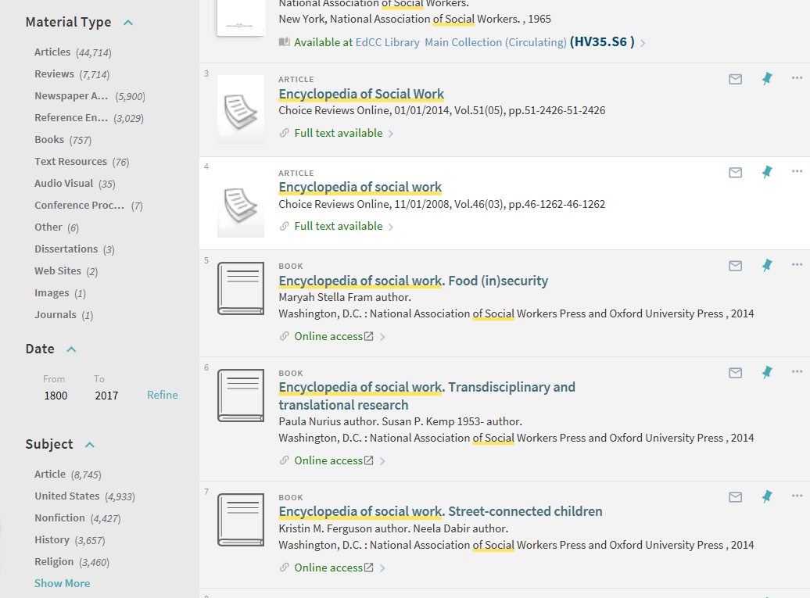
However, in Alma the Electronic material type is “Streaming Video”. I have no idea of what the purpose of the Electronic material type in Alma is for if it has no relationship to Primo.

The Electronic material type does show as a facet in Alma, but there seems to be no relationship for this coding in Primo. I am trying to understand the use of these facets in Alma if they have no connection to faceting in Primo?
