|  |  |
| --- | --- |
| **How to use a list of MMSIDs (or any other value) from a csv file as input in Alma Analytics** |  |



**Introduction**

Often the institution will have a list of values, such as MMSIDs or barcodes, in a column of a csv file. The csv file may originate from a variety of sources, for example

* Exporting a set in Alma
* The “Duplicate title analysis” job
* A local application

It is possible to use these values as a filter in Alma analytics. In the case below we will use the MMSID. The same flow can be used for other values such as barcodes.

**Scenario**

**ONE**

Change the list of MMSIDs to be in one row separated by a semicolon.

Thus, for example, the following:

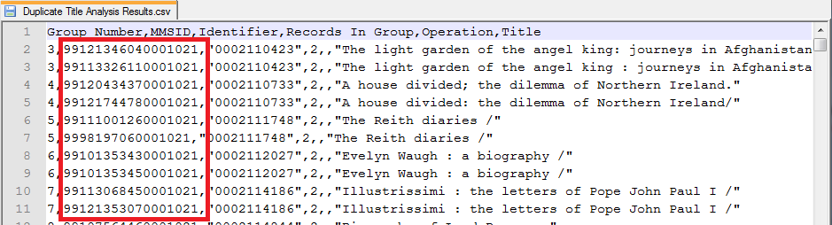

Should change to



**TWO**

The actual changing of the file is beyond the scope of Alma, but if you are using Notepad ++ here is tip for an easy way to do it:

Open the file with csv suffix in notepad ++ and do as follows:

**First**

Remove the first line which has text

**Second**

Do a global replace choosing “Regular expression” and do not choose “matches newline” as follows:

Change

^([^,]*),

To

||| (triple pipe, a value we will change to nothing in the next step)

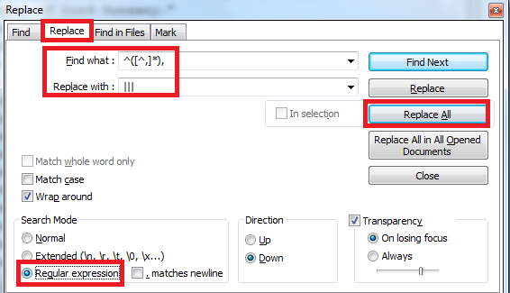

**Third**

Change the III (triple pipe) at the beginning to nothing

Do a global replace choosing “Normal”

Change

|||

To

(nothing)

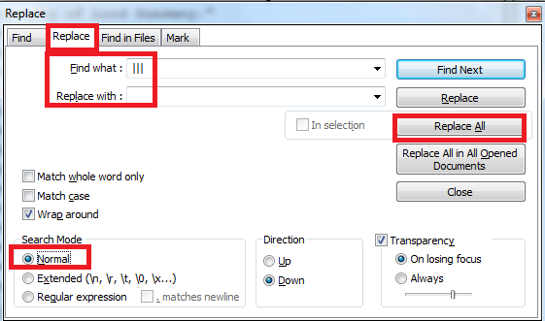

**Fourth**

Put semicolon at end. Do Global Replace choosing Regular Expression.

Change

,.*$

To

; (no space at end here)

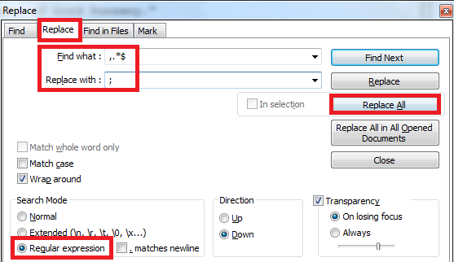

**Fifth**

Put all lines on same line

Do a global replace choosing “extended”

Change

\n

To

[Leave field blank]

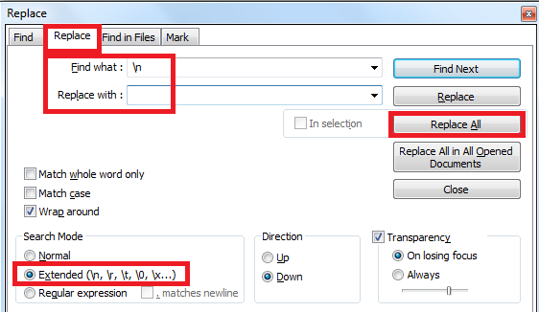

**THREE**

Open an analytics report and do a filter on whatever field you “semicolon separated”. In our case it is MMSID.

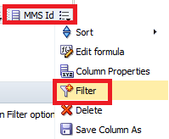

Copy to your mouse the list of MMSIDs in the new format from the csv file (where they are separated by a semicolon). Paste into the filter.

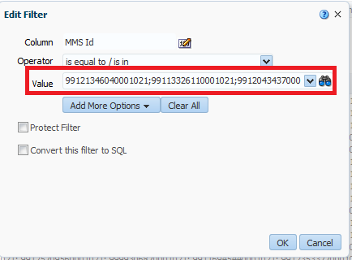

**FOUR**

The report is now filtered by the MMSID.

