1. This question appears right after selecting the program and term of study prior to getting into the main navigation page

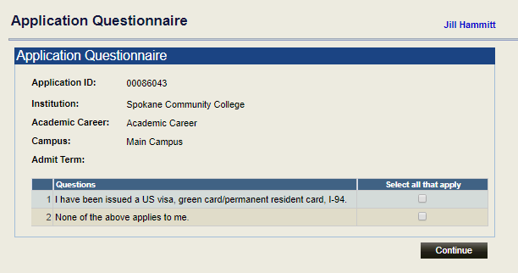

1. When entering Bio/Demo information students are prompted for Citizenship Information

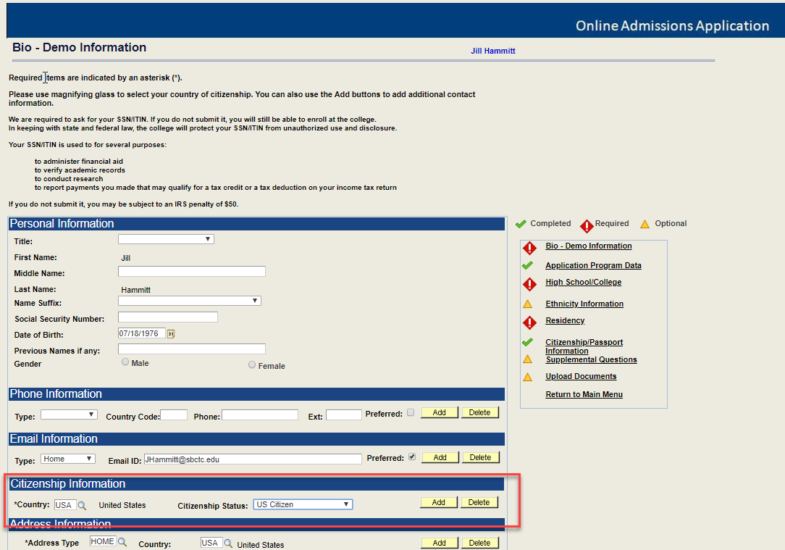

1. There is a Page specific for Citizenship/Passport and Visa Information

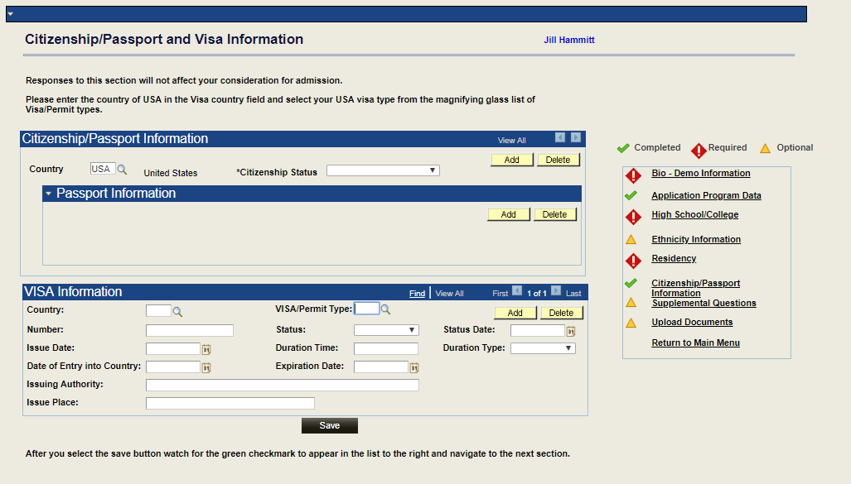

1. There are also questions on the Residency Page

