[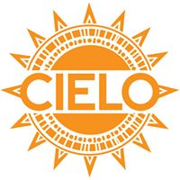](https://www.facebook.com/1414025182167955/photos/1486962218207584/)

[**www.cieloprograms.org**](http://www.cieloprograms.org)

**CIELO’s “Immigrant Family Fund”**

**Potluck/Fundraiser**

**Sunday, August 20, 2-4 p.m**. [bring favorite dish or sweet!] **Roasted chicken will be provided--plus** Latino music!

**Lutheran Church of the Good Shepherd, 1601 North St. SE, Olympia**

***Co-sponsored*** *by Interfaith Works, Holy Wisdom Inclusive Catholic Community, St. Benedict Episcopal Church, Lutheran Church of the Good Shepherd, Olympia Universalist Unitarian Church, First Christian Church, St. John’s Episcopal Church, and other faith communities.*

Immigrant families in the South Sound are **at risk of** **deportation**, and this risk appears to be intensifying. It is up to us to help with the funding of efforts to protect our most vulnerable sisters and brothers and their families (see back for details).

[Charo Portaro, Director of CIELO’s Education Program, will provide comments.]

***We invite you to contribute*** *during the August 20th potluck event-- or by writing and mailing a check to* ***CIELO****, 1601 North St. SE, Olympia 98501. Memo line:* ***“Immigrant Family Fund.”***

**THANK YOU!**