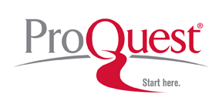
Agenda for Fall 2017 Trainings – State of Washington
DATES:
Monday, October 9th through Friday, October 13th
Monday, October 16th through Friday, October 20th
(Sessions 2-3 hours, depending upon local preference)

- Updates in the resources
  - ProQuest platform resource updates – review
  - SIRS Discoverer updates – review
  - CultureGrams updates – review
  - eLibrary Curriculum Edition updates
    - eLibrary Curriculum Edition – major changes coming for 2018 – review
- When/Why to use ProQuest Research Library, ProQuest U.S. Newsstream, and ProQuest Family Health Database
  - Examples and Sample Searches
  - User Time and Discussion
- When/Why to use ProQuest ABI Inform Trade and Industry
  - Examples and Sample Searches
  - User Time and Discussion
- When/Why to use eLibrary Curriculum Edition (including History Study Center and ProQuest Learning: Literature)
  - Examples and Sample Searches
  - User Time and Discussion
- When/Why to use CultureGrams
  - Examples and Sample Searches
  - User Time and Discussion

Contact and Scheduling: Jeffrey Cutler, Sr. Training and Consulting Partner, ProQuest
jeffrey.cutler@proquest.com; 801-455-9775; 800-521-0600 x72996

