**INSTRUCTIONS FOR FINDING THE LTCC TEAMS ACCOUNT**

1. Open **Microsoft Teams**

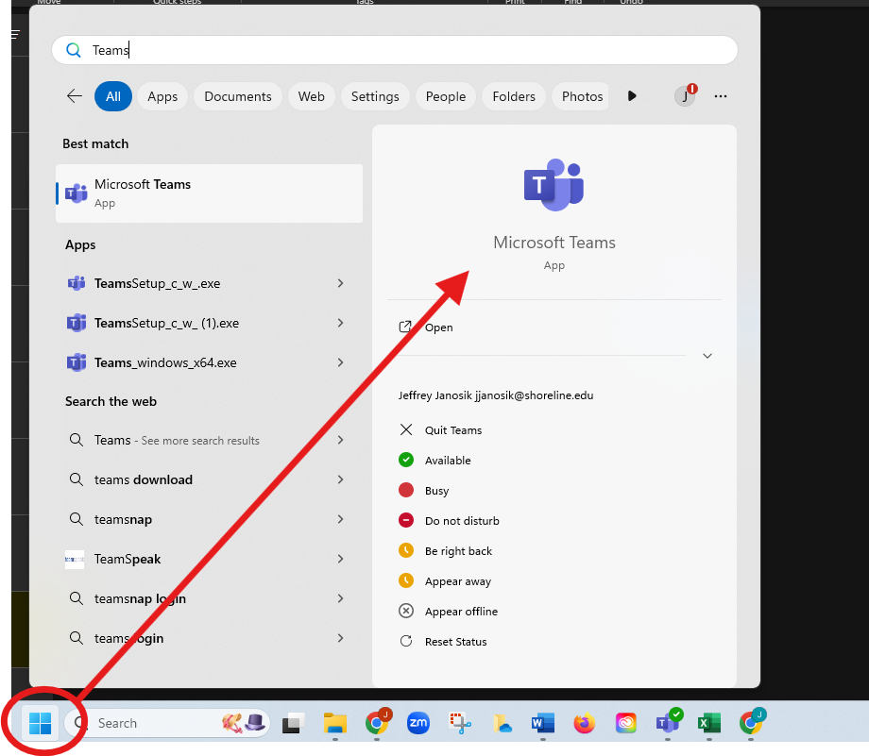

1. In the top right account settings, Select **Clark College**

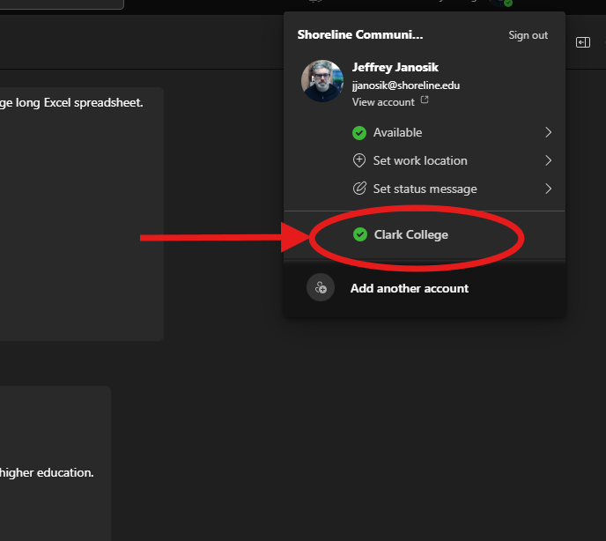

1. On the left toolbar, select **Teams**

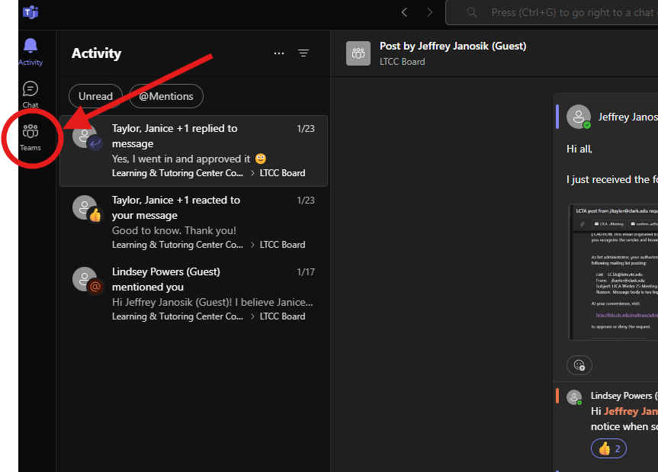

1. Select **General**

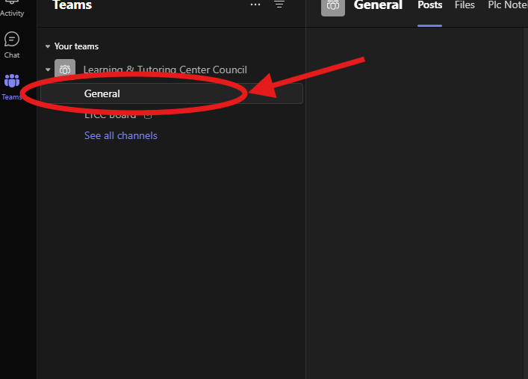

1. Begin or Reply to a topic