LTCA Fall 24 Meeting Minutes
DATE: 10/18/24
TIME: 9:00am-11:00pm
Board: Julia Mitchell, Lindsey Powers, Janice Taylor

 | TOPIC
1. | Introductions & Welcome New Members:  Meeting was attended by 26 members. We were able to welcome several new and/or returning members to the group. Big welcome to new members from Bellingham Tech, Big Bend, Edmonds, Everett, Grays Harbor, Peninsula, Shoreline, UW, Whatcom, Wenatchee & more!
2. | Board Updates, Reminders, & Information: Update on Board Projects (Lyall)  - Board was busy over summer! We have drafted a proposal and reached out to the SBCTC for guidance and support on creating a Council at the SBCTC.  - Board has completed outreach to all members of Washington State Community and Technical Colleges that were not represented in our group to invite and encourage participation in the LTCA. We have now grown to include all but 6 WA CTC’s if anyone has contacts/colleagues within Centralia, Bates, Clover Park, Pierce Fort Steilacoom, Pierce Puyallup, or Spokane Falls, please reach out to your colleagues and invite them to our association.  - All member poll and secondary poll (in meeting) placed our council name solidly as, “Learning & Tutoring Center Council (LTCC) Proposal will be updated to reflect this and Team Site named accordingly  - Meeting frequency poll: Overwhelming response to hold meetings quarterly, on Friday mornings, 2-hour duration  - Lyall R. has made the difficult decision to step down from the board at this time in order to balance personal and professional responsibilities. We are accepting volunteers and nominations to fill Lyall’s position. Jeff Janosik has volunteered for this position. If anyone else is interested please email your board members.
3. | Poll Responses  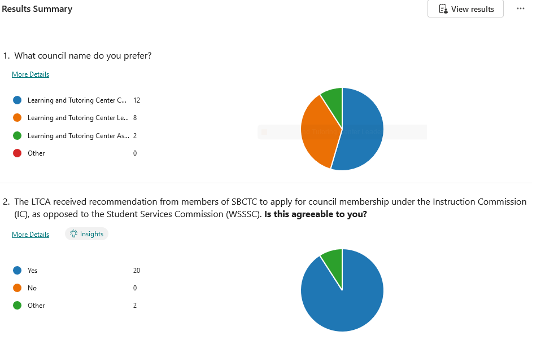
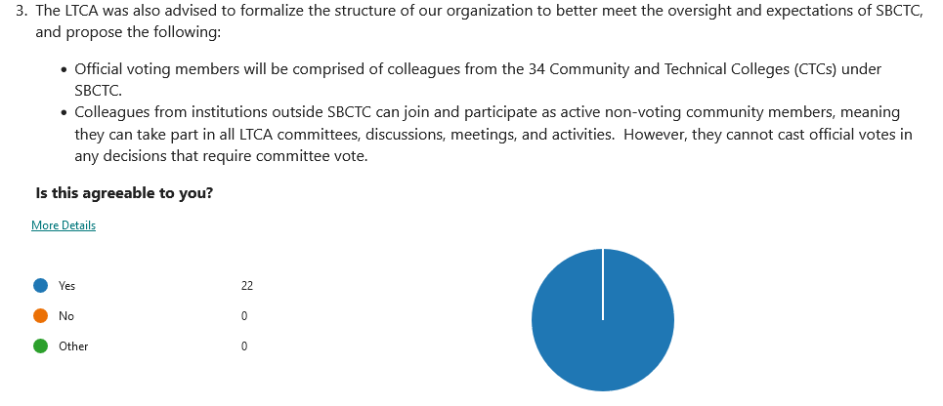
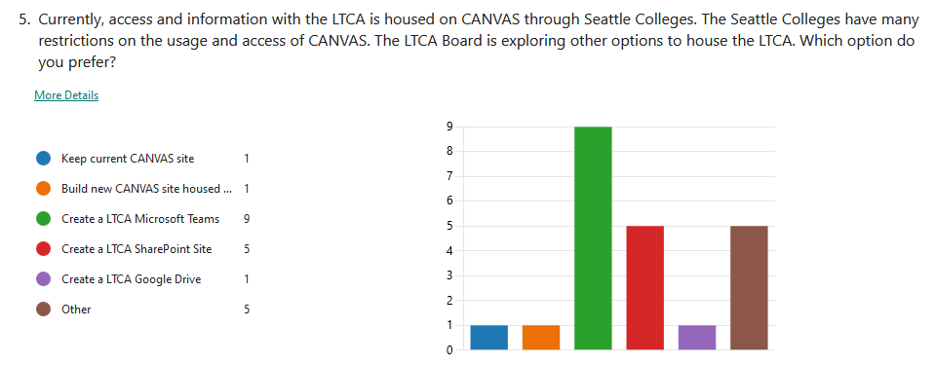
A Teams site will be created and piloted for our group. If successful, we will pull over information from the Seattle Canvas Shell. Everyone will receive an email invite to this shell as the link did not work during the meeting.
Service Names:
- Tutoring Services (2), Tutoring Center (3), Tutoring & Resource Center
- STEM Tutoring Center/Business Education Center, Languages & Communication Lab, The Study Hub
- Supplemental Instruction
- Academic Success Center (2)
- Learning Commons (2), Learning Resources and Career Center, Learning Support Services, Student Learning Center (2), Bock Learning Center, Learning Center
Leadership Roles:
- Program Manager (3), Program Coordinator (6), Program Specialist (2)
- Lab Coordinator/Coordinator (2)
- Director (7), Assistant Director, Assistant Dean
4. | Bylaws:  - Minor change to By Laws regarding SBCTC vs. WA CTC’s wording  - Vote to approve the By Laws with changes noted passed 100%, changes adopted
5. | Council Proposal:  - Draft proposal was sent to all members, no feedback was received, new draft will be re-sent and posted to shared site for feedback and revisions prior to presentation.
6. | Open Discussion time/creation of subgroups  Discussed several topics below and these will be added to the new Teams site for further discussion and ongoing development  - How Tutoring is supported by and supports Guided Pathways  - Budget/Funding opportunities what is being leveraged, what can be?  - How are centers organized? Just one general tutoring center or are there multiple centers for specific topics such as a math lab, writing center, online only, etc.  - Preparing trainings and support for tutors helping neurodivergent and neurotypical students  - Preparing trainings on AI - how is it being addressed at your institution? Supporting tutors with helping students on use of AI. Highlighting positive uses and ethical use.

