# **ENTERING LACES INTAKE FORMS INTO LACES**

1. Log into LACES
2. Go to the **Student tab.**
3. Choose **Tobi view**
4. **Search by one of these options:**
   1. **Last 4 digits of External ID#** - click on the funnel at the top of the column and choose **Contains**, then enter the last 4 digits of their ctcLink ID # next to the funnel and Enter/Return
   2. **Name** – click on the funnel at the top of the column and choose **Contains**, enter their first or last name next to the funnel at the top of the appropriate column (partial is OK, use what is most unique). then Enter/Return
5. Double click on the student record
6. **Go to the Student Data tab**
7. Scroll down to the bottom of the second column to **Data Sharing Agreed**.
   1. Enter either  
      **Yes** – If they signed the form (or the original Spanish version)  
      **No** – if they did not sign any version.
8. Click Save
9. **Go to the Education tab**
10. Click the down arrow for **Education**
11. Scroll down to the bottom of the first column. Enter the following information from their LACES form.
    1. Highest Ed Level Compl on Entry*
    2. Highest Ed Level Compl on Entry Loc*
12. Click Save
13. **Go to the History tab**
14. Click the down arrow for **Work History**
15. Double click on the record that is already there or add a new record.
16. Enter their Employment status in the Employment Status* category.
17. Click Save
18. Double check that the data you entered is showing in the correct column
19. Click the down arrow for **Barriers to Employment**
20. Double click on the record that is already there or add a new record.
21. Check the boxes the student marked on their LACES Intake form.
    1. **Note:** Some are phrased differently:  
       **Skills Development** = Low Literacy Levels  
       **Bias Considerations** = Cultural Barriers  
       **Justice Involved** = Ex Offender
22. Click Save
23. Double check that the data you entered is showing in the correct columns
24. Click the **arrow next to Dashboard** in the top left corner.
25. Double check that the data you entered is showing in the following columns:
    1. Highest Ed Level Compl on Entry
    2. Highest Ed Level Compl on Entry Loc
    3. Employment Status
    4. Data Sharing Agreed

**To search for more students, you have two options.**

**Option 1:** on the filter you applied (name or ID#), click on the X and start again at step 4.  
  
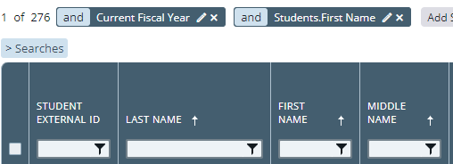

**Option 2:** If you will use the same filtered column (name or ID#), click the pencil icon then change the name or number you are searching for and click Apply. Then start again at step 5.   
  
