Registration Still Open
5th Annual Metacognition & Mindfulness:
Reading Apprenticeship Conference
March 8, 2019 – 3:00 p.m. to 7:00 p.m.
March 9, 2019 – 8:00 a.m. to 3:30 p.m.
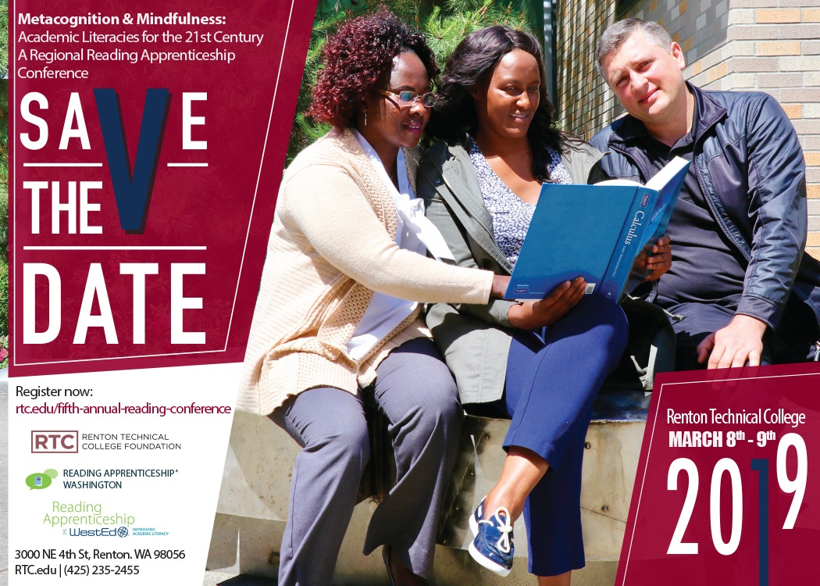
Come see what your peers and their students are accomplishing in ELA, HSE, IBEST, and college courses using the Reading Apprenticeship framework to their curricula.
Register at
https://www.rtc.edu/fifth-annual-reading-conference

