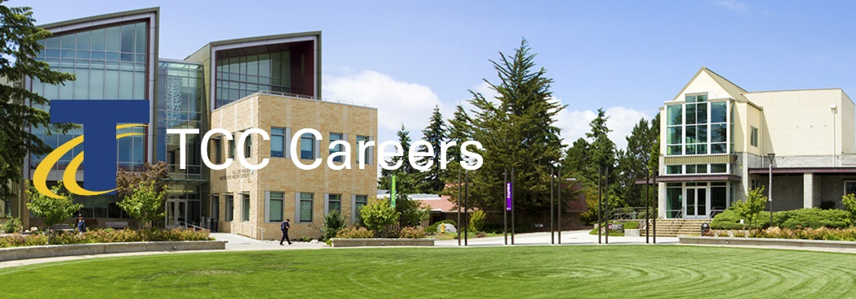 | We invite you to join us and be an active part of a multicultural environment dedicated to academic excellence.  Posting Date: 08/06/2020  Priority Date: 08/23/2020  Announcement: 20-08-AP #MON  Advancing Equity, Diversity and Inclusion  Cultivating Exceptional Learning  Strengthening Community Partnerships  Enhancing Institutional Vitality

Professional Development Coordinator

Priority Consideration Date: August 23, 2020
About Us
Since opening its doors in 1965, Tacoma Community College has provided a high-quality, affordable education to more than 500,000 people. Serving Tacoma, Gig Harbor, the Key Peninsula, online students and the women’s prisons, TCC educates about 11,000 students annually. Many TCC students are the first in their families to attend college, 58 percent receive financial aid, 13 percent have children, 42 percent are students of color, and 48 percent work while attending school. TCC has two campuses, the main campus in Tacoma and another in Gig Harbor. Situated northwest of Tacoma across the Narrows Bridge, the Gig Harbor campus offers credit and non-credit courses.

TCC is committed to developing and sustaining a vibrant educational environment where all students can thrive by providing educational opportunities such as learning communities, honors programming, undergraduate student research, bachelor of applied science degrees, and study abroad. TCC is committed to student success, and promotes innovation to help students. TCC is one of 67 colleges selected nationally to participate in the Department of Education’s Second Chance Pell pilot program, providing access to education for incarcerated individuals. Designated a Military Friendly College®, TCC is proud to serve Pierce County’s military community. In fall 2018, the college opened a food pantry on campus to support students experiencing food insecurity and was recognized by the Harvard Kennedy School for its College Housing Assistance Program, a community partnership that helps students access affordable housing.

Position Summary
Tacoma Community College (TCC) serves the educational, workforce, and cultural needs of our diverse students and communities through the core themes of advancing equity, diversity, and inclusion; cultivating exceptional learning; strengthening community partnerships; and enhancing institutional vitality. We are seeking a Professional Development Coordinator (PDC) who will be responsible for (1) identifying the professional development needs of our campus employees, and (2) developing, implementing, monitoring and evaluating formal and informal professional development opportunities offered on campus. As the winner of the regional Charles Kennedy Award for Equity, equity, diversity and inclusion are high priority initiatives for TCC. The PDC is critical in maintaining and enhancing ongoing learning for staff and faculty, both on – and – off – campus to create organizational accountability and effectiveness, momentum, and advancement towards TCC’s equitable and anti-racist goals.

This position will report to the Office for Equity, Diversity, and Inclusion (OEDI) and will collaborate with, and report to, the Vice President (VP) for Equity, Diversity, and Inclusion (EDI). OEDI includes the Vice President (VP) for EDI, the executive assistant to the VP for EDI, Institutional Research, Professional Development, Assessment, Accreditation and Strategic Planning. Together, OEDI leads the integration of EDI principles, values and practices across TCC towards the fulfillment and maintenance of the goals outlined in our strategic plan, and mission, while helping to foster an equitable and inclusive culture of learning and effectiveness.

Essential Functions
- Develop comprehensive Faculty and Staff Development programs in support of the college’s strategic objectives.
- Collaborate with the campus to conduct needs assessments, involving surveys and conversations with faculty, staff, and students to determine institutional needs for professional development, using an equity lens.
- Based on survey and conversational data and analysis, lead the planning, evaluating, and reporting requirements for institutional professional development days, and making recommendations to strengthen professional development infrastructure, opportunities and engagement for the campus.
- Maintains database, generates reports and develops proposals to support the direction and activities of professional development.
- Promotes professional development through activities that support cultural responsiveness, equity, anti-racism creativity, and innovation in teaching and delivery of services to students.
- Promotes leadership development through activities that encourage individual and team growth.
- Encourage collaboration, teamwork, courageous conversations, and positive learning and working relationships among administrators, faculty, staff, and students.
- Collaborates with the campus community in the collection and production of professional development materials.
- Evaluate and research trends in higher education professional development activities.
- Builds and maintain a library of resources that addresses frequently needed and/or required development competencies in all positions at the college, including content related to equitable, diverse, and inclusive practices.
- Develop self-service resources and provide support to faculty and staff to promote effective use of learning environments.
- Compile, analyze, and share relevant dialogue and data with various campus wide committees.
- Works closely with faculty and staff to research, develop, and implement assessment instruments and models designed to improve the delivery of programs and services
- Works collaboratively with faculty and staff to sponsor and facilitate workshops, meetings, and presentations.
- Collaborate with various campus constituents to develop and support the onboarding and orientation of new faculty and staff.
- Collect information on various professional development opportunities offered by different departments, divisions, offices, and programs within the institution, and promote them across campus.
- Evaluates outcomes and make recommendations to the VP for EDI on strategies to improve program outcomes.
- Serve on college committees.
- Assist faculty and staff in identifying resource on issues of equity and student success for the development of teaching and learning, and services to support student success.
- Produce an annual Professional Development Report.
- Build consensus and collective momentum across departments.
- Collaborate with all members of the OEDI Team, and affiliated groups on various projects and evens for seamless alignment and delivery of services.
- Perform the responsibilities of the job within the framework and consistent with the priorities established by the OEDI.
- Perform other duties as assigned.

Minimum Qualifications
- Bachelor’s degree from an accredited college or university. Three or more years of experience directly related to the duties and responsibilities specified.
- Experience developing or implementing professional development/training programs using a lens for reducing or dismantling inequity.
- Experience creating processes or instruments to identify institutional professional development needs.
- Experience using institutional data to design and evaluate professional development and training opportunities.

Preferred Qualifications
- Master’s degree from an accredited college or university.
- Experience in an education environment, especially a community college.
- Teaching experience, particularly, but not limited to the college level.
- Experience supporting faculty and higher education staff in professional development and training activities.

The Successful Candidate Must Demonstrate
- Work successfully with individuals and groups representing a wide range of diverse cultural, geographic, and socioeconomic backgrounds
- Model professional decorum and mutual respect in all personal interactions.
- Demonstrated record using principles and practices of creating equitable access and an inclusive environment for students and employees.
- Experience working with cross-departmental groups to accomplish college-wide goals.
- Ability to establish and maintain positive and respectful working relationships with internal and external customers.
- Must maintain a high standard of conduct and ethical behavior
- Strong organization and communication skills, including experience presenting complex ideas to various constituencies.
- Demonstrated record using principles and practices of creating equitable access and an inclusive environment for students and employees.
- Experience working with cross-departmental groups
- Broad knowledge and understanding of the trends and changes taking place in higher education and their implications.

Conditions of Employment
- Successful completion of a criminal history background check.
Application Process
Complete application packages must include the following:
- Tacoma Community College application.
- Resume and cover letter. Indicate in your letter how your educational background and experience align with the qualifications for this position.
- Copies of transcripts for all colleges and universities attended
- Tacoma Community College is committed to creating and supporting a multi-cultural climate that welcomes, fosters, respects, and celebrates diversity. Please attach a statement (maximum two pages) describing your experiences with other cultures and communities, your level of cultural self-awareness and how you have integrated both experience and self-awareness into your living/working environment.

Term of Employment
This is a full-time professional exempt position contracted on an annual basis. The salary for this position is $60,000 to $65,000 per year DOE/DOQ. The salary will be prorated to reflect the actual number of contract days worked in the remainder of the fiscal year. Flexibility in scheduling is required to meet the needs of the department. Tacoma Community College provides a generous comprehensive benefits package. Inclusive of considerate PTO, competitively affordable medical-dental plans, substantial life insurance options and broad range of retirement plans. Degrees must be from accredited colleges or universities recognized by the U.S. Department of Education and verified by National Student Clearinghouse.

Tacoma Community College provides equal opportunity in education and employment and does not discriminate on the basis of race, color, national origin, age, disability, genetic information, sex, sexual orientation, marital status, creed, religion, or status as a veteran of war. Prohibited sex discrimination includes sexual harassment (unwelcome sexual conduct of various types). Provides reasonable accommodations for qualified students, employees, and applicants with disabilities in accordance with the Americans with Disabilities Act and Federal Rehabilitation Act. The following persons have been designated to handle inquiries regarding non-discrimination policies: Stephen Smith, Title VII and Title IX, 253-566-5055; Dolores Haugen, Section 504 Officer, 253-566-6090. Tacoma Community College is a smoke-free/drug free environment. This recruitment announcement does not reflect the entire job description and can be changed and or modified without notice.
Tacoma Community College
Human Resources
6501 S 19th St Bldg. 14, Tacoma WA 98466
www.tacomacc.edu/about/employment

