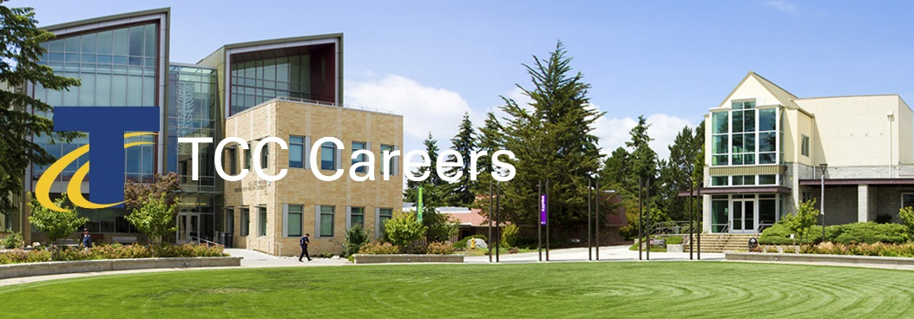 | We invite you to join us and be an active part of a multicultural environment dedicated to academic excellence.  Posting Date: 07/30/2020  Priority Date: 08/16/2020  Announcement: 20-06-AP #MON  Advancing Equity, Diversity and Inclusion  Cultivating Exceptional Learning  Strengthening Community Partnerships  Enhancing Institutional Vitality

Accreditation Liaison and Strategic Planning Officer

Priority Consideration Date: August 16, 2020

About Us
Since opening its doors in 1965, Tacoma Community College has provided a high-quality, affordable education to more than 500,000 people. Serving Tacoma, Gig Harbor, the Key Peninsula, online students and the women’s prisons, TCC educates about 11,000 students annually. Many TCC students are the first in their families to attend college, 58 percent receive financial aid, 13 percent have children, 42 percent are students of color, and 48 percent work while attending school. TCC has two campuses, the main campus in Tacoma and another in Gig Harbor. Situated northwest of Tacoma across the Narrows Bridge, the Gig Harbor campus offers credit and non-credit courses.

TCC is committed to developing and sustaining a vibrant educational environment where all students can thrive by providing educational opportunities such as learning communities, honors programming, undergraduate student research, bachelor of applied science degrees, and study abroad. TCC is committed to student success, and promotes innovation to help students. TCC is one of 67 colleges selected nationally to participate in the Department of Education’s Second Chance Pell pilot program, providing access to education for incarcerated individuals. Designated a Military Friendly College®, TCC is proud to serve Pierce County’s military community. In fall 2018, the college opened a food pantry on campus to support students experiencing food insecurity and was recognized by the Harvard Kennedy School for its College Housing Assistance Program, a community partnership that helps students access affordable housing.

Position Summary
Tacoma Community College (TCC) serves the educational, workforce, and cultural needs of our diverse students and communities through the core themes of advancing equity, diversity, and inclusion; cultivating exceptional learning; strengthening community partnerships; and enhancing institutional vitality. We are seeking an Accreditation Liaison and Strategic Planning Officer (AL & SPO) who will be responsible for the development, coordination, management, and reporting of: (1) our institutional strategic plan, (2) accreditation activities and compliance as it pertains to all accrediting bodies, such as, the Northwest Commission on Colleges and Universities (NWCCU), program accreditation, and state accreditation,(3) other college initiatives (such as Achieving the Dream, institutional awards, etc.), and our institutional review board (IRB) process . As the winner of the regional Charles Kennedy Award for Equity, equity, diversity and inclusion are high priority initiatives for TCC. The AL & SPO is critical in helping to create organizational accountability and effectiveness, compliance, momentum, and advancement towards TCC’s equitable and anti-racist goals.

This position will report to the Office for Equity, Diversity, and Inclusion (OEDI) and will collaborate with, and report to, the Vice President (VP) for Equity, Diversity, and Inclusion (EDI). OEDI includes the Vice President (VP) for EDI, the executive assistant to the VP for EDI, Institutional Research, Professional Development, Assessment, Accreditation and Strategic Planning. Together, OEDI leads the integration of EDI principles, values and practices across TCC towards the fulfillment and maintenance of the goals outlined in our strategic plan, mission, and accreditation standards, while helping to foster an equitable and inclusive culture of learning and effectiveness.

Essential Functions
Strategic Plan

- Understand and shape TCC’s strategic plan, mission, and values.
- Establish strategic initiative priorities, in partnership with the VP for EDI.
- Oversee TCC’s strategic initiatives from development through successful execution under the guidance of the Colleges’ Leadership Team and departmental leaders.
- Collaborate with the College’s Leadership Team and departmental teams to develop and implement short and long term roadmap planning and review as it relates to institutional strategic initiatives.
- Provide technical support and consultation on all matters relating to the strategic plan, including, development, measurement, implementation, evaluation, modifications, enhancements, and reporting of strategic planning activities.
- Review, design, and execute improvements to strategic initiatives and fulfillment.
- Prepare and submit quarterly and annual reports relating to strategic planning activities.
- Leading the College’s commitment to use an evidence based approach to improving student completion and closing opportunity gaps.

Accreditation
- Serve as the Accreditation Liaison Officer to NWCCU.
- Organize, coordinate, and monitor on-going implementation of accreditation agendas and recommendations and provide regular progress reports to the College Leadership Team.
- Work with departments to monitor, collect, compile and report annual review processes and action plans as it relates to accreditation.
- Maintain knowledge regarding the accreditation standards, policies, and processes of the NWCCU, and communicate these to the college community as appropriate.
- Prepare and submit reports for NWCCU, as required.
- Prepare the college’s self-study for submission to the Commission.
- Coordinate and host site visits from representatives of the NWCCU.
- Prepare the campus community for host site visits from NWCCU.
- Leading the College’s commitment to use an evidence based approach to improving student completion and closing opportunity gaps.

Other
- Attend and engage with college committees.
- Use college committee and governance structures to drive the execution and fulfillment of strategic planning and accreditation goals.
- Responsible for approving, monitoring, and maintaining the institution’s research activities through our Institutional Review Board (IRB) processes.
- Development, coordination, management, and reporting of institutional reports and processes related to college initiatives and projects.
- Develop and maintain processes that foster continuous improvement across departments.
- Collaborate with others to effectively communicate and align efforts related to the institution’s strategic plan, accreditation, and other college initiatives such as assessment, professional development, research, Guided Pathways, etc.
- Build consensus and collective momentum across departments.
- Collaborate with all members of the OEDI Team, and affiliated groups on various projects and evens for seamless alignment and delivery of services.
- Perform the responsibilities of the job within the framework and consistent with the priorities established by the OEDI.
- Perform other duties as assigned.

Minimum Qualifications
- Bachelor’s degree from an accredited college or university.
- Three or more years of experience directly related to the planning, development, evaluation, management, and reporting of institutional-wide initiatives and projects.
- Experience creating and maintaining program or project review and continuous improvement plans.
- Experience gathering and analyzing data to effectively support decision-making.
- Experience with maintaining accreditation or compliance outcomes.

Preferred Qualifications
- Master’s degree from an accredited college or university.
- Experience in an education environment, preferably in a community college.
- Broad knowledge and understanding of the trends and changes taking place in higher education and their implications.
The Successful Candidate Must Demonstrate
- Work successfully with individuals and groups representing a wide range of diverse cultural, geographic, and socioeconomic backgrounds
- Strong organization and communication skills, including experience presenting complex ideas to various constituencies.
- Experience developing, implementing, and maintaining processes.
- Model professional decorum and mutual respect in all personal interactions.
- Demonstrated record using principles and practices of creating equitable access and an inclusive environment for students and employees.
- Experience working with cross-departmental groups to accomplish college-wide goals.
- Ability to establish and maintain positive and respectful working relationships with internal and external customers.
- Must maintain a high standard of conduct and ethical behavior

Conditions of Employment
- Successful completion of a criminal history background check.
Application Process
Complete application packages must include the following:
- Tacoma Community College application.
- Resume and cover letter. Indicate in your letter how your educational background and experience align with the qualifications for this position.
- Unofficial (copies) transcripts for all colleges and universities attended
- Tacoma Community College is committed to creating and supporting a multi-cultural climate that welcomes, fosters, respects, and celebrates diversity. Please attach a statement (maximum two pages) describing your experiences with other cultures and communities, your level of cultural self-awareness and how you have integrated both experience and self-awareness into your living/working environment.

Term of Employment
This is a full-time professional exempt position contracted on an annual basis. The salary for this position is $65,000 to $70,000 per year DOE/DOQ. The salary will be prorated to reflect the actual number of contract days worked in the remainder of the fiscal year. Flexibility in scheduling is required to meet the needs of the department. Tacoma Community College provides a generous comprehensive benefits package. Inclusive of considerate PTO, competitively affordable medical-dental plans, substantial life insurance options and broad range of retirement plans. Degrees must be from accredited colleges or universities recognized by the U.S. Department of Education and verified by National Student Clearinghouse.

Tacoma Community College provides equal opportunity in education and employment and does not discriminate on the basis of race, color, national origin, age, disability, genetic information, sex, sexual orientation, marital status, creed, religion, or status as a veteran of war. Prohibited sex discrimination includes sexual harassment (unwelcome sexual conduct of various types). Provides reasonable accommodations for qualified students, employees, and applicants with disabilities in accordance with the Americans with Disabilities Act and Federal Rehabilitation Act. The following persons have been designated to handle inquiries regarding non-discrimination policies: Stephen Smith, Title II and Title IX, 253-566-5055; Dolores Haugen, Section 504 Officer, 253-566-6090. Tacoma Community College is a smoke-free/drug free environment. This recruitment announcement does not reflect the entire job description and can be changed and or modified without notice.
Tacoma Community College
Human Resources
6501 S 19th St Bldg. 14, Tacoma WA 98466
www.tacomacc.edu/about/employment

