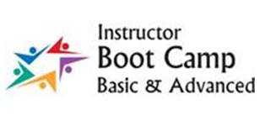

**Please join us** for Basic Boot Camp for Professional-Technical Instructors! What is normally a “class within a class” will also be a *Zoom within a Zoom* this year– AND IT’S FREE!

**Who will benefit?**

* New faculty
* Faculty with limited teaching experience
* Faculty who previously attended and want to “re-boot” and re-energize (and enhance their Zoom skills)

Did you notice that it is **FREE?**

Here’s a snapshot of what will be covered in the *newly revised* curriculum:

* Engaging adult learners
* Why outcomes matter
* Creating your presence as an instructor
* Building your instructor toolkit (syllabi, rubric, lesson plans)
* Mastering the art of feedback
* *And much more!*

**When can you participate?**

Session I: August 10-12 ***Registration closes August 5***

Session II: August 17-19 ***Registration closes August 12***Session III: August 24-26 ***Registration closes August 19***

Sessions are limited to 24 participants.

Wait *– it is free!* And you can show up in your pajamas! ☺

Contact [bootcamp@olympic.edu](mailto:bootcamp@olympic.edu) for more information. These trainings are made possible by funding from the Carl D. Perkins Act and are limited to Washington state Community and Technical faculty and staff.

Olympic College is an Equal Opportunity College.